Lecture 1 : Motivations for Macroeconomic Model

Two broad kinds of model:
- An integrated model for analysing the output, unemployment, inflation, and exchange rate
- Analysing growth

The basic question in macroeconomic analysis:
- How are the level of output and employment determined and why do they fluctuate?
- Why does inflation occur and when should we worry about it?
- How does G policy affect inflation and unemployment?
- How do trade, international financial markets, and exchange rate affect employment and inflation?
- Why are some countries rich and others poor?
- Why are some countries catching up with the leaders and others not?

(v) and (vi) need to understand the economic growth theory

1 Output, unemployment, and inflation
Three basics questions:
Q1:How is the actual or current level of output and employment in the economy determined?
Q2:What determines the level of employment in the economy at which level of inflation steble? This also call the medium-run equilibrium level of employment.
Q3:How and why does the economy tend to adjust from its current position towards the medium-run equilibrium and what factors influence the speed and smoothness of adjustment?

  - Assumptions and terminology

The behaviour of economics agents (H, F, G, Unions, and CB) are simultaneous.
Ex: Individuals make decisions to enter to labour force, to save, and to spend. They respond to job offers, to the interest rates, to changes in their current income level, and the value of their accumulated wealth.

Firms
- Alter the level of production as demand for their output fluctuates
- set the price
- make investment decision
- set the wages or through joint negotiation with workers or union

Both H and F will be sensitive to the G, T, and IR policy

Macroeconomics Terminology

The aggregate supply side refers to the supply of goods and services, which is consists of:
(i)the factors of production (L, and K). The supply and demand for L and K atre part of the supply side
(ii)the technology through which the input of labour and capital are tranformed into output.
(iii)the way in which the incomes (W, and profits) that workers and firms receive are determined.

The AD side refers to the aggregate demand for good and services, which consists of:

- consumption demand (both durable and non-durable product)
- investment demand (expenditure on capital goods-machinery, equipment, and buildings)
- demand stemming from G purchases

Building the Macroeconomics Model
- Short run
Period during which output and employment can change but before prices and wages respond to the changes in output and employment. (price and wages are fixed) or ‘sticky’ and ‘rigid’. Only AD that determines the level of output and employment

- Medium run
The period during which wages and prices can respond to changes in output and employment and in which the supply side of the economy adjust to establish a medium-run-equilibrium in which the inflation is constant once again. The capital stock and labour force are fixed

- long run
Long run analysis allow for growth in the population, in the pysical stock (machinery and equipment), human capital stock (skill of workers), and improvesment in technology.

1.2 Fluctuations in output and employment: Business cycle

Figure 1.1 : Quarterly growth rate of GDP for the US, and annual growth rate of GDP for France and USA

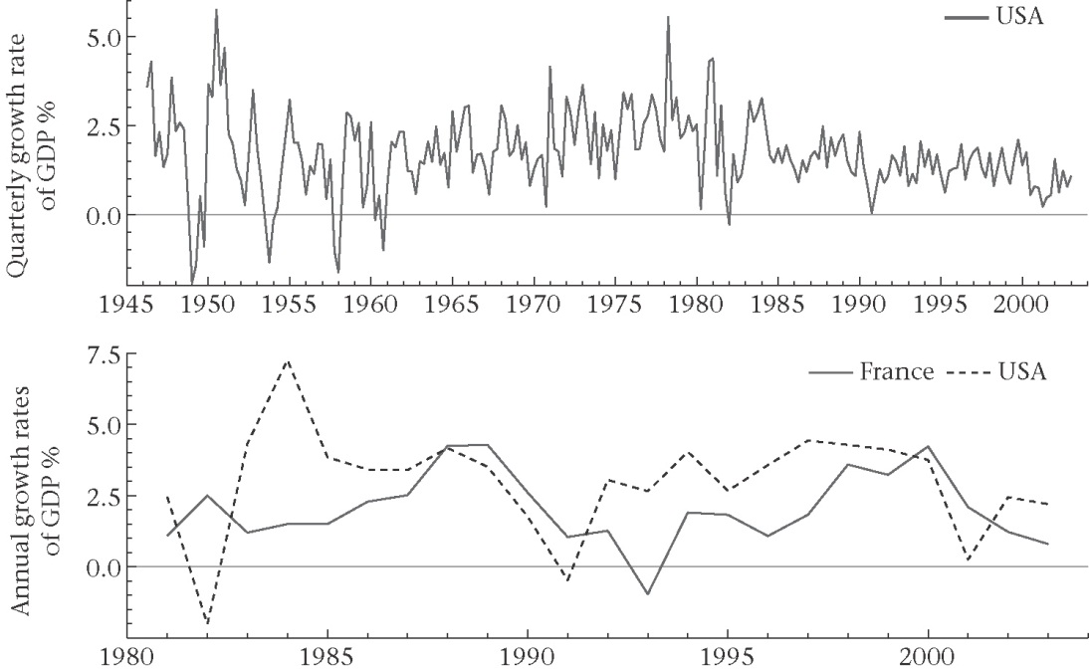

Q? What determine the business cycle or the level of output in the short run??

1.3 Unemployment: international comparisons

Figure 1.2 : Monthly unemployment rate for US, and comparison of the unemployment rates for the USA and Europe
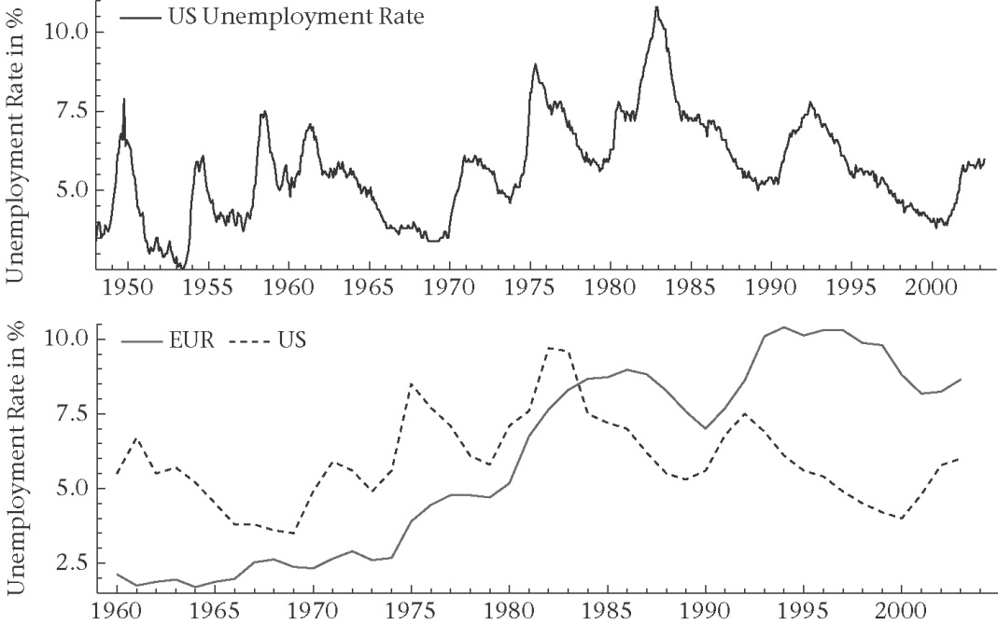

Two questions arise:
Q1? Why do different countries appear to have different unemployment rates?
Q2? Why are there persistent trends in unemployment in some countries?
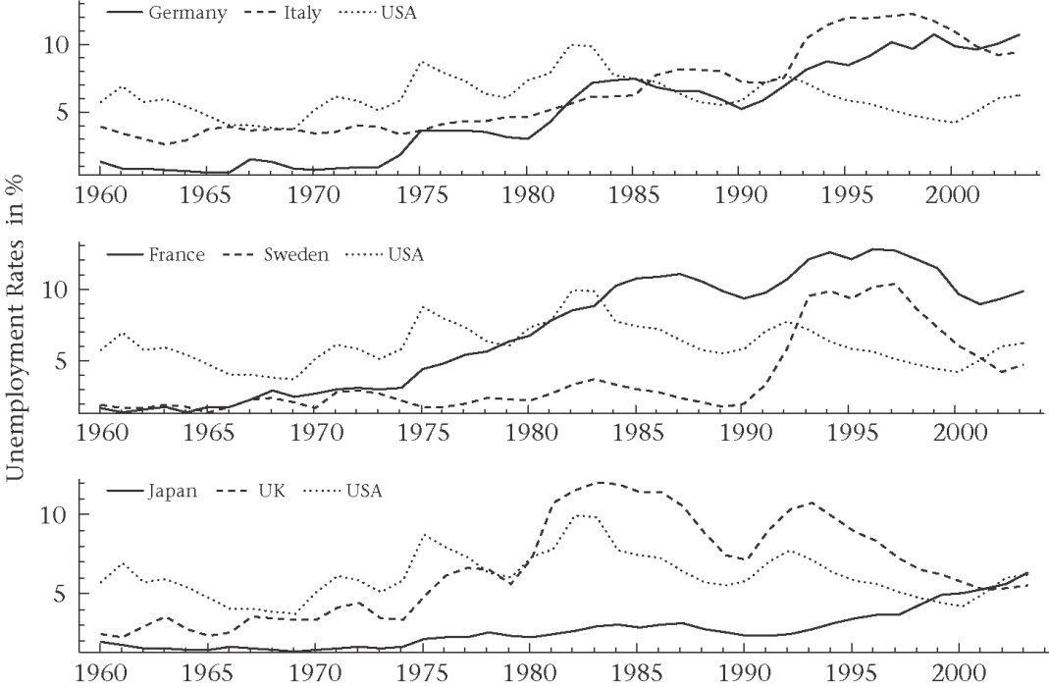

1.4 Modelling medium-run unemployment
Competitive model:
Labour market clears. That means the real wage adjusts so that the demand for labour by firms is equal to the supply of labour by individuals.
Only voluntary unemployment are exists.

(i)Imperfect competiton model
The equilibrium in the labour market does not necessarily coincide with market clearing. It can be involuntary unemployment even at equilibrium.
The role of wage-setters and price-setters.
Ex:Prices are set by firms and firm earn ‘supernormal’ profit because they have some market power (P>MC). Profit is the difference between the price and the MC.

With imperfect competition in the labour market, money wages will be set by employer or by unions or by both through negotiation.

1.5 Inflation

Figure 1.4 : Inflation of consumer prices in the US, and annually in some OECD economies
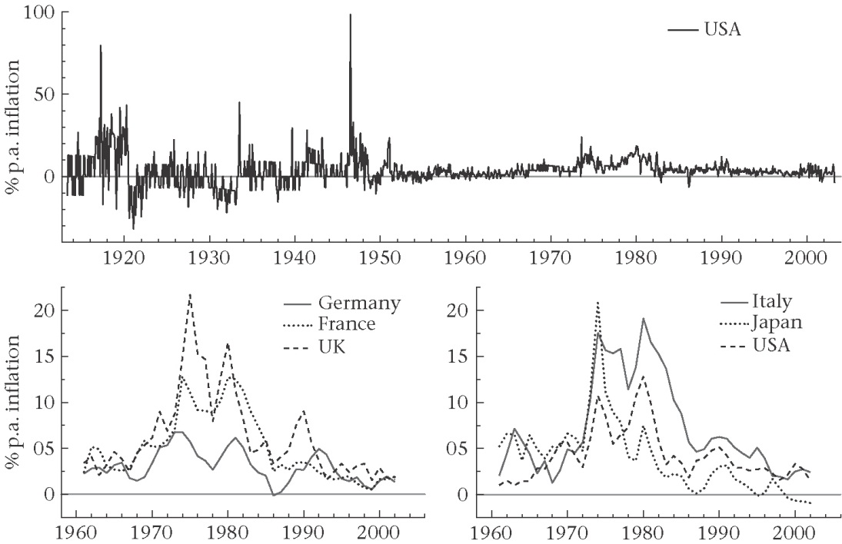

1.6 Inflation and monetary policy
Figure 1.5: Schematic view of the short- and medium-run model
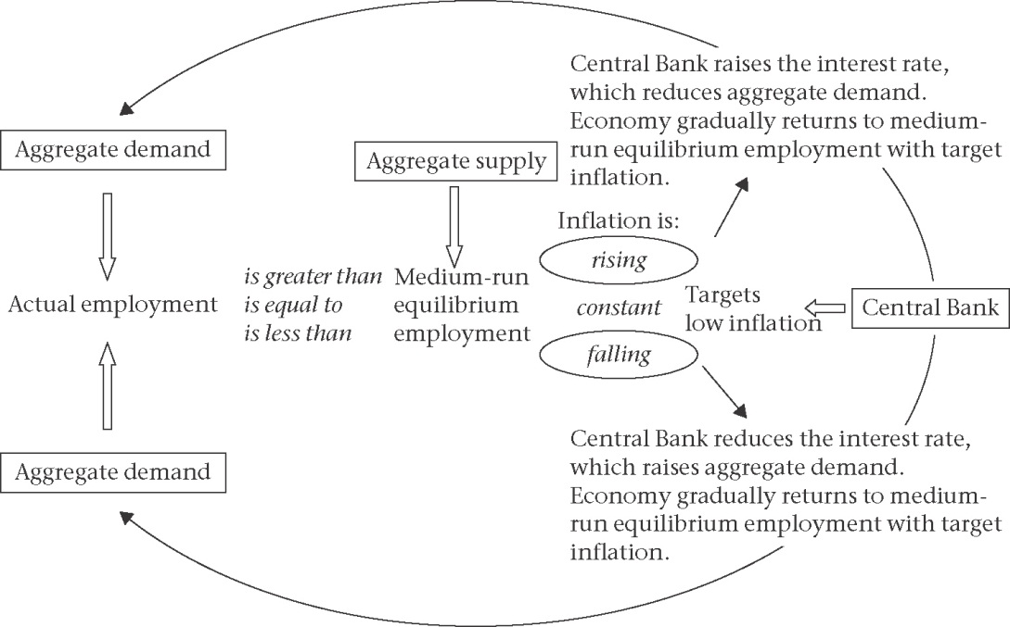
2. Economic Growth
2.1 The world income distribution

Figure 1.6: The world income distribution , and Kernel density estimates
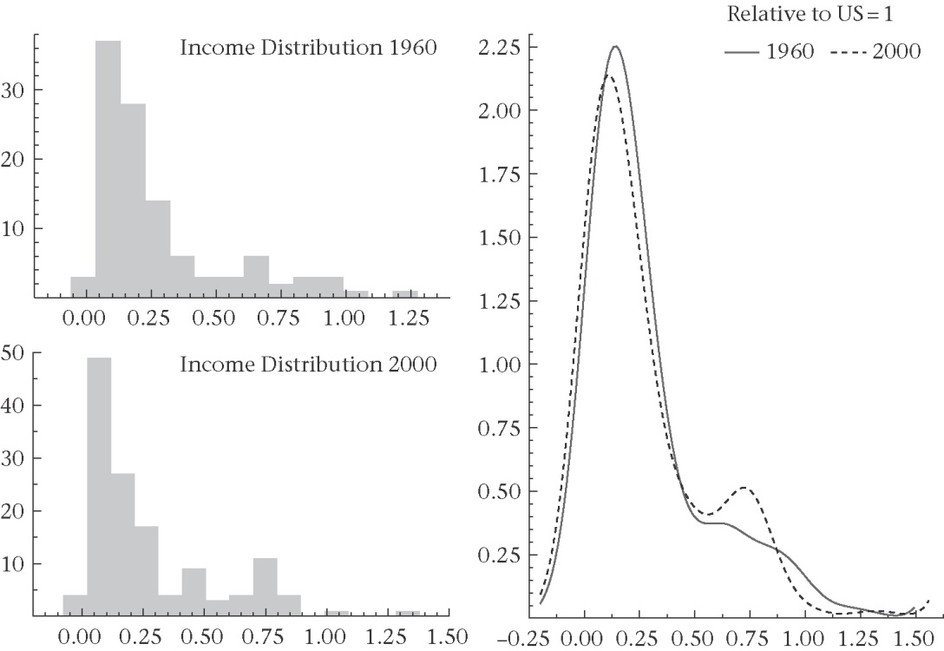

Figure 1.7: Scatter plot of relative income per capita in 2000 and 1960
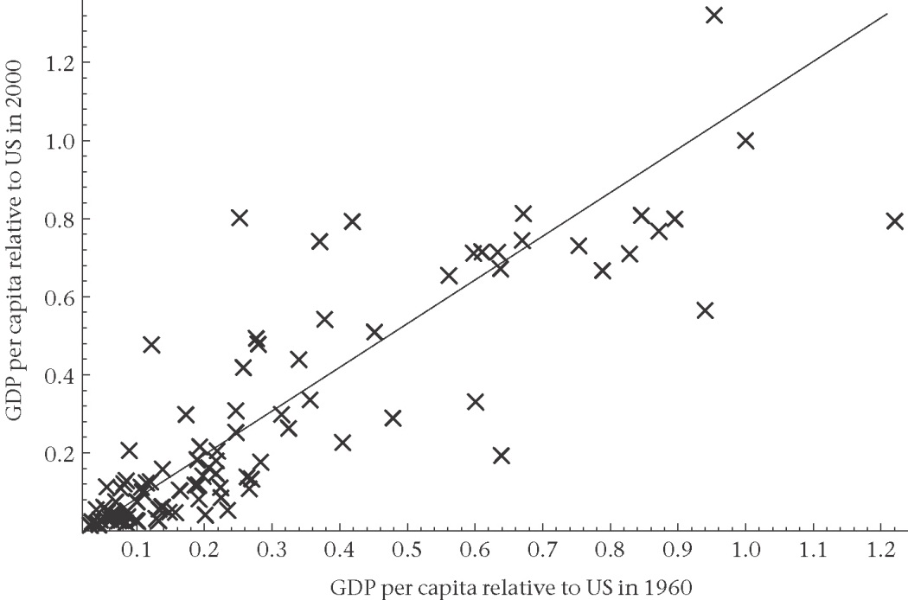

2.2 The stylized facts of economic growth
(1) Large discrepancies between both levels and growth rates of per capita income persists across countries and across time
(2) In the long run e onomies exhibit a balance growth path, that is output per capita and capital per capita grow at roughly constant positive growth rates over time
(3) The real rate of return to capital is approximately constant over the long run, while real wages grow at a rate colse to that of output per head.
(4) The ratio of capital to output shows no trend over time, ans shares of capital and labour in total income stay roughly constant.
(5) High investment rates in both physical capital and formal education are closely related to high living standard.
(6) Low population growth is associated with high living standard
(7) technological progress associated with product market innovation is the main driving force behind the long-run growth of living standard in the leader country.
(8) Political, social, institutional and historical factors affect the long-run economic performance of an economy and are associated with differences in growth rates across countries. Such factors help to predict which countries have converged to high levels of GDP per capita and which countries have not.

Figure 1.8: Cross-country concergence
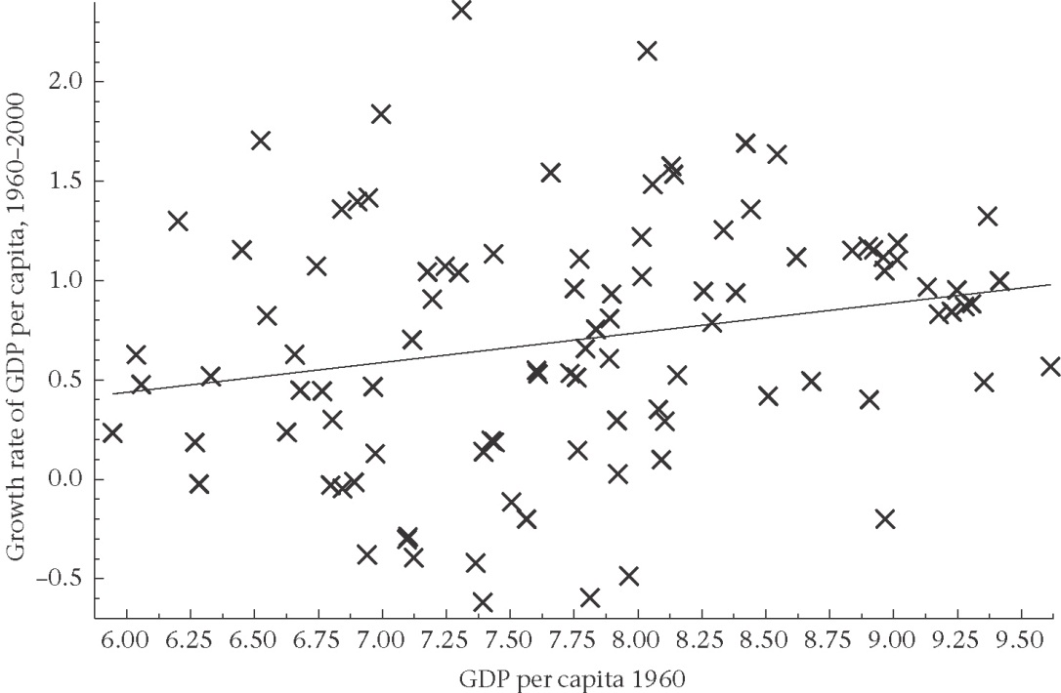

2.3 Growth and diminishing returns to factor accumulation
2.4 Growth and constant returns to factor accumulation
2.5 Innovation and incentives: Schumpeterian growth

