LECTURE 10: INFLATION AND UNEMPLOYMENT IN THE OPEN ECONOMY

1. Inflation and unemployment in the open economy
Three main questions in an open economy model:
(i)What determines the unemployment rate at which inflation is constant?
-In open economy PS curve and hence the actual real wage is affected by the real cost of imports, and therefore by the real exchange rate. Ex: A real appreciation means that the real cost of import is lower, thus raises real wages, and means that we have constant inflation equilibrium at lower unemployment.
(ii)What determines the constant rate of inflation at a medium-run equilibrium?
-Flexible vs fixed exchange rate
(iii)How does inflation behave when the economy is not at a constant inflation equilibrium?
-The consequences for inflation of any disturbances to the economy. Ex: a change in the real exchange rate affects real wages, and therefore disturbs the equil. In the labour market.
Figure 10.1: Equilibrium employment in the closed economy

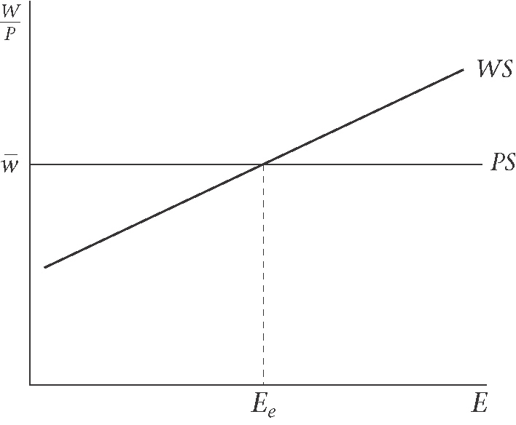
-Medium-run equil. in the closed economy is characterized by constant inflation (ERU or NAIRU)
  - Example 1. Fiscal Policy expansion with fixed exchange rate: what happens to inflation

Figure 10.2: Equilibrium employment in the open economy at low A and high B employment
Fiscal expansion: A to C to B (fixed exchange rate); A to D to B (flexible exchange rate)

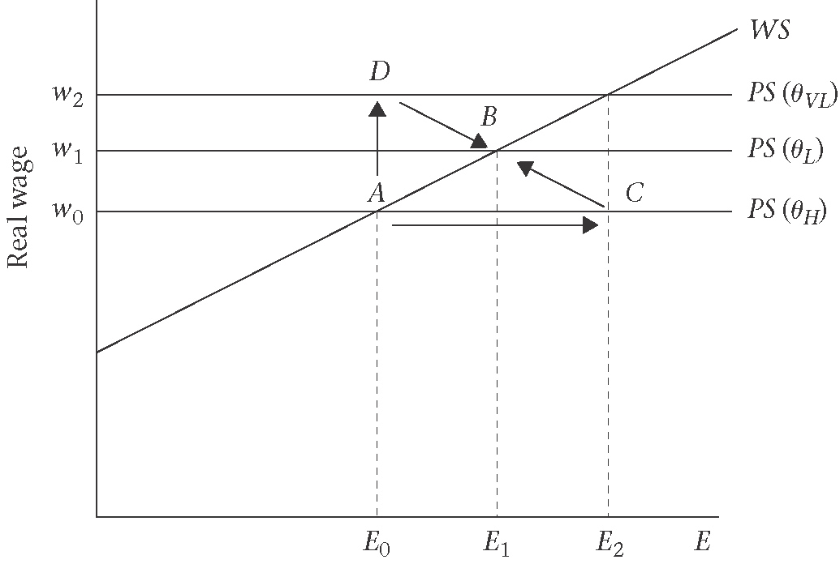

Table 10.1: Fiscal expansion under fixed exchange rate
1st new SR equil. : at C | $↑g→↑y→↑E⇒ΔE>0$ and $Δw=0$
2nd (W and P adjust) | $↑E→↑W→↑P$ rel. to $P^{}→↑w$ and $↓θ→↓y→↓E$
3rd –new MR equil. at B | $π$constant, w higher, $θ$ lower, E higher

  - Example 2. Fiscal expansion with flexible exchange rates: what happens to inflation
Table 10.2: Fiscal expansion under flexible exchange rate
1st new SR equil. : at D | $↑g→↓θ→↓\left(x−m\right)⇒ΔE=0$ and $Δw>0$
2nd (W and P adjust) | $↑w→↓W→↓P$ rel. to $P^{}→↑θ→↑y→↑E$
3rd –new MR equil. At B | Same as under fixed ER

2. Supply side in the economy
2.1 Wage and price setting in the open economy
$P=P_{x}=\frac{1}{1−μ}⋅$ unit cost ; $μ$ is the mark-up (cost-plus pricing)
The consumer price index:
$P_{C}=\left(1−φ\right)P+{φP}^{}e$ (consumer price index)
Using the fact that $P_{m}=P^{}e$, the real wage in terms of consumer prices:
$w=\frac{W}{P_{c}}$ (real wage)

2.1.1 Wage setting
$W=P_{c}b\left(E\right)$ (wage equation)
The wage-setting curve is defined by
$$\frac{W}{P_{c}}=b(E)$$
$w^{\text{ws}}=b(E)$ (wage-setting real wage)

2.1.2 Price setting
$P=P_{x}=\frac{1}{1−μ}⋅\frac{W}{λ}$ [price equation]
The first step is to substitute the price equation into the equation for the consumer price, $P_{c}$.
$P_{c}=(1−φ)P+{φP}^{}e$
$=(1−φ)\left[\frac{1}{1−μ}⋅\frac{W}{λ}\right]+{φP}^{}e$
In order to find the expression for the price-setting real wage, we divide each side by $P=\frac{1}{1−μ}⋅\frac{W}{λ}$. Using the definition of the real wage, $w=\frac{W}{P_{c}}$, and of the real exchange rate, $θ=\frac{P^{}e}{P}$.
$$\frac{P_{c}(1−μ)λ}{W}=\left(1−φ\right)+\frac{{φP}^{}e}{P}$$
$$\frac{(1−μ)λ}{w}=\left(1−φ\right)+\text{φθ}$$
$$\frac{w}{(1−μ)λ}=\frac{1}{(1−φ)+\text{φθ}}$$
By rearranging the equation, so that the price setting real wage is on the left hand side;
$w^{\text{PS}}=\frac{λ(1−μ)}{1+φ(θ−1)}$ [price-setting real wage, open economy]
$=F(θ)$
If there are no imported goods the weight of imports in the CPI is zero (i.e. $θ=0$), thus we have the price setting in a closed economy as;
$w^{\text{PS}}=λ(1−μ)$[price-setting real wage, closed economy]

Figure 10.3: Price-setting curves in closed and open economies; (a)closed economy, (b)open economy
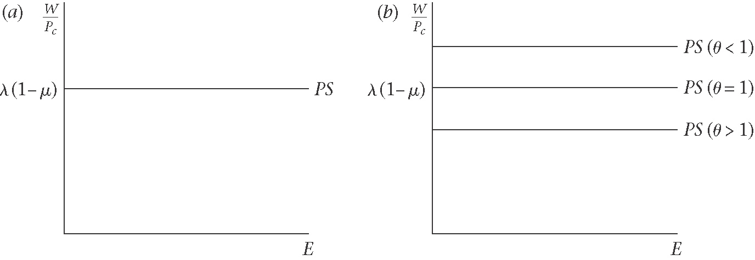

2.2 Medium-run equilibrium

Figure 10.4: Equilibrium rate of unemployment curve (ERU)
(a)WS and PS curves (b)ERU curves
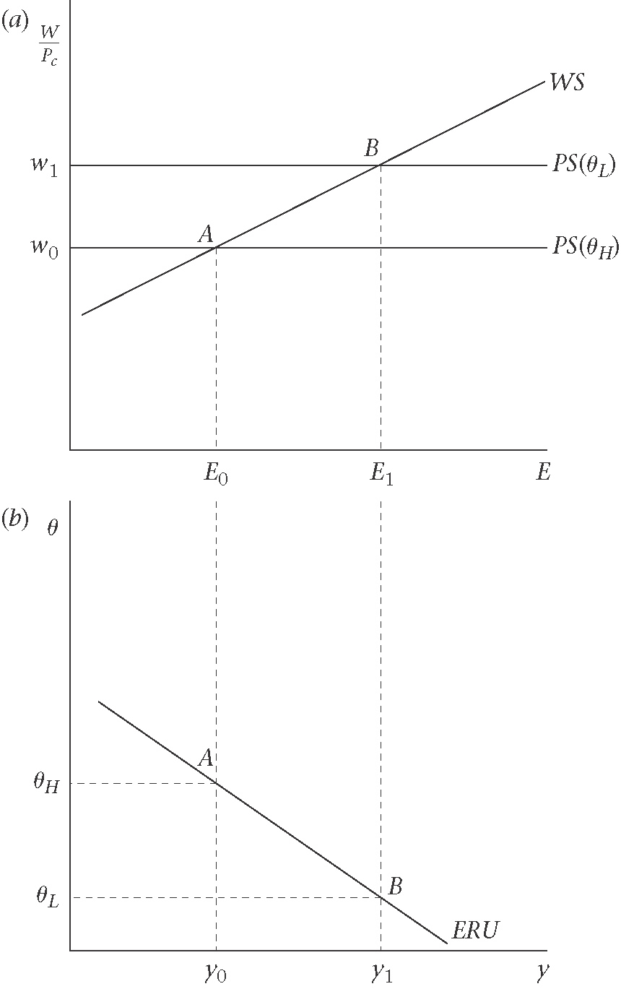

2.2.1 Equilibrium rate of unemployment (ERU) curve
2.2.2 Slope of the ERU curve

2.2.3 Off the ERU curve, the real exchange rate is rising or falling

Figure 10.5: Off the ERU curve
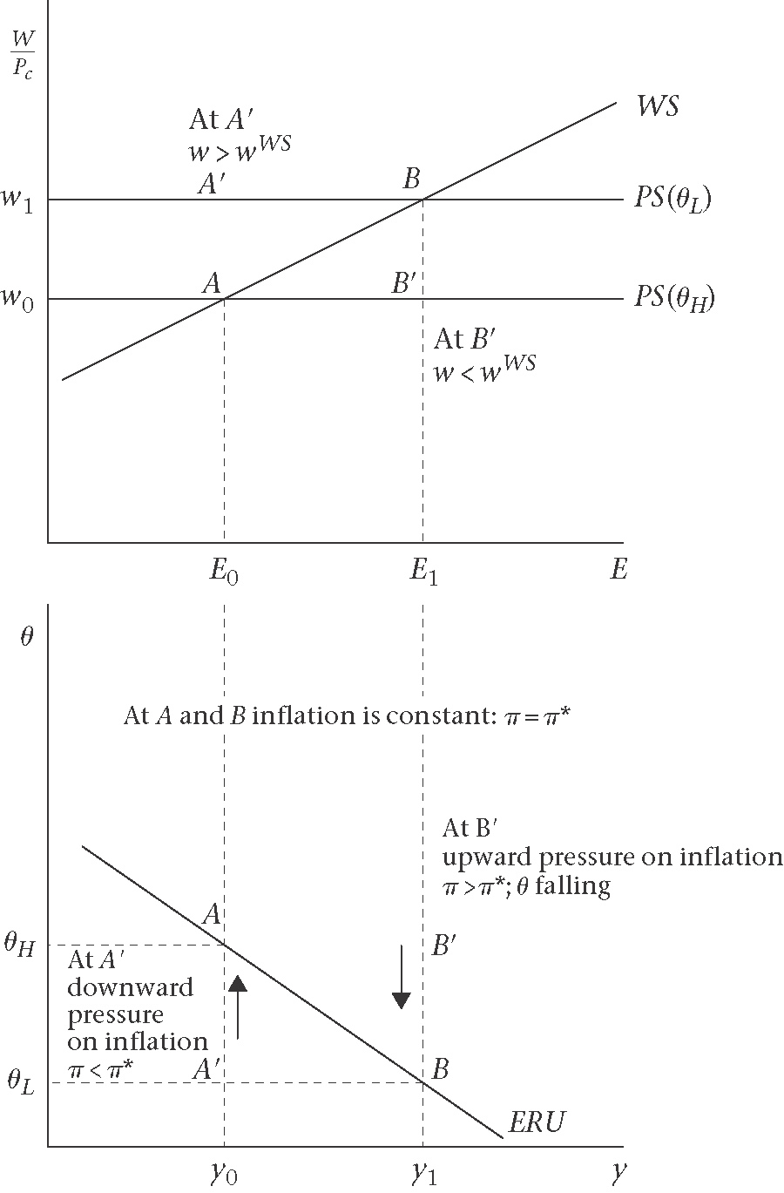

3. Demand side and trade balance
Goods market equilibrium is summarized by:
$$y=y^{D}$$
$=c+I(r)+g+(x−m)$
$=c+I(r)+g+σ\left(θ\right)y^{}−{θm}_{y}\left(θ\right)y$ , and $r=r^{}$

Figure 10.6: short-run equilibrium (goods and money market): AD curve; and trade equilibrium: BT curve.
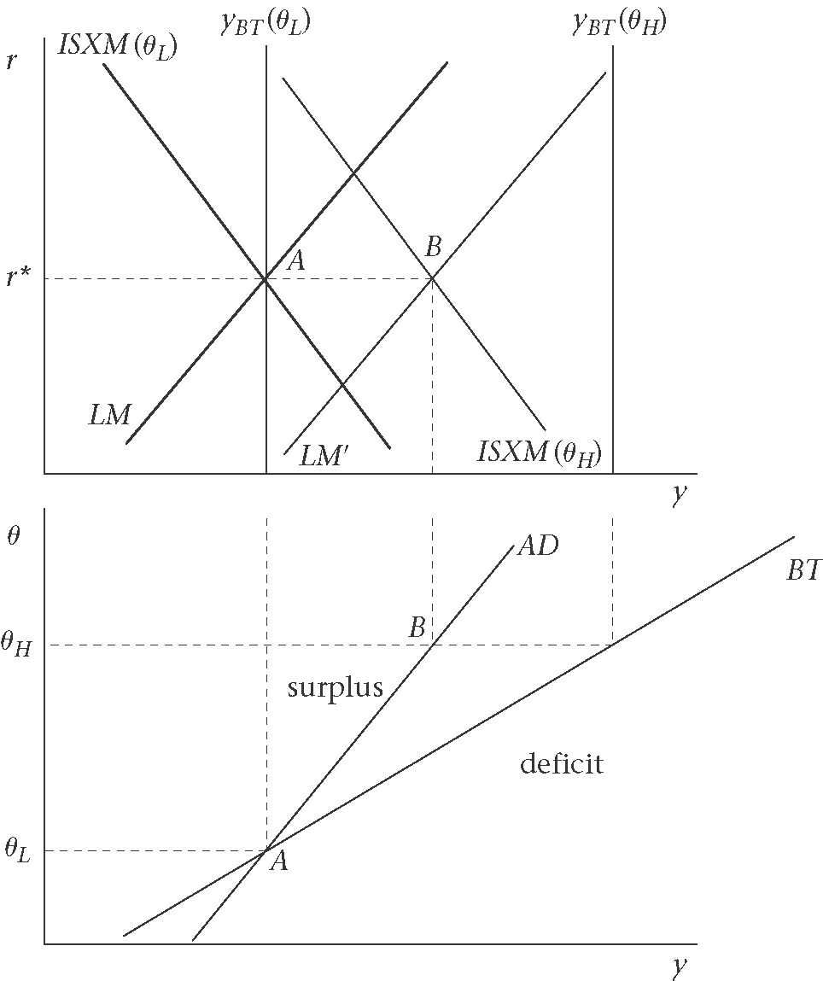

Figure 10.7: Use a devaluation (or looser monetary policy) and fiscal policy to achieve target output level, $y_{1}$, and trade balance
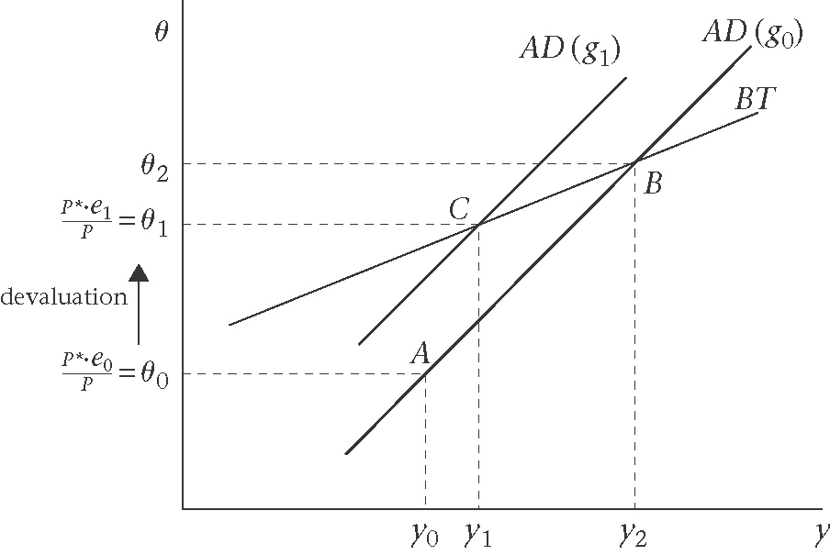

4. The open economy model : AD-BT-ERU model
The basic model for analysis in the small open economy consists of;
(i)the demand side represented by the AD curve. On the AD curve, the goods market is in equilibrium and $r=r^{}$
(ii)the supply side represented by the ERU curve. On the ERU curve inflation is constant
(iii)the balance of trade equilibrium represented by BT curve

Figure 10.8 : Short run, medium-run, and long-run equilibria in the open economy
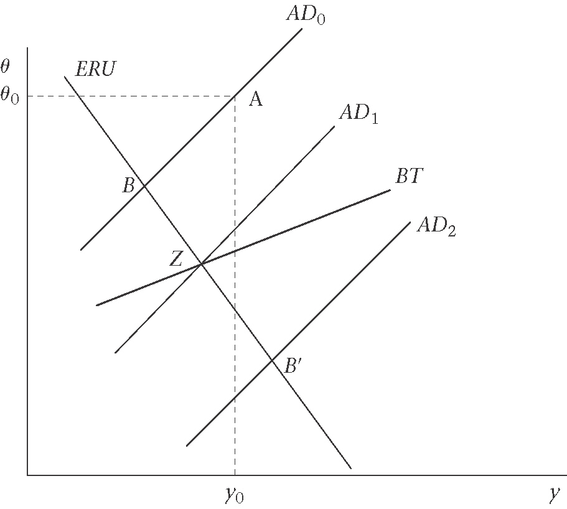

Figure 10.9 Point C at target output and trade balance is not a medium-run equilibrium
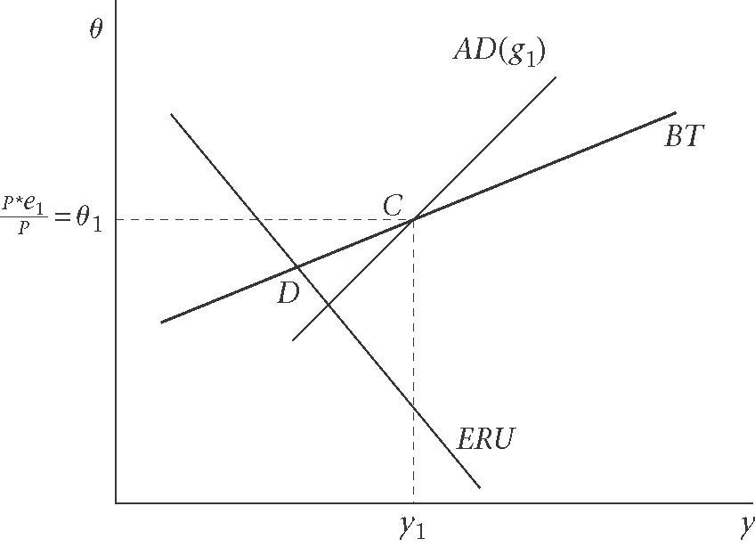

4.1 Inflation in the open economy
If $θ=\frac{P^{}e}{P}$ is constant, this implies that home inflation is equal to the world inflation plus the depreciation of home’s nominal exchange rate:
$$\frac{ΔP}{P}=\frac{{ΔP}^{}}{P^{}}+\frac{Δe}{e}$$
Or
$$π=π^{}+\frac{Δe}{e}$$
Under fixed exchange rate
$\frac{Δe}{e}=0$, so that home inflation must equal to world inflation: $π=π^{}$
With inflation at world rate, and with $r=r^{}$, the equilibrium in the home money market is:
$${\left(\frac{M}{P}\right)}^{S}={\left(\frac{M}{P}\right)}^{D}$$
$=L\left(y_{e},i\right)$
$=L\left(y_{e},r+π^{E}\right)$
$=L\left(y_{e},r^{}+π^{}\right)$
Since, $π=π^{}$;
$$\left(\frac{ΔM}{M}\right)=π=\left[π^{}\right]$$

Under Flexible exchange rate
$$π=π^{}+\frac{Δe}{e}$$
At the medium run,
$${\left(\frac{M}{P}\right)}^{S}={\left(\frac{M}{P}\right)}^{D}$$
$=L\left(y_{e},r^{}+π\right)$
$$\left[\frac{ΔM}{M}\right]=π$$
$$\frac{Δe}{e}=\left[π\right]−\left[π^{}\right]$$

5. Long-run Equilibrium

Figure 10.10 Long-run equilibrium in the open economy: on the BT and ERU curves
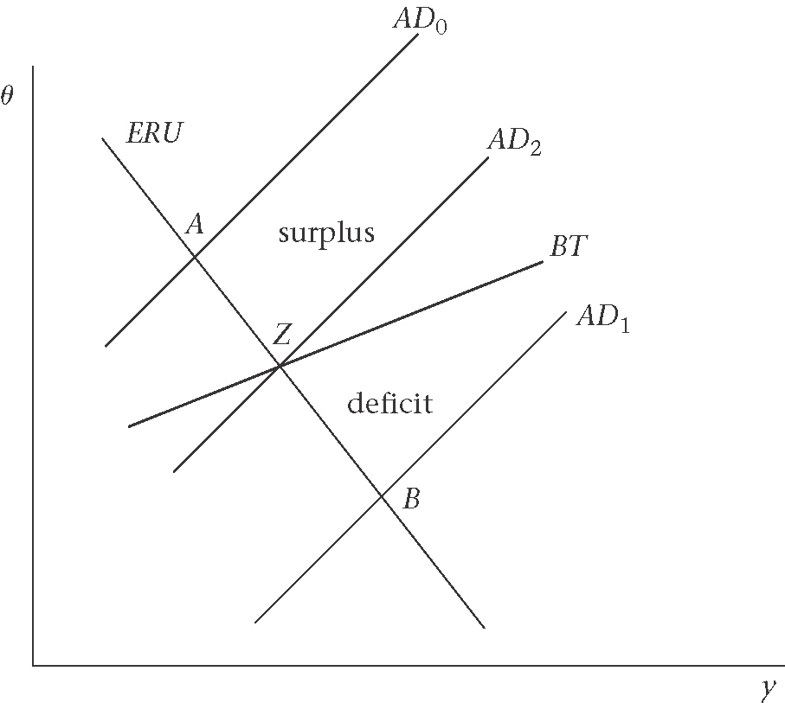

5.1 Mechanisms with stable exchange rate expectations
5.1.1 Wealth effects
5.1.2 Market pressure
5.1.3 Political pressure

5.2 Unstable exchange rate expectations

Figure 10.11 Medium-run equilibrium at B (trade deficit) is disturbed by an exchange rate depreciation
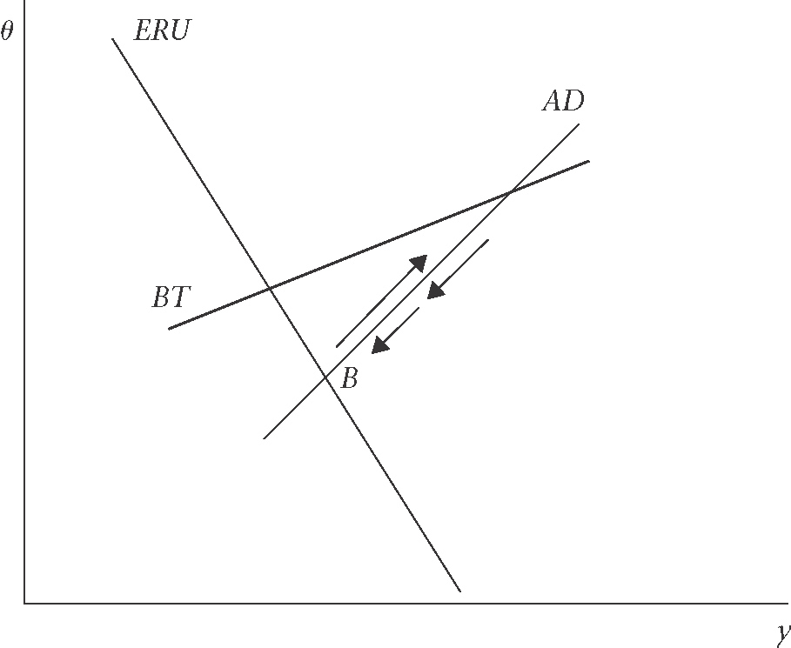

Figure 10.12 : Interaction of foreign exchange rate market and labour market: unique constant inflation equilibrium if exchange rate expectations are oriented to trade balance
(a)Pressure on $e$ and hence on $θ$ (b) Pressure on inflation and hence on $θ$
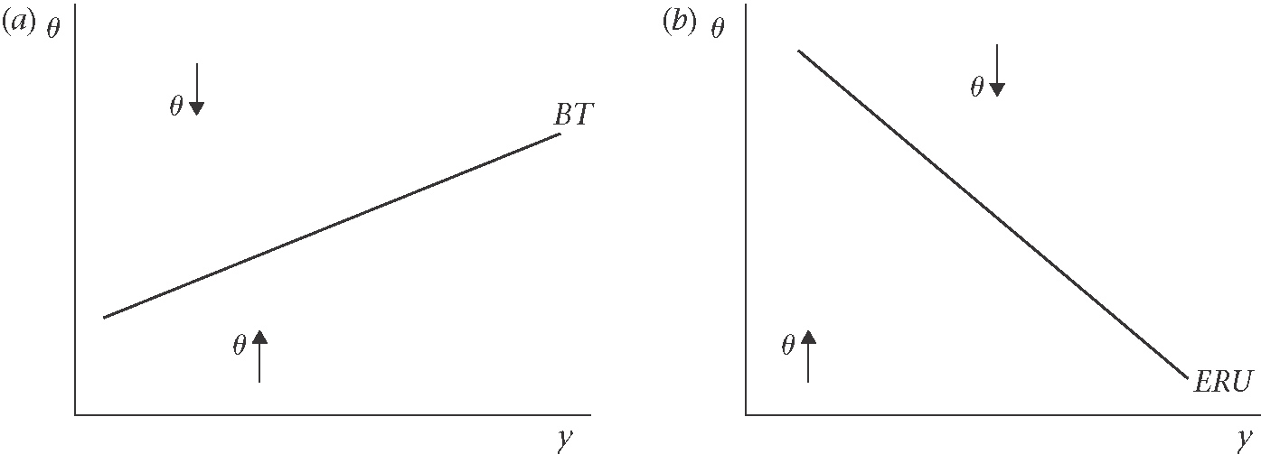

Figure 10.3 Unique constant inflation equilibrium if exchange rate expectations are oriented to trade balance
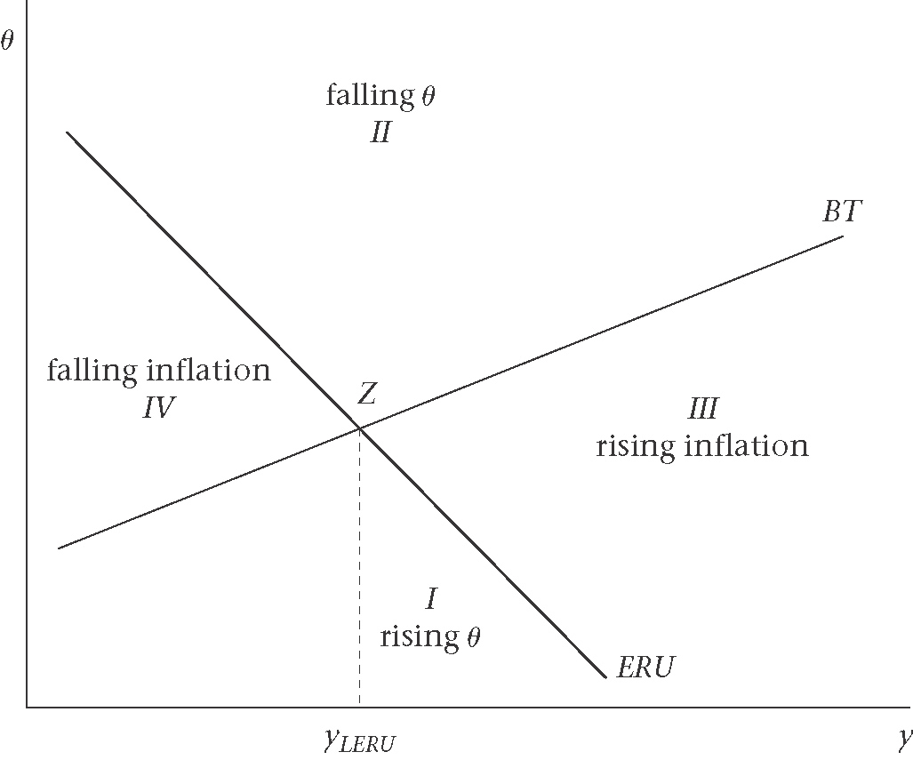

Appendix : Sketching the ERU curve

