LECTURE 11: SHOCKS AND POLICY RESPONSE IN THE OPEN ECONOMY

1. Introduction
- Shocks describe a disturbance to the economy that is unanticipated.
- Four types of shocks
-domestic aggregate demand shocks
-domestic supply shocks
-foreign trade shocks
-external supply shocks
- Model - AD-BT-ERU to analyze the effects of the shocks to the domestic economy in the short run, medium-run, and long run.
- Q? (i)What would happen after each kind of shock if the government did not react to it at all. (ii)What is the appropriate tools for the government to offset or to mitigate the effects of the shocks on the economy?

2. Fiscal, monetary, exchange rate, and supply side policies
2.1 Timing assumptions
- Short run (SR)
-Goods market equilibrium is established. Home interest rates=world interest rates. Changes in nominal r, the nominal ER, output, and employment. The wage and price setters do not change wages or inflation.
- The medium run (MR)
-w and p setters start to respond to two things: (i)to any change in the level of activity (output, and employment), (ii)to any change in the real wage due to nominal (or real) exchange rate in the SR.

- The long run (LR)
-The present of CA surplus or deficit may produce shifts in the AD curve (ex: consumer react to the changes in W or the G adjust FP in response to market or political pressure).
-CA surplus/deficit may lead to change in the ER expectation

2.2 Fiscal policy
2.2.1 New medium-run equilibrium

Figure 11.1: Fiscal policy shifts the AD curve: new medium-run equilibrium at B and comparison with Mundell-Fleming predictions

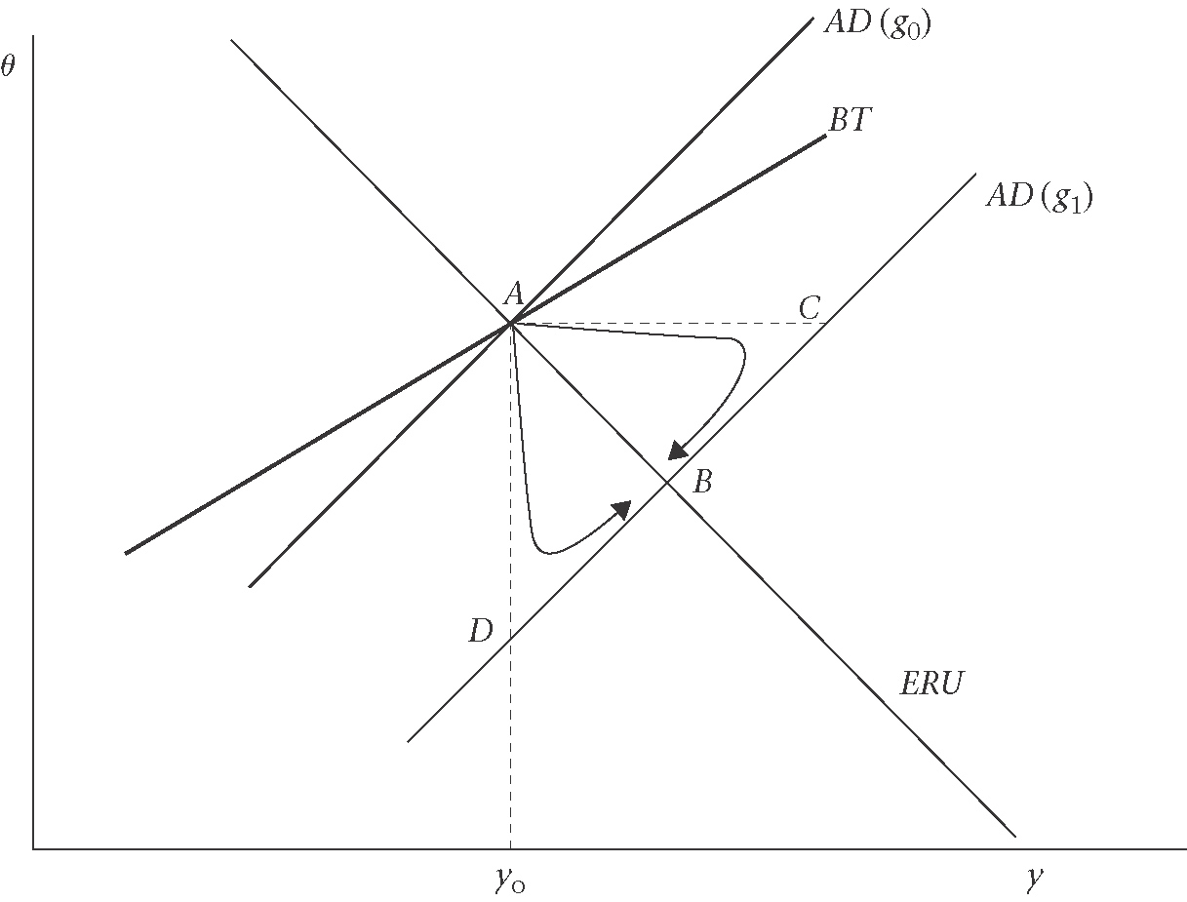
At the new medium-run equilibrium:
- Output is higher and unemployment lower
- $θ$ is lower (i.e. a real appreciation), and the real wage is higher
- there is a trade deficit, and
- inflation

2.2.2 Under fixed exchange rate
The short run equilibrium move from A to C.
$$P=\frac{1}{1−μ}⋅\frac{W}{λ}$$
$$P_{c}=\left(1−φ\right)P+{φP}^{}e$$
$$θ=\frac{P^{}e}{P}$$

Figure 11.2 Adjustment of real wages and inflation
: fiscal expansion under fixed exchange rates
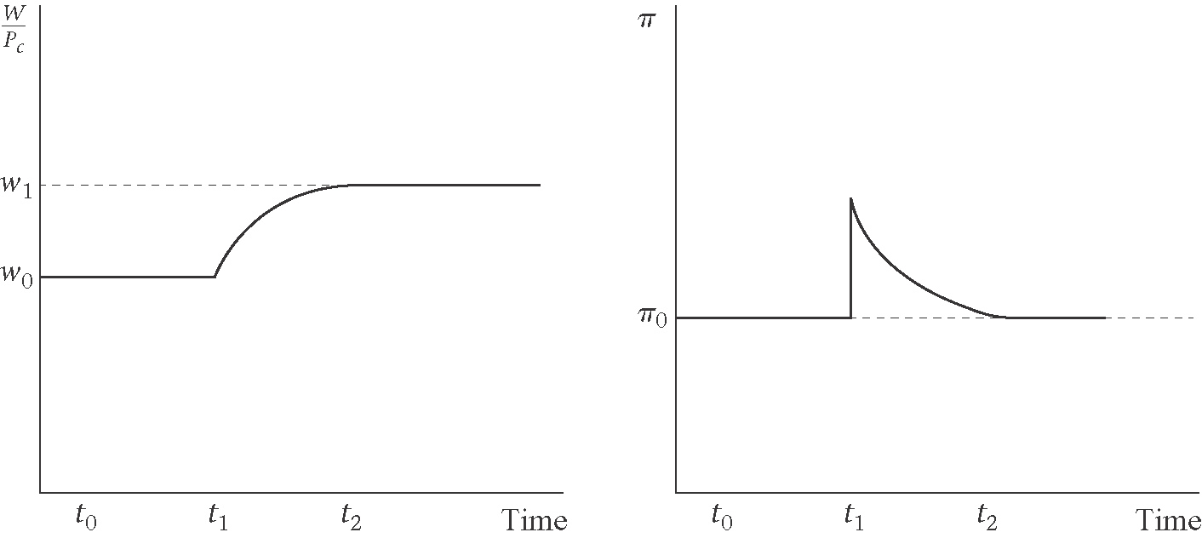

2.2.3 Under flexible exchange rates

Figure 11.3 Adjustment of real wages and inflation
: fiscal expansion under flexible exchange rate

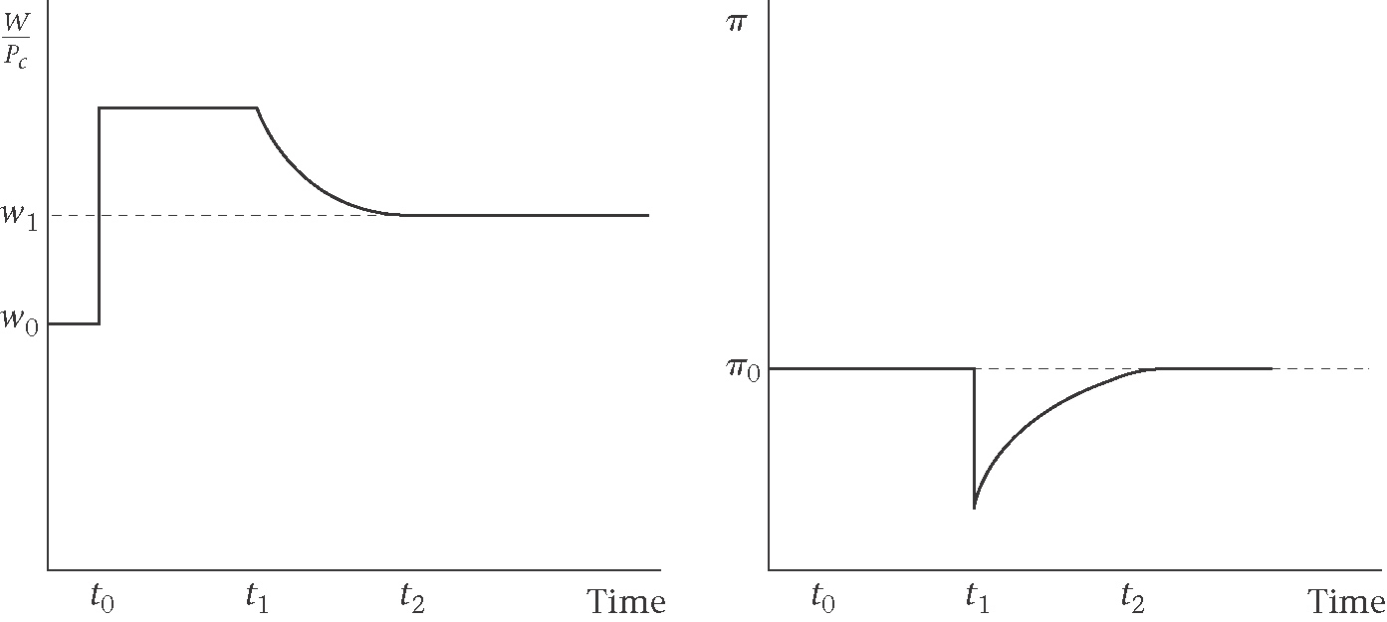

2.3 Monetary and exchange rate policy

Figure 11.4 Monetary/exchange rate policy is a shift along the AD curve: medium-run equilibrium remains unchange as A
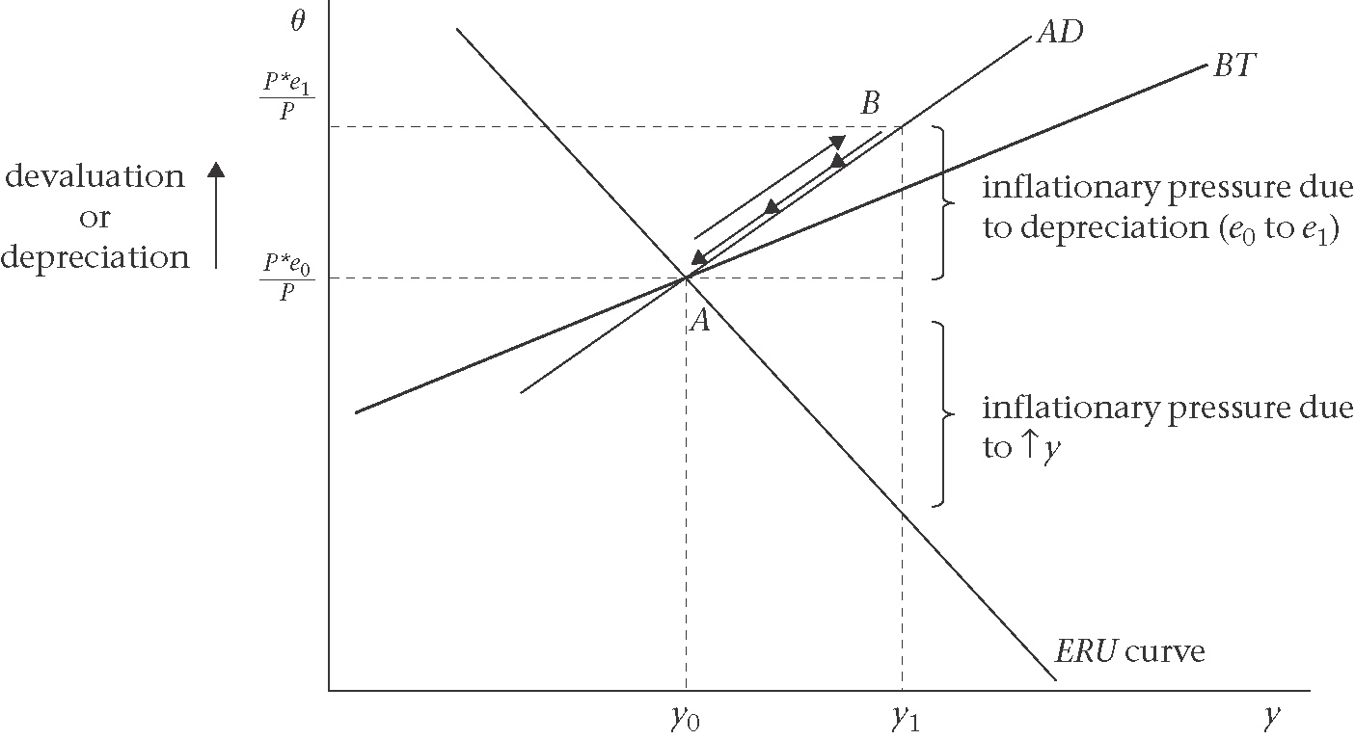

Figure 11.5 Monetary policy expansion under flexible exchange rates: inflation erodes short-run effect on employment

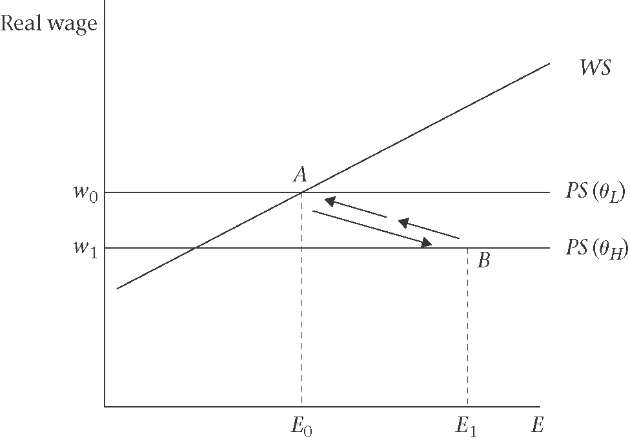
Table 11.1 Monetary expansion under flexible exchange rates
1st new short-run equil. at B | $↓i→↑e→↑θ→↑\left(x−m\right)⇒ΔE>0$ and $Δw<0$
2nd W and P adjust to change in E & w | $↑E$ and $↓w→↑W→↑P$ rel. to $P^{}→↓θ→↓y→↓E$
3rdmedium-run equil. at A | $π,w,θ,E$ back to initial levels

Figure 11.6 Adjustment of real wages and inflation: looser monetary policy under flexible exchange rates, devaluation
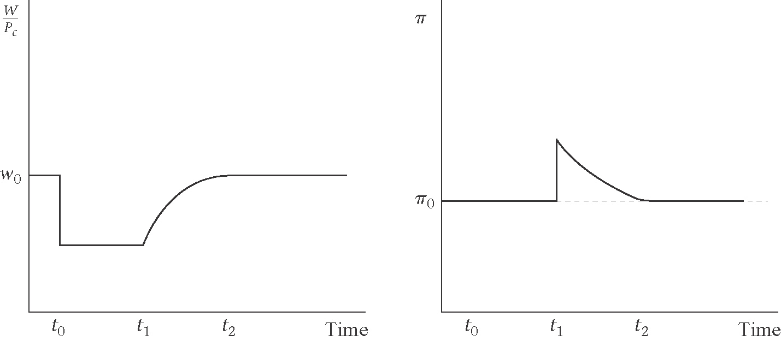

2.4 Supply side policies
Supply side policies are those that shift the ERU curve-either by shifting the WS or PS curve.
$w=\frac{W}{P_{c}}$= [wage net of income tax and social security/consumer price index including VAT]
(real consumption wage)

2.4.1 Policies that shift the wage-setting curve

$W=P_{c}^{E}⋅b(E)$ [wage equation]
The WS curve is:
$w^{\text{WS}}=\frac{W}{P_{c}^{E}}=b(E)$ [wage-setting real wage]
The WS curve shifts down:
- A fall in unemployment benefits
- Unions are given less legal protection or become weaker as union density or coverage declines
- Unions agree to exercise bargaining restraint- ex: wage accord

2.4.2 Policies that shift the price setting curve for a given real exchange rate
PS curve shift up if:
- Reduction in the tax wedge
- Reduction in mark-up due to, (i.e) to a change in competitive conditions
- Fall in the real interest rates
- Rise in efficiency (i.e. labour productivity)

2.4.3 Example: wage accord

Figure 11.7 Supply-side policy: WS shifts down.
Step 1 Derive the new ERU curve. Step 2 Examine adjustment to the new medium-run equilibrium at B
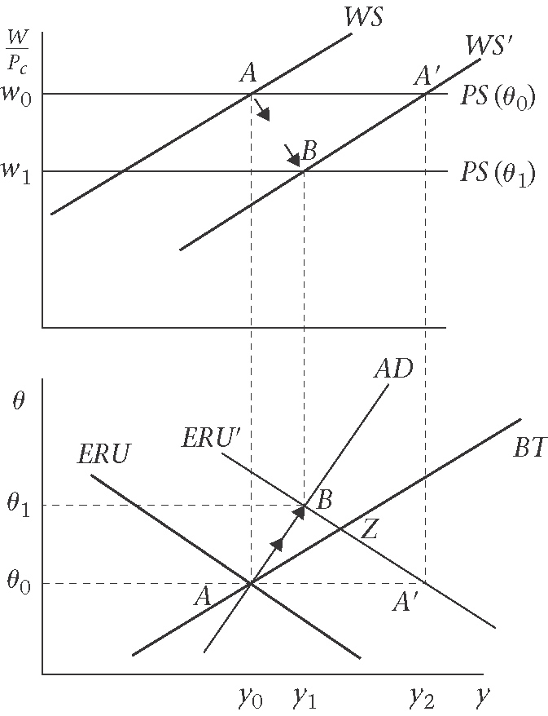

2.4.4 Example: supply-side fiscal policy-cut in income tax
Figure 11.8 Adjustment of real wages and inflation: wage accord
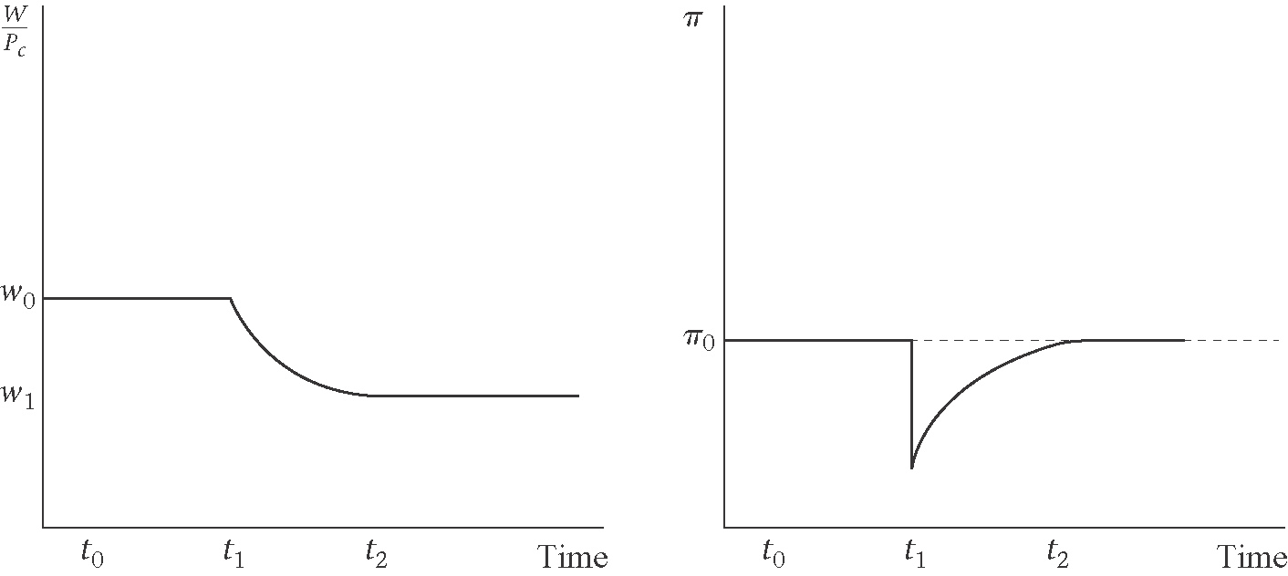
Figure 11.9 Supply-side policy. Tax cut means$\text{PS}\left(θ\right)$ shifts up. Step 1 Derive the new ERU curve. Step 2 Examine adjustment to the new medium-run equilibrium at B.
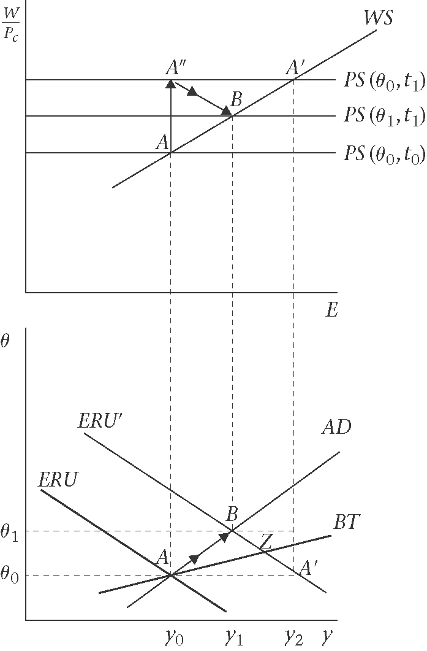

3. Aggregate demand shocks
Flexible exchange rate vs. fixed
Figure 11.10 Negative aggregate demand shock

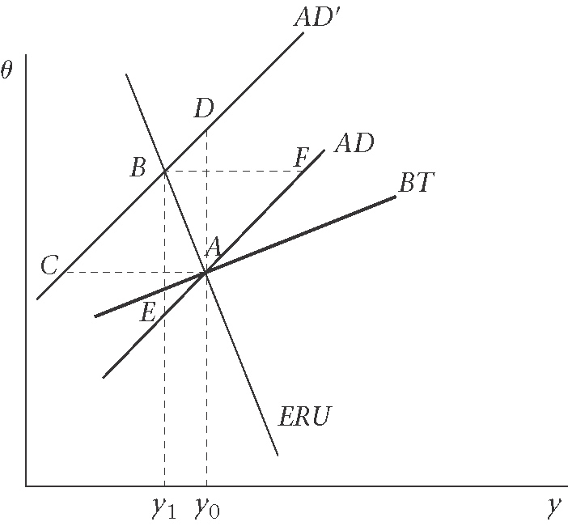

4. Domestic supply shocks
Figure 11.11 A domestic supply-side shock
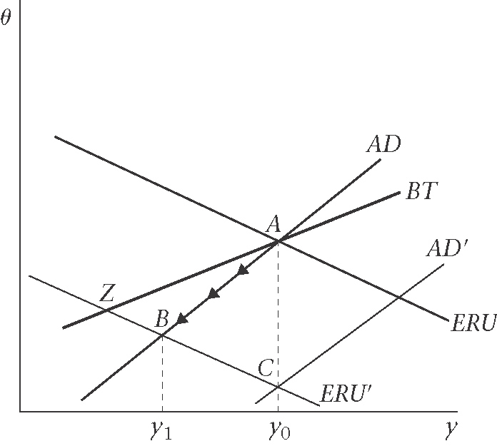
5. External trade and supply shocks
5.1 External trade shocks
Figure 11.12 A negative external trade shocks
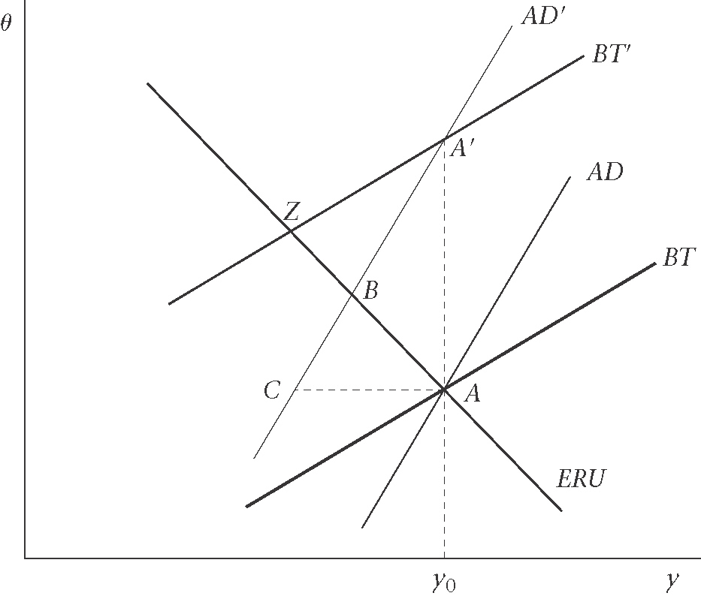
5.2 External supply shocks
Figure 11.13 A negative external supply shocks: increase in the oil price shifts ERU curve left
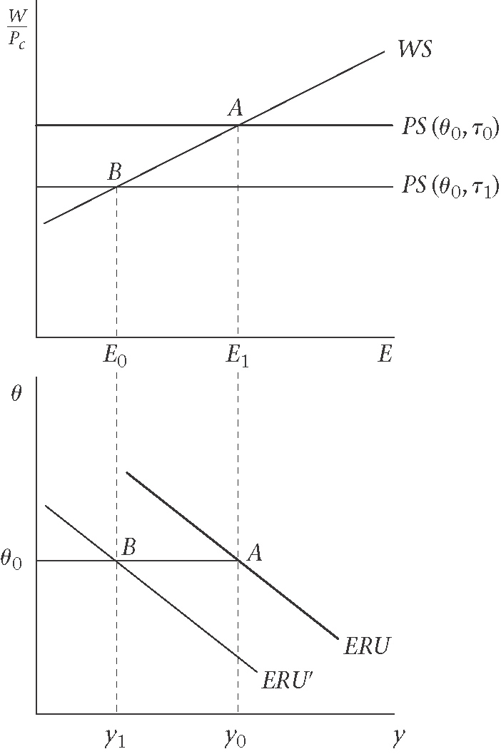

Figure 11.14 External supply shock

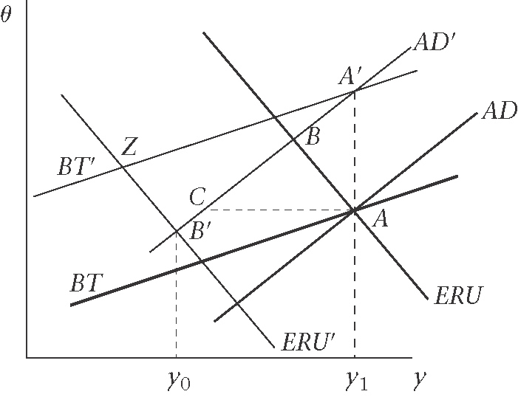

6. Real wages in open and closed economy
Figure 11.16 Procyclical real wages in the open economy
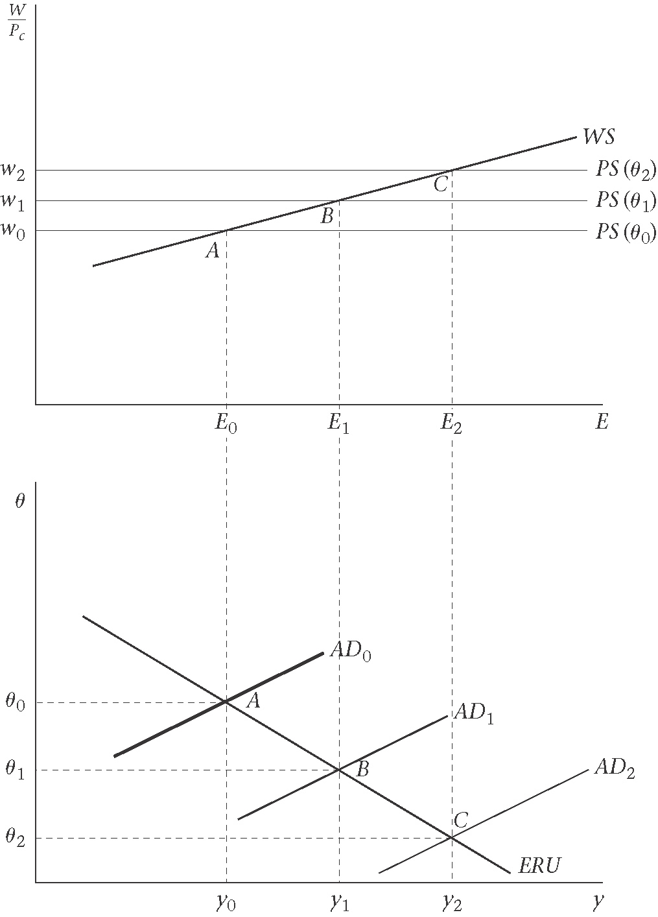

Figure 11.16 Supply-side policy and real wages: comparing the closed and open economies
(a)closed economy (b)open economy
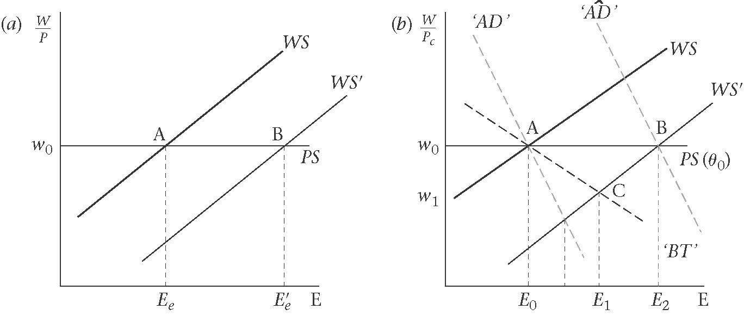

7. Introduction to the economies of currency unions

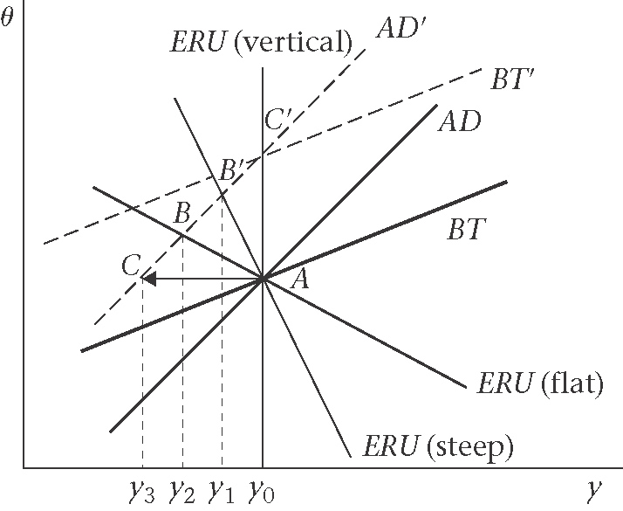
8. Monetary rules in the open economy

Figure 11.18 MR adjustment to increased government spending, with inflation, and exchange rate inertia
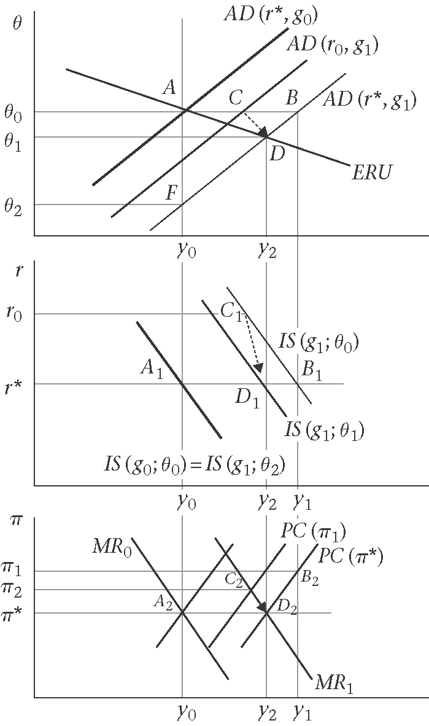

Appendix : Open Economy Inflation and Short-Run Phillips Curves: An Example

Figure 11.19 Phillips curves in the open economy: temporary rise in inflation following a loosening of fiscal policy under fixed exchange rate
