LECTURE 12: INTERDEPENDENT ECONOMIES

1. The 2-Bloc Model

Two countries model, ‘home’ (x) and ‘foreign’ (x*), and perfect capital mobility.
Three main economic issues that arise:
(i)the nature of the spillovers between economies may be positive or negative. Ex: ‘locomotive’ and’ beggar-thy-neighbour- effects.
(ii)spillover can lead to a prisoner’s dilemma game between economies
(iii)the logic of policy coordination
In the short run:
- There is a positive AD spillover often referred to as a locomotive effect (i.e. $Δy>0$, and ${Δy}^{}>0$) of a home expansionary FP under flexible ER. A home expansionary MP under fixed exchange also has a locomotive effect: the world MS rises and pushes down the world interest rate, so output expands in both Home and Foreign.
- There is a negative spillover referred to as a beggar-thy-neighbour effect (i.e. $Δy>0$, and ${Δy}^{}<0$) of home expansionary MP under flexible ER. Home monetary expansion produces a depreciation for it and hence an appreciation for foreign country, which depressed its net export and output. Likewise, a Home fiscal expansion under fixed ER is contractionary for foreign: the world interest rates is pushed up and depressed output abroad.
In the medium, (i.e. after wages and prices at home and abroad have adjusted),
- Short run MP effects disappear: Home and foreign return to their initial equilibrium level of output
- In the MR, the effects of a home F expansion are independent of the ER regime. The outcomes is $Δy>0$, and ${Δy}^{}<0\text{.}$
- Thus, locomotive effect of a home fiscal flexible ER is reversed in the MR, so that in the new equilibrium: $Δy>0$, and ${Δy}^{}<0\text{.}$
- The beggar-thy-neighbour effect of a home fiscal expansion under fixed ER prevails, i.e ($Δy>0$, and ${Δy}^{}<0$) but is attenuated in the MR.

  - Spillovers and the case for policy coordination
1.2 Interdependence in the short run: extending the Mundell-Fleming model

Figure 12.1 The 2-bloc model diagram
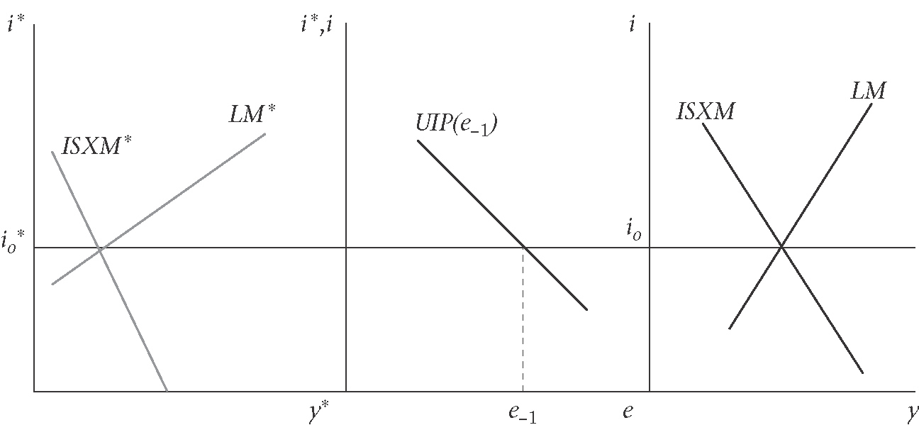

1.2.1 Flexible exchange rate

Fiscal policy: Home expansion

Figure 12.2 Locomotive effect of a fiscal policy expansion in home: flexible exchange rates
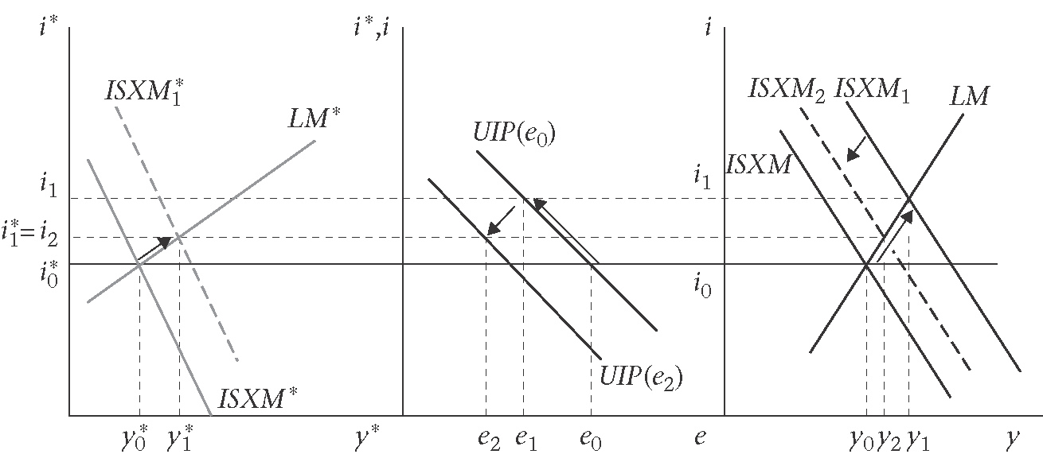

Some simple mathematics
The ISXM schedule is written as:
$$y=\text{ag}−\text{bi}+\text{cB}(e)$$
Where, $B$ is the balance of trade, a, b, and c are positive constants. $B$depends positively on exchange rate (assuming Marshall-Lerner condition holds), and for simplicity we assume B(e)=0. The net changes from the initial to the new short-run equilibrium (i.e. from $y_{0}$ to $y_{2}$, as $Δy=y_{2}−y_{0}$. Thus, we can write as:
$Δy=aΔg−bΔi+cΔe$ [1]

The LM schedule is $i=λy−μM$ or in difference terms
$Δi=λΔy−μΔM$[2]

For Foreign,
${Δy}^{}={aΔg}^{}−{bΔi}^{}+cΔe$ [3]
${Δi}^{}={λΔy}^{}−{μΔM}^{}$ [4]
A Home fiscal expansion in a flexible exchange rate system implies that $ΔM={ΔM}^{}={ΔG}^{}=0$. In addition, $Δi={Δi}^{}$.
For home,
$$Δy=aΔg−bλΔy+cΔe$$
Note: ${Δi}^{}={λΔy}^{}=Δi=λΔy$, so $Δy={Δy}^{}$. Hence from the two Foreign equations;
$$Δy=−bλΔy−cΔe$$
Adding these two equations together;
$$2Δy=aΔg−2bλΔy$$
$$⇒Δy=\frac{a}{2(1+bλ)}Δg={Δy}^{}$$
Since $Δi=λΔy$, it follow that:
$$Δi=λΔy=\frac{aλ}{2(1+bλ)}Δg$$
Substituting the previous two equations into $Δy=aΔg−bλΔy+cΔe$ implies :
$$Δe=−\frac{\text{ab}λ}{c(1+bλ)}Δg$$

Monetary policy with flexible exchange rates: home expansion
Figure 12.3 Beggar-thy-neighbour effect of a home monetary expansion: flexible exchange rate
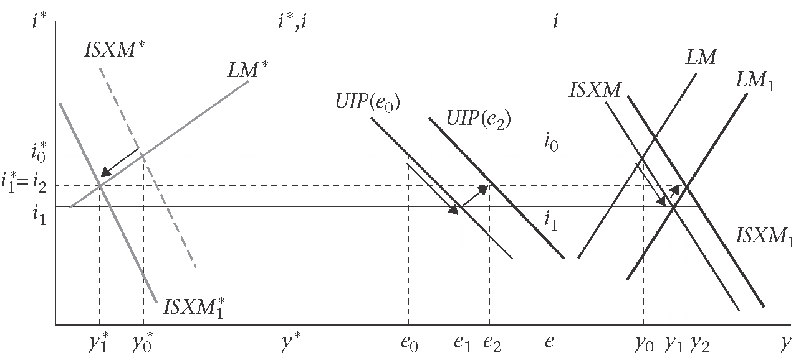

1.2.2 Fixed exchange rates
Fiscal policy: home expansion
Figure 12.4 Home fiscal expansion: fixed exchange rate
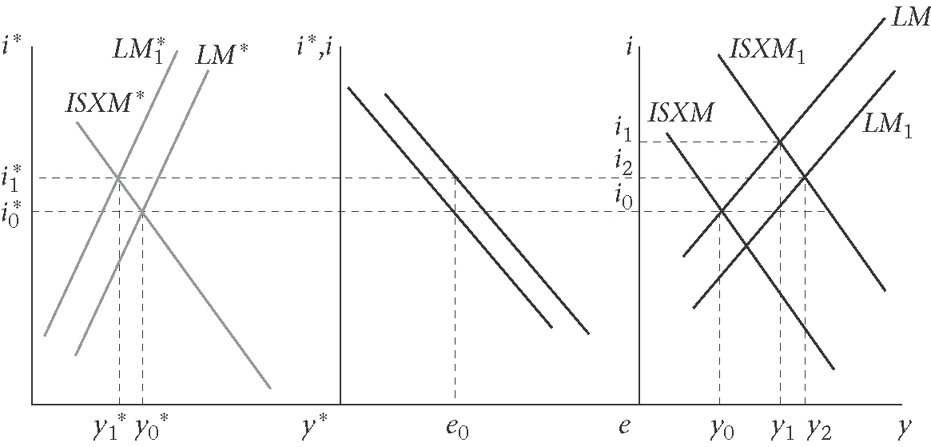

Monetary policy: home expansion

Figure 12.5 Home monetary expansion: fixed exchange rates
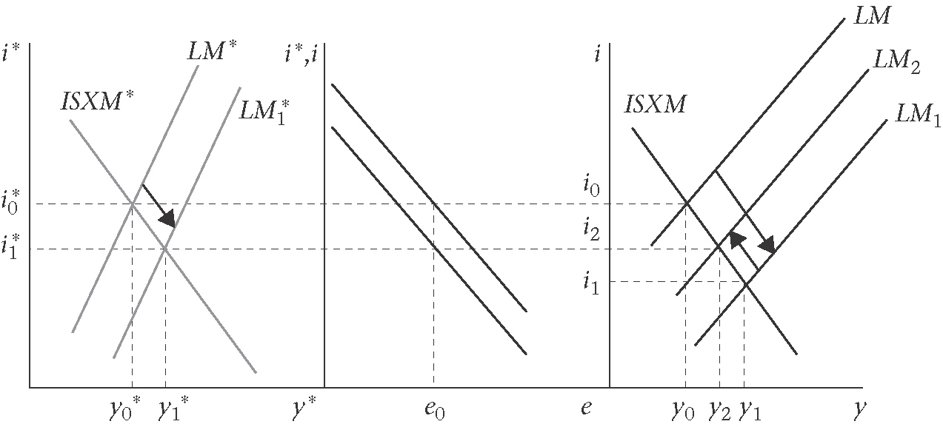

1.3 Adding the income feedback effect
Figure 12.6 Locomotion effects: home fiscal expansion: fixed exchange rate
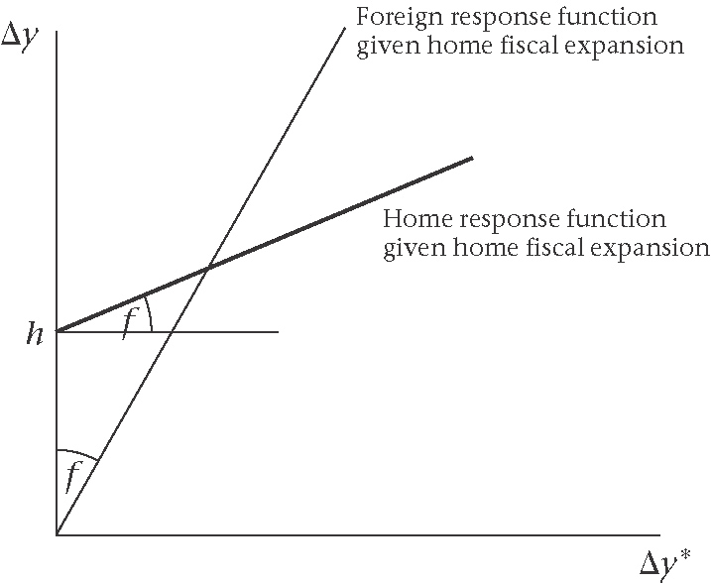
Up to this point, the spillovers between economies have occurred only through changes in the interest rates and exchange rate. We have not taken account of the possibility that a changes in foreign income boosts home aggregate demand via increased home exports and vice versa.
In the 2-block model, it is the case that an expansion of output in Home will raise demand in foreign since Home’s imports rise with income and constitute Foreign’s export.
Q? How are the results for the 2-block model modified or amplified by income feedback effects?
In the four cases so far, the changes in y and y* have been:
(i)flexible exchange rate/fiscal expansion, $Δy,{Δy}^{}>0$
(ii)flexible exchange rate/monetary expansion, $Δy>0,{Δy}^{}<0$
(iii)fixed exchange rate/fiscal expansion, $Δy>0,{Δy}^{}<0$
(iv)fixed exchange rate/monetary expansion, $Δy,{Δy}^{}>0$

In case (i) and (iv), we have locomotive effects in the sense that the effects on output are positive in both blocs, further positive linkages between home and foreign output will reinforce those positive effects. What is more interesting is that the positive income feedback effect-if sufficiently strong-can alter the beggar-thy-neighbour predictions of (ii) and (iii).

Ex: case (iii), a fiscal expansion under fixed exchange rate
The ISXM equations for Home and Foreign:
$$Δy=aΔg−bΔi+{dΔy}^{}$$
$${Δy}^{}=−bΔi+{dΔy}^{}$$
and the LM equations are:
$$Δi=λΔy−μΔM$$
$$Δi={λΔy}^{}−{μΔM}^{}$$

Where $ΔM+{ΔM}^{}=0$. The LM equations imply that, $Δi=\frac{λ}{2}Δy+\frac{λ}{2}{Δy}^{}$, thus the reduced form aggregate demand equations:
$$Δy=\frac{a}{1+\frac{bλ}{2}}Δg+\frac{d−\frac{bλ}{2}}{1+\frac{bλ}{2}}{Δy}^{}$$
$${Δy}^{}=\frac{d−\frac{bλ}{2}}{1+\frac{bλ}{2}}Δy$$
In Figure 12.6, the angle $f$ is $\frac{d−\frac{bλ}{2}}{1+\frac{bλ}{2}}$, and the distance $h$ is $\frac{a}{1+\frac{bλ}{2}}$.

