2. Aggregate Demand (AD), Aggregate Supply (AS), and Business Cycle

The goods market : the IS curve
IS curve shows the combination of the interest rates and output level at which there is equilibrium in the goods market. For goods market equilibrium, the AD for goods & services must equal the supply.
Assumptions: Wages (W) and prices (P) are fixed, the supply of output will adjust to any change in AD.
AD refers to the planned real expenditure on goods and services. In equilibrium, planned real expenditure $\left(y^{D}\right)$ must equal to real output $\left(y\right)$, as:

$y^{D}=y$ (goods market equilibrium)

AD is made up of planned expenditure on consumption $\left(c\right)$, investment by private sector$\left(i\right)$, and planned government spending $\left(g\right)$.

$y^{D}=c\left(y,t,\text{wealth}\right)+I\left(r,A\right)+g$ (AD)

$c=c_{0}+c_{y}\left(y−t\right)$ (consumption function)
$t=t_{y}Y$, where, $0<c_{y}<1$ (tax function)
Thus, the consumption function is:
$$c=c_{0}+c_{y}\left(1−t\right)y$$

Investment is assumed to response negatively on the real rate of interest $\left(r\right)$, and positively on the expected future profitability $\left(A\right)$. Thus, the investment function;
$$I=I\left(r,A\right)$$

To derive the IS curve, we use the planned expenditure equation as;
$y^{D}=c_{0}+c_{y}\left(1−t_{y}\right)y+A−\text{ar}+g$ (planned expenditure)
By rearranging the fact that $\left(y^{D}=y\right)$, and replacing $\left(1−c_{y}\right)$ by the MPS, $s_{y}$, the locus equilibrium of combinations of the interest rates and output is:

$$\begin{aligned}y=\frac{c_{0}+A+g}{1−c_{y}\left(1−t_{y}\right)}−\frac{a}{1−c_{y}\left(1−t_{y}\right)}r \\ \frac{1}{1−c_{y}\left(1−t_{y}\right)}\left[c_{0}+\left(A−\text{ar}\right)+g\right]\end{aligned}$$
$=\frac{1}{s_{y}+c_{y}t_{y}}\left[c_{0}+\left(A−\text{ar}\right)+g\right]$

Figure 2.1 : Deriving the IS curve

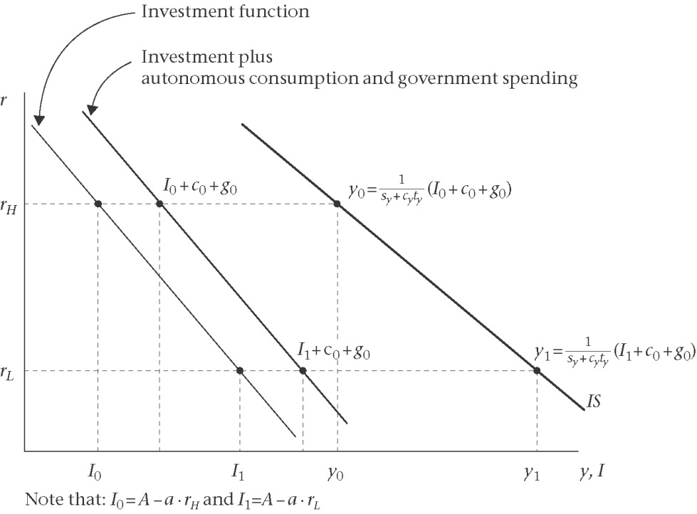

Multiplier Process
To calculate the total change in income, we sum up the geometric series as shown below;

$$Δy=ΔI+c_{y}ΔI+c_{y}^{2}ΔI+c_{y}^{3}ΔI+\text{.}\text{.}\text{.}\text{.}\text{.}\text{.}\text{.}\text{.}\text{.}\text{.}\text{.}\text{.}$$
$=\left(1+c_{y}+c_{y}^{2}+c_{y}^{3}+\text{.}\text{.}\text{.}\text{.}\text{.}\text{.}\text{.}\right)ΔI$
$=\frac{1}{1−c_{y}}ΔI$
$=\frac{1}{s_{y}}ΔI$ = multiplier X $ΔI$

Figure 2.2: Adjustment to goods market equilibrium

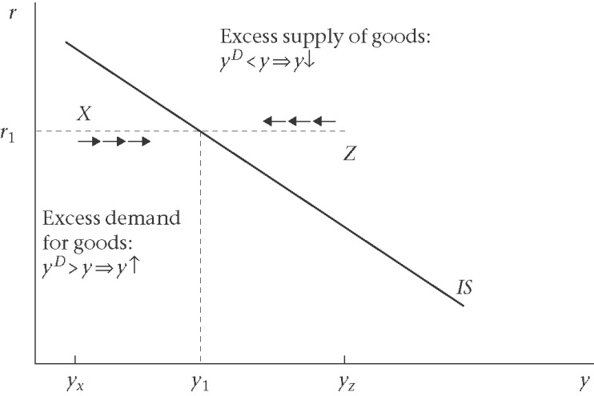

The Money market : the LM curve
LM curve represents the combinations of the interest rate and output at which the money market is in equilibrium. It is assumed that the central bank controls the money supply.
$\frac{M^{D}}{P}=L\left(y,i\right)$, where $\frac{∂L}{∂y}>0,\frac{∂L}{∂i}<0$ The demand fro money
In linear function, the demand fo money is;
$\frac{M^{D}}{P}=L\left(y,i\right)=\bar{l}−l_{i}i+\frac{1}{v_{T}}y$,
$\bar{l}−l_{i}i$ is asset demand or asset motive for holding money, and $\frac{1}{v_{T}}y$ is transactions demand (transaction motive for holding money).

Money market equalibrium:
$\frac{M^{D}}{P}=\frac{M^{S}}{P}$ $→$ money demand = money supply
By assuming $M^{S}$ is to be fixed by the cantral bank; the money market equalibrium is:
$$L\left(y,i\right)=\frac{{\bar{M}}^{S}}{P}$$

Deriving LM Equation
$$\bar{l}−l_{i}i+\frac{1}{v_{T}}y=\frac{{\bar{M}}^{S}}{P}$$
$i=\frac{1}{l_{i}}\left(\bar{l}−\frac{{\bar{M}}^{S}}{P}\right)+\frac{1}{l_{i}}\left(\frac{1}{ν_{t}}\right)y$ $→$ LM Equation

Figure 2.3 : Deriving the LM curve

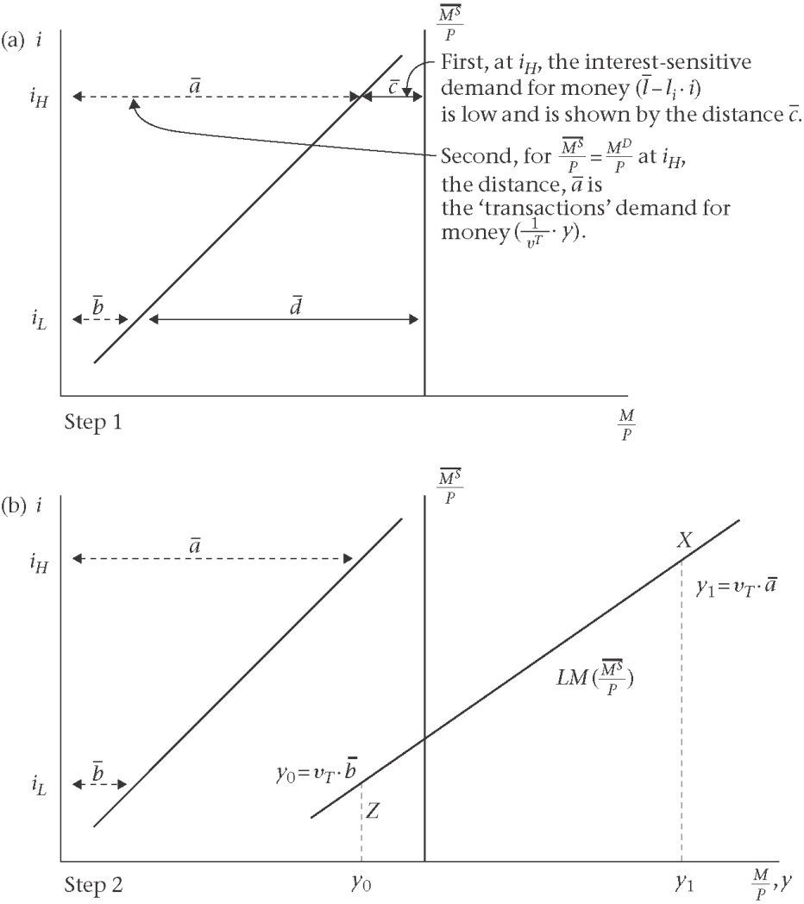
What do the figures explain?
- The transactions demand for money and the role of $ν_{t}$
- The asset (or speculative) demand for money and the role of $l_{i}$
- The role of ${\bar{M}}^{S}$ set by the central bank
- The equilibrium condition in the money market: $L\left(y,i\right)=\frac{{\bar{M}}^{S}}{P}$
Four way in which the position and the slope of the LM curve can be affected
- A change in the transactions velocity of circulation
- A change in the interest rates sensitivity of the asset demand for money
- A change in the money supply
- A change in price level
Figure 2.4 Adjustment to money market equilibrium

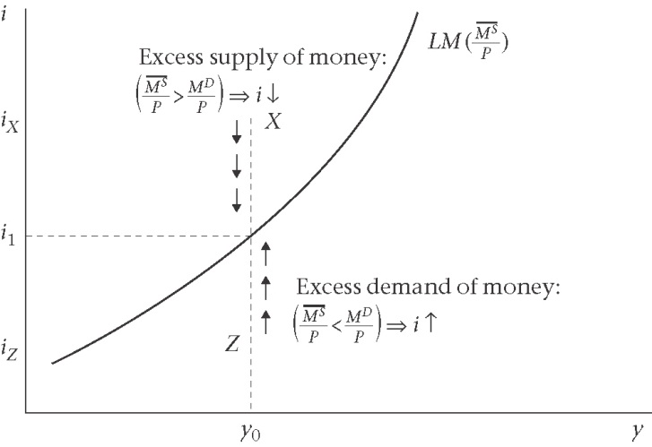

The IS-LM Model

Figure 2.5 : Comparative Static in the IS-LM model: sluggish adjustment in the goods market, and rapid adjustment in the money market
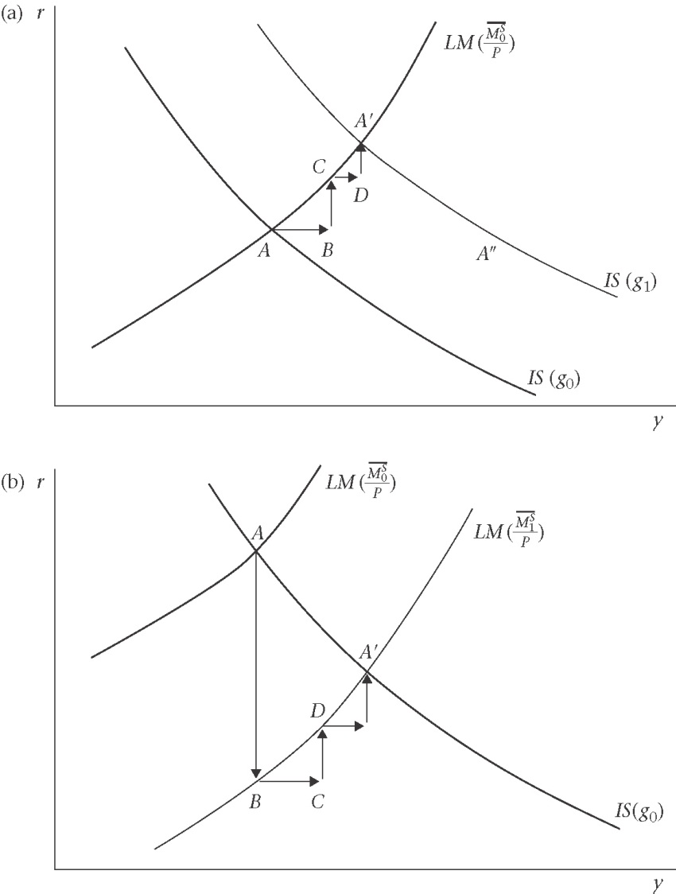

- Fiscal policy : rise in G
- Monetary policy : rise in money supply

Figure 2.6 : The liquidity trap

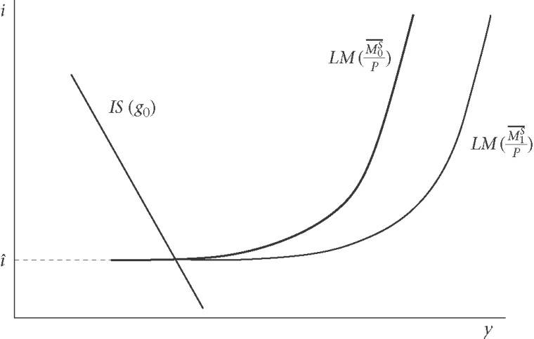

Aggregate Supply

In the competitive labour market, with fixed capital stock (short and medium run), output is a positive function of the level of employment as;

$$y=f\left(E\right)$$

Figure 2.7: Equilibrium in the competitive labour market
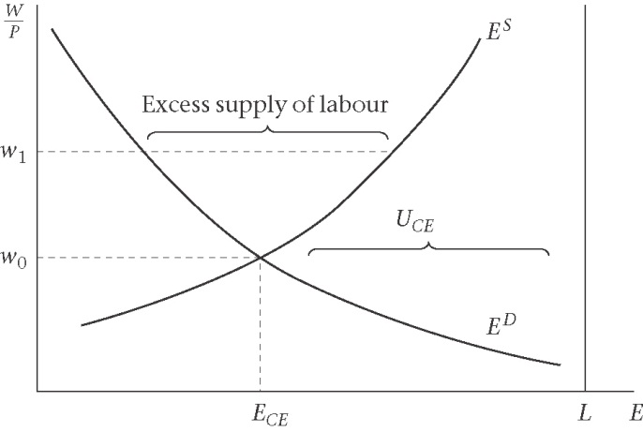

Supply Side in the imperfect competition model
(1)wage setting (WS)

$W=P\text{.}b(E)$ $⇒$wage equation
By assuming the actual and expected price level are equal, the wage equation in terms of real wages is;

$$w^{{}_{\text{WS}}}=b(E)$$
The excess of w on the WS curve abobe that on the labour supply at any level of employment is the mark-up per worker (in real terms) associated with labour market imperfections.
Two common interpretations of this mark-up are:
- Wage setting by unions
- Efficiency wage setting by firms

Figure 2.8: The wage setting real wage curve: WS curve and the labour supply curve
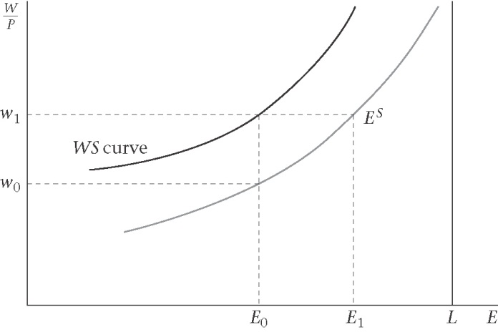

(2)Price setting (PS)
Under perfect competition, firms take the market price (P), and set it equal to their marginal cost (MC) as ;

$$P=\text{MC}$$
$$=\frac{W}{\text{MPL}}$$
$$⇒\frac{W}{P}=\text{MPL}$$
In contrast, under imperfect competition, firms set price to maximize profit. The mark up on marginal cost will defend on the elasticity of demand;
Ex: Monopoly case
Profit are maximized when marginal revenue (MR) is equal to marginal cost (MC). If $ε$ elasticity of demand is constant, then there is a constant mark-up greater than one of $\frac{ε}{ε−1}>1$. Thus we have the standard monopoly pricing as:

$$P=\frac{ε}{ε−1}⋅\frac{W}{\text{MPL}}$$
And the price setting real wage is;

$$\frac{W}{P}=\frac{ε−1}{ε}⋅\text{MPL}$$

Figure 2.9: Relationship between the MPL, the price elasticity of demand, and the PS curve
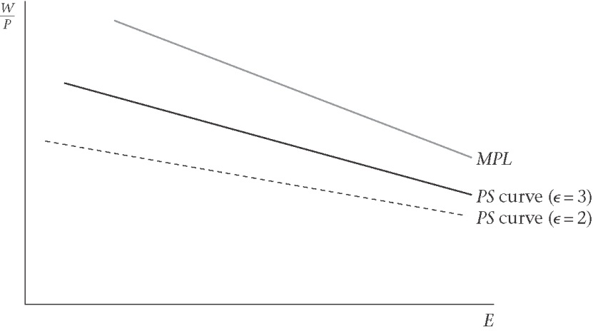
Three additional assumptions:
- If MPL is constant (equal to the average product), and the mark-up is constant, the PS real wage = to a constant fraction of labour productivity.
- If the MPL declines but the mark-up is counter cyclical (i.e: the mark-up shrinks as employment rises), then PS curve will flatten.
- If firms set their prices using rule of thump, basing their price on their average costs over BC, the PS would also flatten.
The assumptions of Baseline Case: A Flat PS curve
- A constant MP and a constant mark-up
Given these assumption, is firms set prices to deliver a specific profit margin, then the fixed amount of output per worker is split into two parts: profits per worker and wages per worker. Then, PS can be summarized as the marking up of labour costs by fixed percentage ($\hat{μ}$) as:
$P=\left(1+\hat{μ}\right)\left(\frac{W}{λ}\right)$ (mark-up pricing rule)
Where, unit labour cost$\hat{μ}$ are the cost of labour per unit of output (W X E divided by y). w/E is output per worker, and $λ$is labour productivity.
If $μ_{t}=\frac{μ_{t}}{\left(1+μ_{t}\right)}$, then the pricing equation is:
$P=\frac{1}{1−μ}⋅\frac{W}{λ}$
Dividing both side by P and rearangging;
$$λ=μ⋅λ+\frac{W}{p}$$
Output per head = real profit per head + real W per head

Gicen mark up, the level of productivity, and money wage, the prive level set by firms implies a specific value of the real wage. Thus, the price setting real wage is:
$$w^{\text{PS}}=\frac{W}{P}=λ⋅\left(1−μ\right)$$

Figure 2.10: The price-setting real wage : PS curve
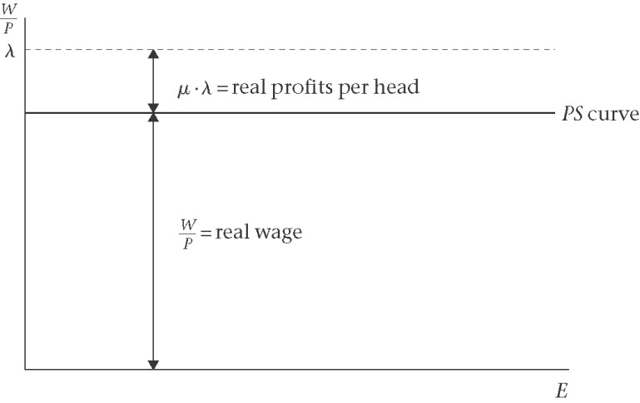

Figure 2.11 : Equilibrium employment and unemployment

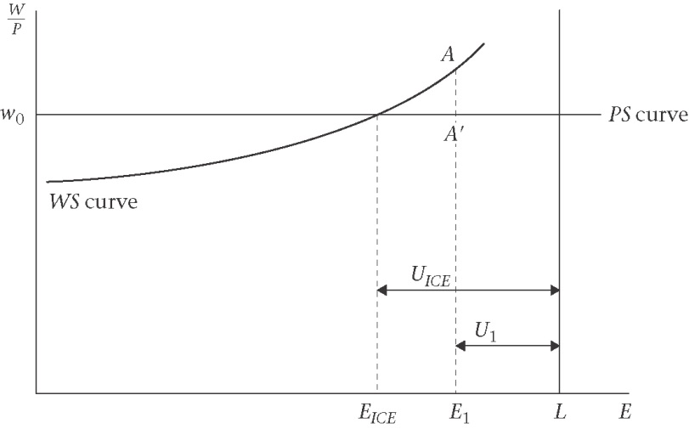

Equalibrium in the labour market under imperfect competition
The labour market is in equilibrium where the curve cross as:

$$w^{\text{WS}}=w^{\text{PS}}$$
$$b\left(E\right)=λ⋅\left(1−μ\right)$$

Figure 2.12 : Concept of unemployment

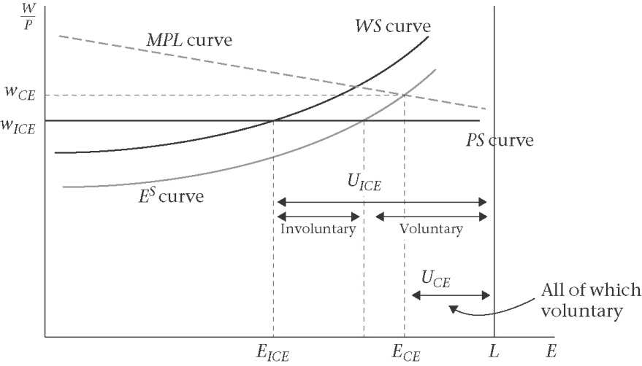

Aggregate demand (AD), and aggregate supply (AS)
AD: from the IS/LM diagram to the AD curve
Figure 2.13 : Deriving the AD curve

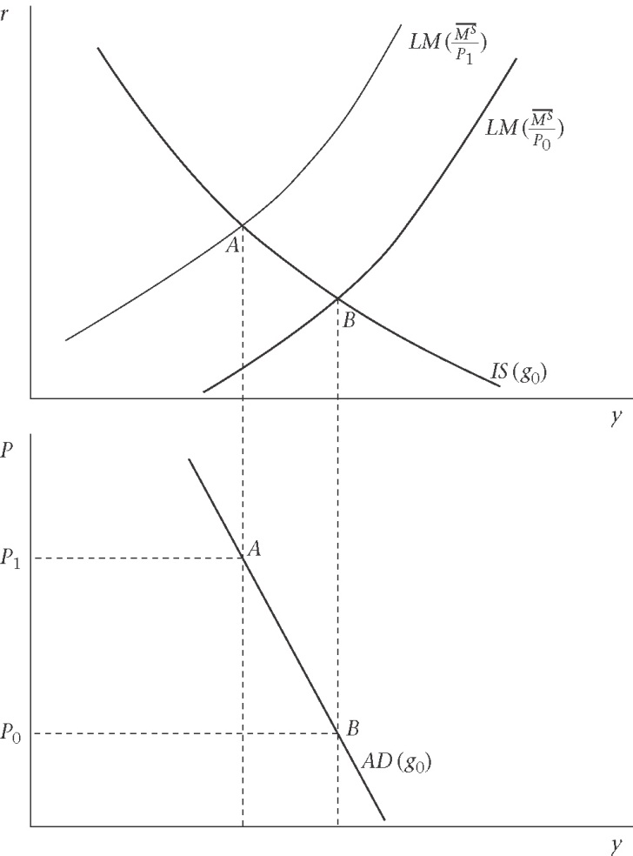

AS: from labour market diagram to the AS curve

Figure 2.14: The AD and AS curve
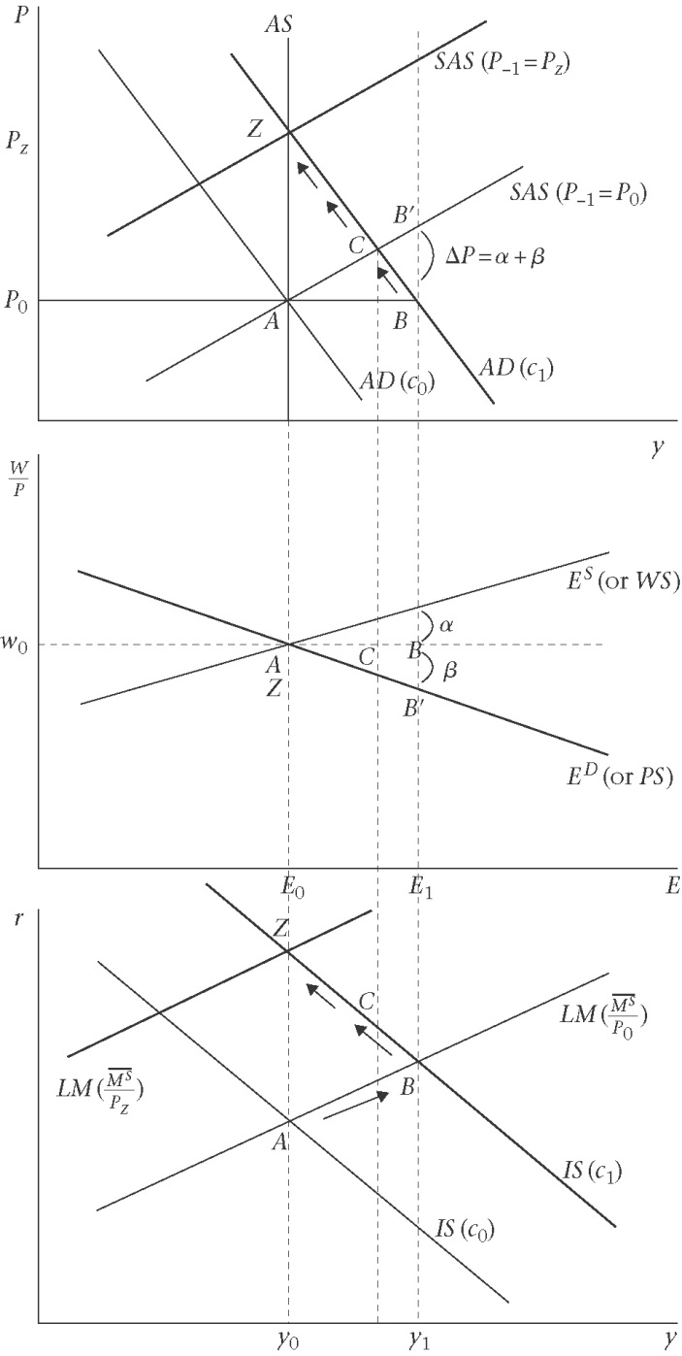

Real Business Cycle model : supply shocks

Figure 2.15: The Real Business Cycle (RBC) model: equilibrium fluctuations due to the technology shocks

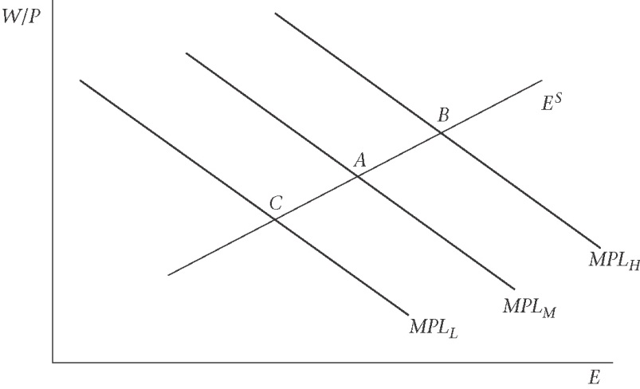

The Derivation of IS/LM Model

