CHAPTER 3 : INFLATION, UNEMPLOYMENT, AND MONETARY RULES

3.1 Introduction
The CB sets the IR to stabilize economy around an inflation target at the equilibrium level of output. The main reason why the CB plays an active role in managing economy is because the economy is subject to all kinds of disturbances that shift either inflation away from its target or output away from the equilibrium level or both.

3.2 Inflation and Philips Curves
$π=\frac{P−P_{−1}}{P_{−1}}$, where $P$ is the today price level, and $P_{−1}$ is the last period’s price level.
Inflation Inertia
The standard model in which inflation depends on;
- past inflation, $π_{−1}$
- the gap between current unemployment and the ERU
There are two broad interpretations of the past inflation: (i) in terms of expectations, and (ii) in terms of inertia.
Adaptive expectations
$π^{E}=π_{−1}^{E}+a\left(π_{−1}−π_{−1}^{E}\right)$ , where $a$ is a positive constant less than or equal to one. If past forecasting mistakes are fully corrected, than $a=1$, we have;
$π^{E}=π_{−1}$ (simple adaptive expectations)
Inflation in term of inertia term is defined as;
$$π^{I}=π_{−1}$$
$$π=π^{I}+α\left(y−y_{e}\right)$$
$π$ = $π_{−1}$ + $α\left(y−y_{e}\right)$ (inertia-augmented Philips curve)
(current inflation) (inflation inertia ) (output gap)

When the lagged inflation term is interpreted as reflecting expected inflation (by assuming of adaptive expectations, $\left(π^{E}=π_{−1}\right)$, thus the term expectations-augmented Philips curve is used as:

$$π=π^{E}+α\left(y−y_{e}\right)$$
$π$ = $π_{−1}$ + $α\left(y−y_{e}\right)$ (inertia-augmented Philips curve)
(current inflation) (expected inflation ) (output gap)

Deriving Philips Curve

$$P=\left(1+\hat{μ}\right)⋅\frac{W}{λ}$$
$$\frac{ΔP}{P}=\frac{ΔW}{W}−\frac{Δλ}{λ}$$

If the average labour productivity $\left(λ\right)$ is constant;
$$\frac{ΔP}{P}=\frac{ΔW}{W}$$

Figure 3.1: Upward pressure on inflation when employment is above equilibrium employment; downward pressure on inflation when employment is below equilibrium employment

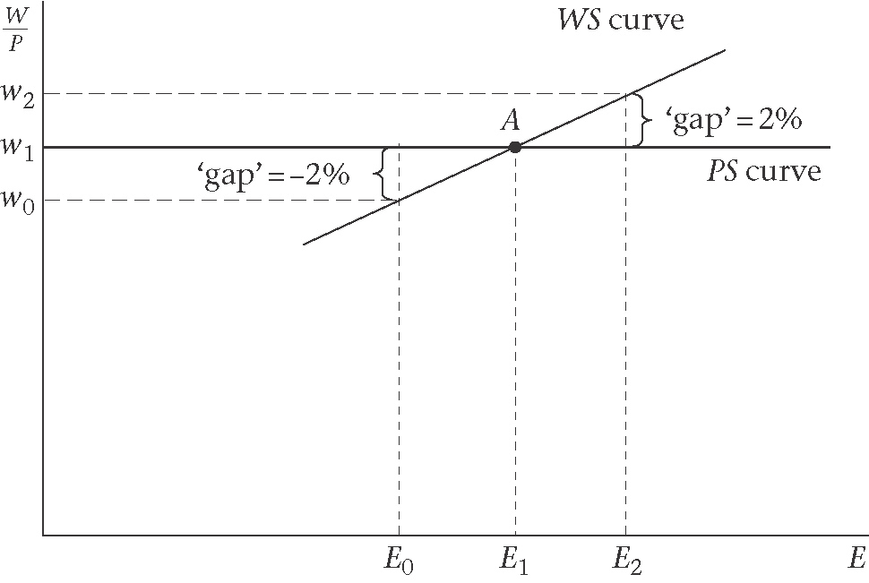

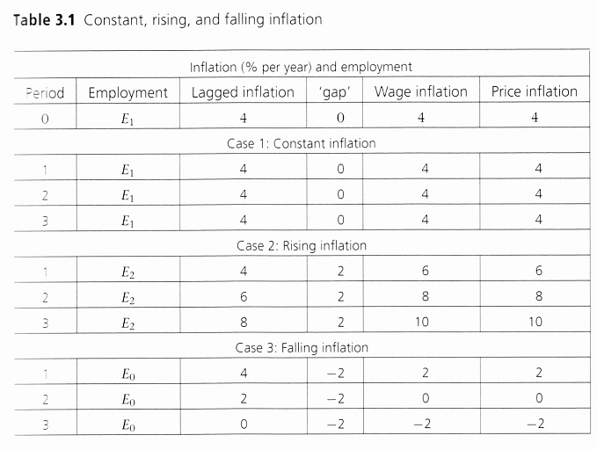

Figure 3.2 : Deriving the Philips Curves

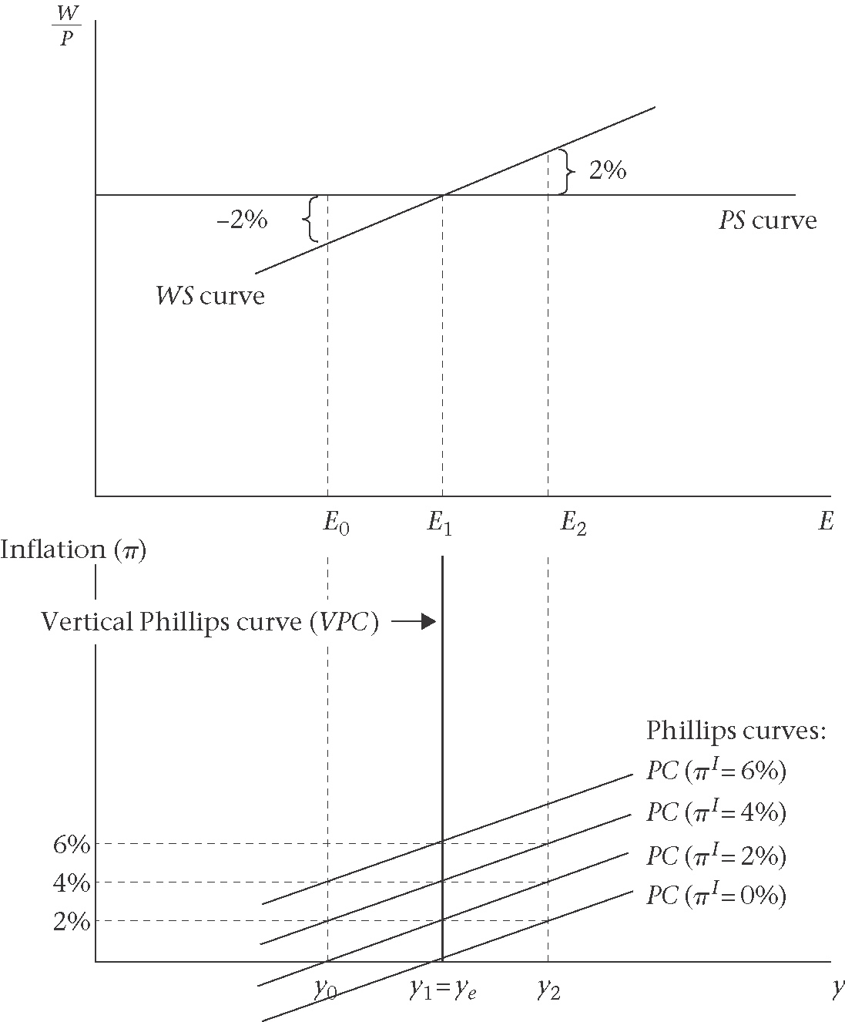
Each PC is defined by two characteristics:
(i)The lagged inflation rate, which is equal to the past inflation and fixes the height of the Philips on a vertical line above the level of output associated with the ERU.
(ii)The slope of the WS curve, which fixes its slope. The PC curves will be steeper if the WS curve is steeper and vice versa
$$π=π^{I}+α\left(y−y_{e}\right)$$
$π$ = $π^{I}$ + $α\left(y−y_{e}\right)$
(current inflation) (inflation inertia ) (output gap)

Figure 3.3: The Original Philips Curve
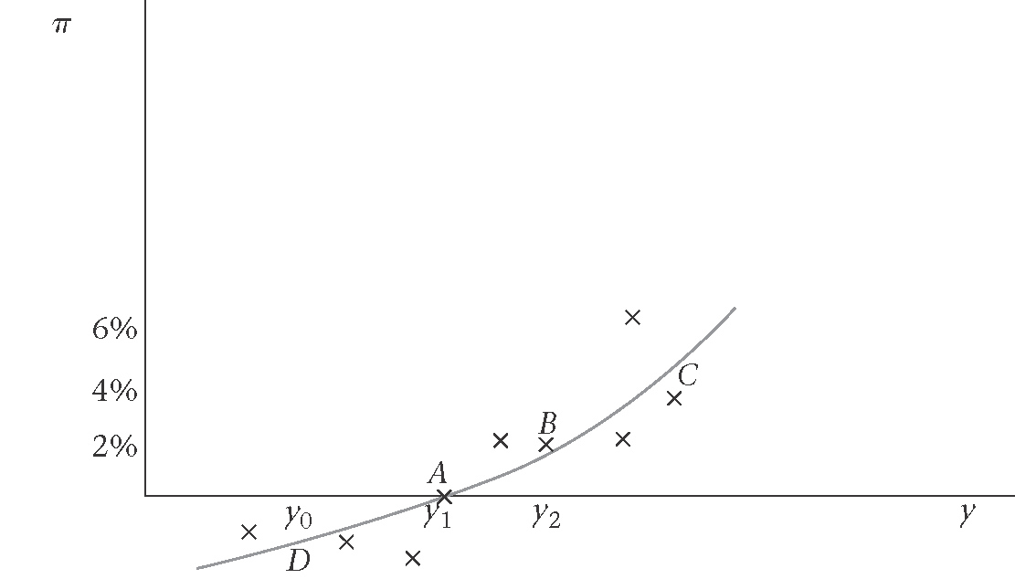

Figure 3.4: Philips original curve: UK 1861-1913
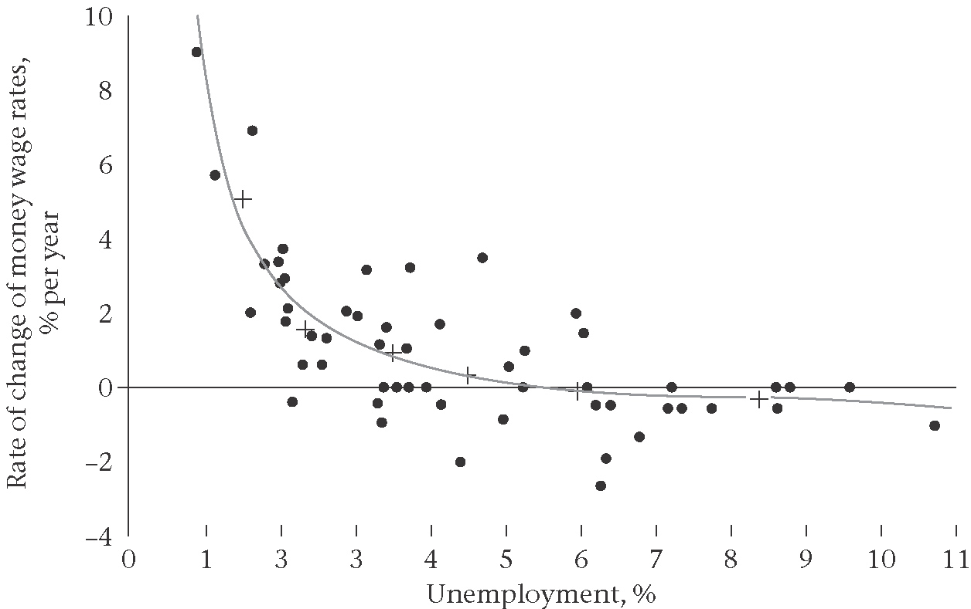

Disinflation is costly
Figure 3.5: Disinflation is costly
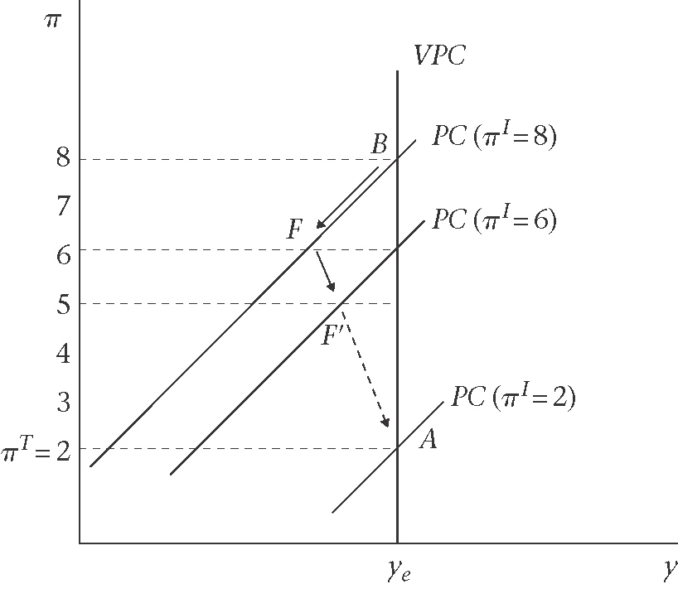

Disinflation and central bank preferences
Figure 3.6: Disinflation and central bank preference
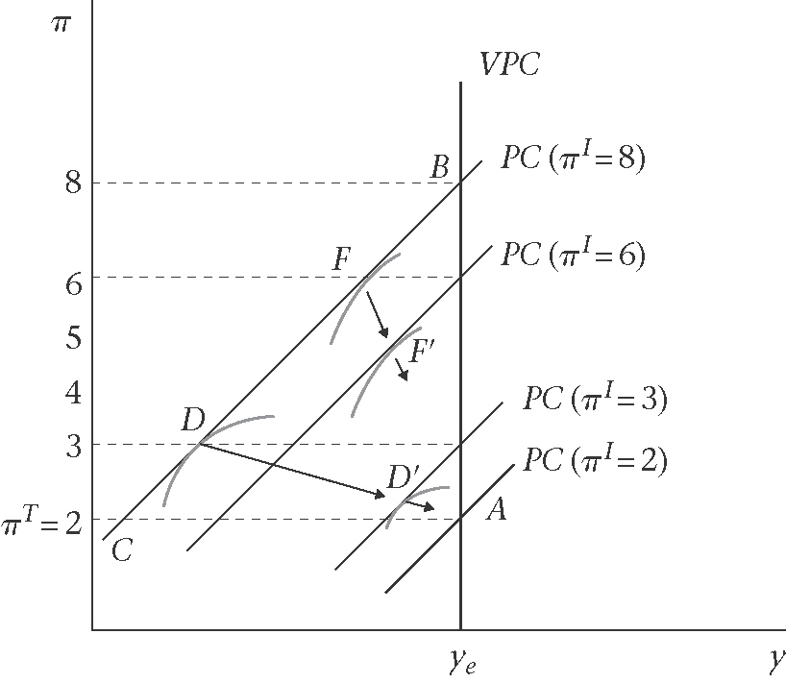
- The indifference curves of the more inflation-averse CB are flatter (D, D’, A)
- The indifference curves of the less inflation-averse CB are steeper (F, F’,A)

Costless disinflation and rational expectations
Additional assumption about the economy to eliminate the cost of disinflation:
(i)Inflation inertia is absent
No nominal rigidities in the economy in wage or price setting. Adaptive expectations play no role in wage setting. Instaed, it also called ‘rational expectations hypothesis’ as :
$π=π^{E}+α\left(y−y_{e}\right)+ε$, where $ε$(epsilon) is a random shock term.
(ii)When the central bank announces a new low inflation target, $π^{T}$, that is believed by market participant. This also indixates that the central bank policy announcement is credible. For the target to be credible, it must be consistent with:
$$π=π^{T}+ε$$
Rational expectations Hypothesis
- Agents do not make any systematic error
- All informations are vailable
- There os no correlation between the error term and the information available when the expectation is formed.
$$π^{E}=Eπ=E\left(π^{T}+ε\right)=π^{T}+Eε=π^{T}$$
$π^{E}=π^{T}$ (rational expectations of inflation), where $E$ is the ‘objective’ expected value, and the Philips curve is now ;
$π=π^{T}+α\left(y−y_{e}\right)+ε$ (Philips curve; rational expectations)
By rearrangging;
$$y−y_{e}=\frac{1}{α}\left(π−π^{T}−ε\right)$$
$=\frac{1}{α}\left(π−π^{E}\right)$
Hence, $y=y_{e}+\frac{1}{α}\left(π−π^{E}\right)$; where $\frac{1}{α}\left(π−π^{E}\right)$ is an inflation surprises
$y=y_{e}+ξ$ (Lucas surprise supply function)

3.3 Monetary Rules, and the 3-Equation IS-PC-MR model
The three equation models are:
(i)The IS equation
(ii)The Philips curve equation, and
(iii)the monetary rule derived from the central bank’s policy trade-off between output and inflation

The 3-Equation model: IS-PC-MR

IS equation
$y=A−\text{ar}$ [IS equation]
$y_{e}=A−{\text{ar}}_{s}$[stabilizing interest rates]
$y−y_{e}=−a(r−r_{s})$ [IS, output gap form]

The inertia-augmented Philips curve equation
$π=π_{−1}+α\left(y−y_{e}\right)$ [Phillips Curve, PC]

Monetary rule (MR)
$y−y_{e}=−b\left(π−π^{T}\right)$ [monetary rule, MR]

Figure 3.7: The Monetary rule: the MR line
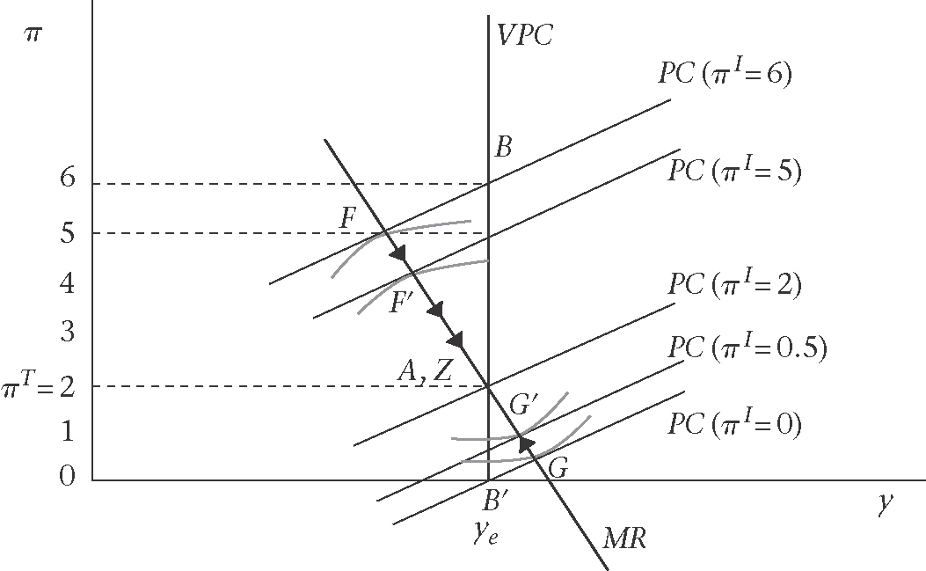
Constructing the MR Line
- Take a PC and find the CB best output-inflation combination along the PC.
- Find the tangency between the CB indifference curve and the relevant PC constraint
- Joining up these points of tangency, the MR is formed.
Two cases:
(i)Inflation above the target – CB has to implement a tight MP
(ii)Inflation below the target – CB has to implement an easing MP

An Inflation Shock
Figure 3.8: Inflation shock and the monetary rule
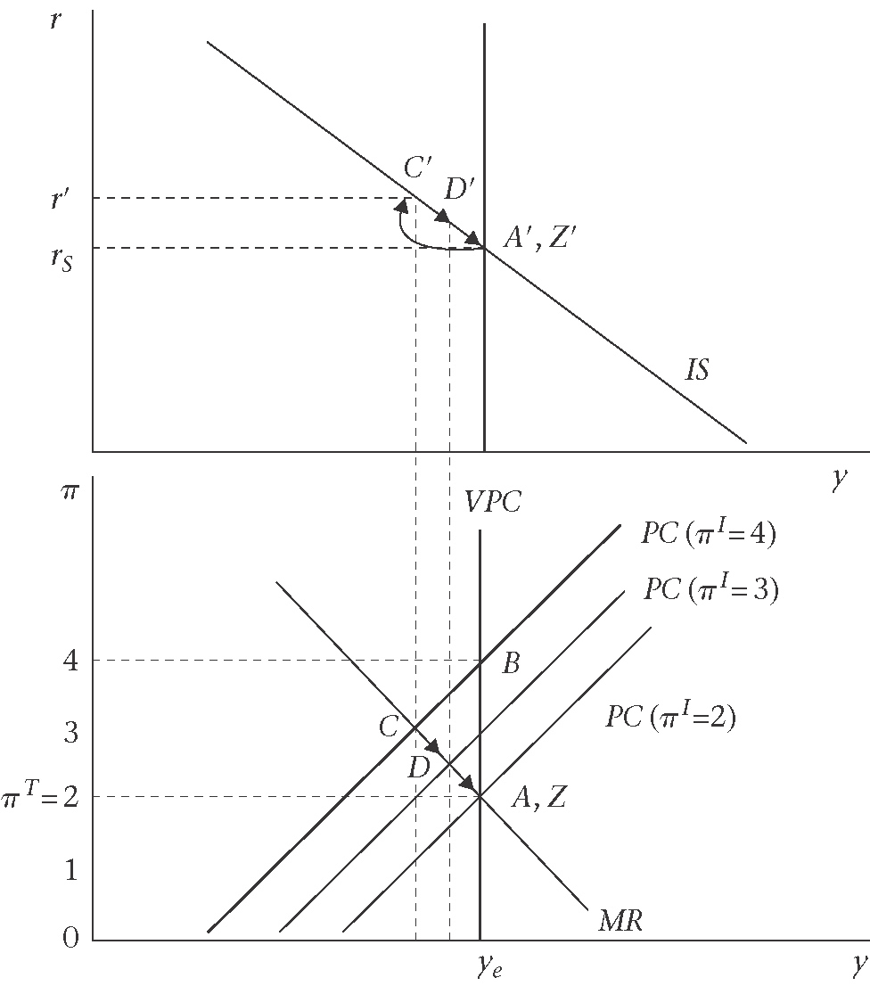

A temporary demand shock
Figure 3.9: Temporary aggregate demand shock and the monetary rule
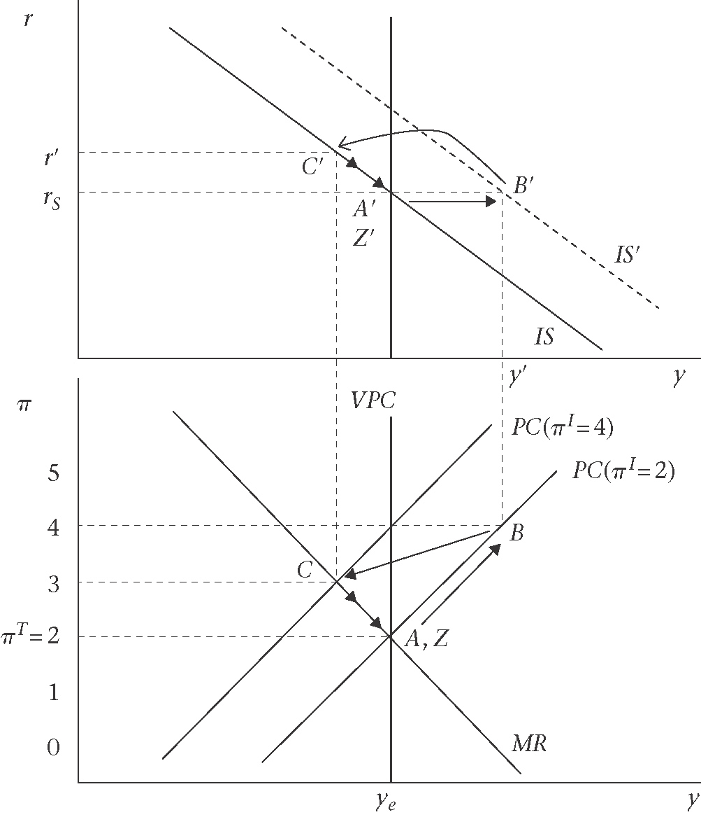

A permanent demand shock
Figure 3.10: Permanent aggregate demand shock and the monetary rule

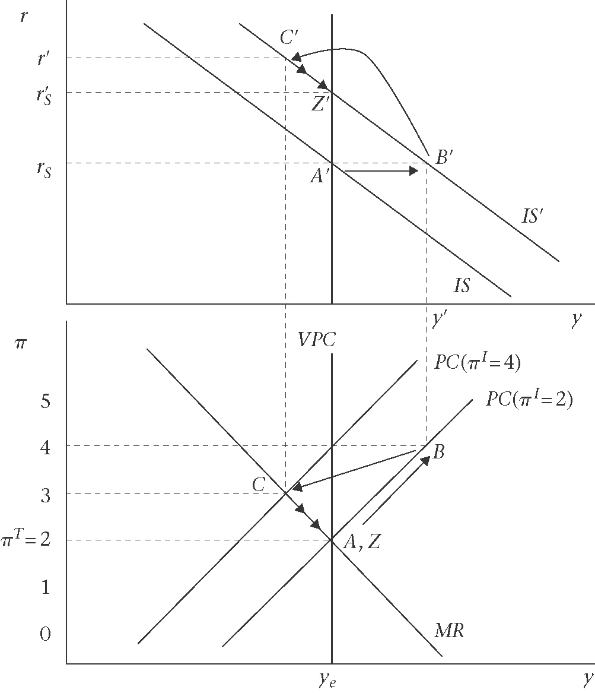

Sacrifice ratios, and disinflation strategies
Figure 3.11: Disinflation strategies, and sacrifice ratio: ‘cold turkey’ vs’gradualism’
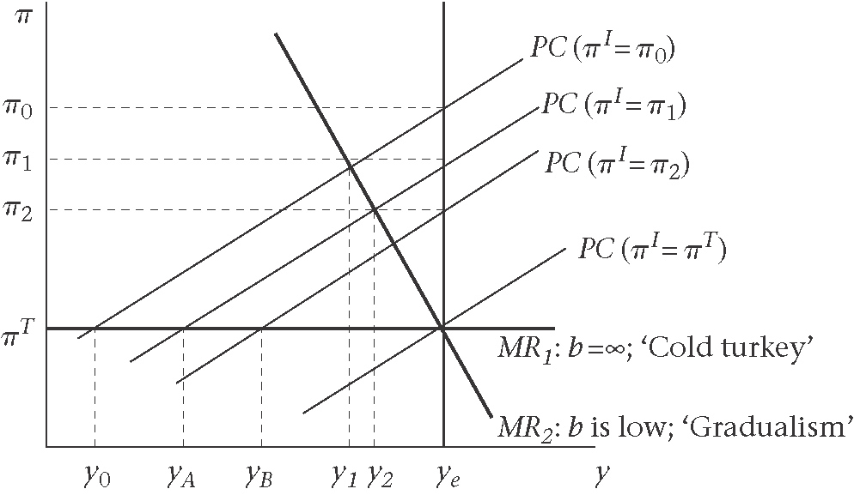

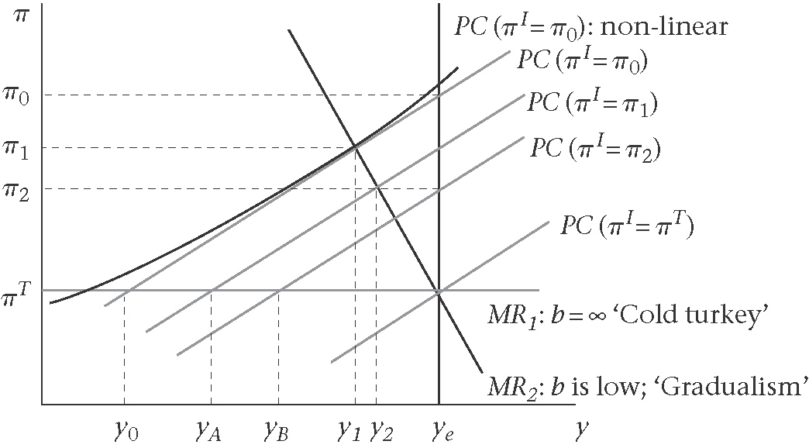

3.4 Inflation at the medium-run equilibrium

Two monetary policies
(i)Interest ates rules (MR approach)
(ii)Money supply rule (LM approach)
Assume:
$$i=r+π^{E}$$
and note that at medium-run equilibrium, $π=π^{E}$
The money market equilibrium condition:
$$\frac{M^{s}}{P}=L\left(i,y\right)$$
$=L(r+π,y)$ (LM)
Since by definition of the medium-run equilibrium, $π$is constant, the real demand for money $(L)$ is also constant. Money market is in equilibrium is that the real supply of money must also be constant, thus the prive level (P) must grow at the same rate as the nominal money supply. Thus, the growth rate of money supply $\left(λ_{M}\right)$ is assume constant:
${\bar{λ}}_{M}=\frac{M−M_{−1}}{M_{−1}}$, which implies that;
$$π={\bar{λ}}_{M}$$

How the MR relates to the LM curve?

3.4 Inflation in the IS/LM model

Figure 3.13: AD shock: central bank holds money growth rate constant
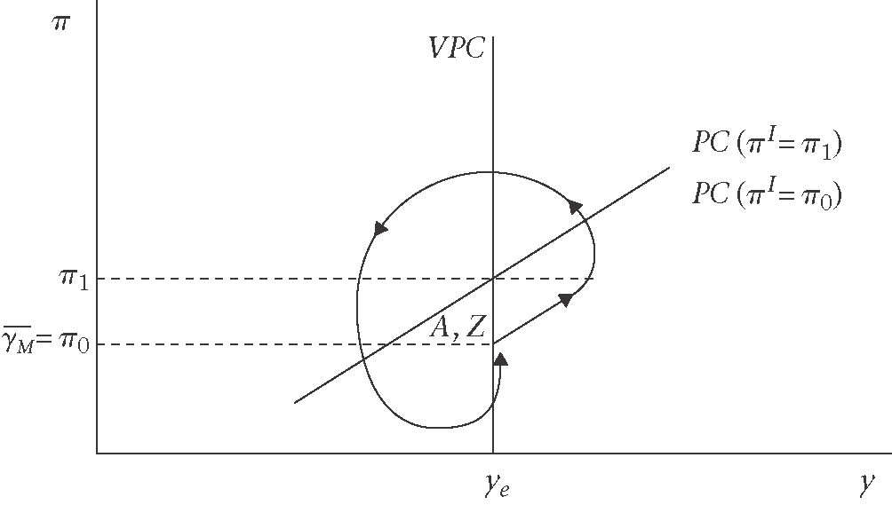

Appendix (self-study)

Inflation in the competitive model: Friedman’s model
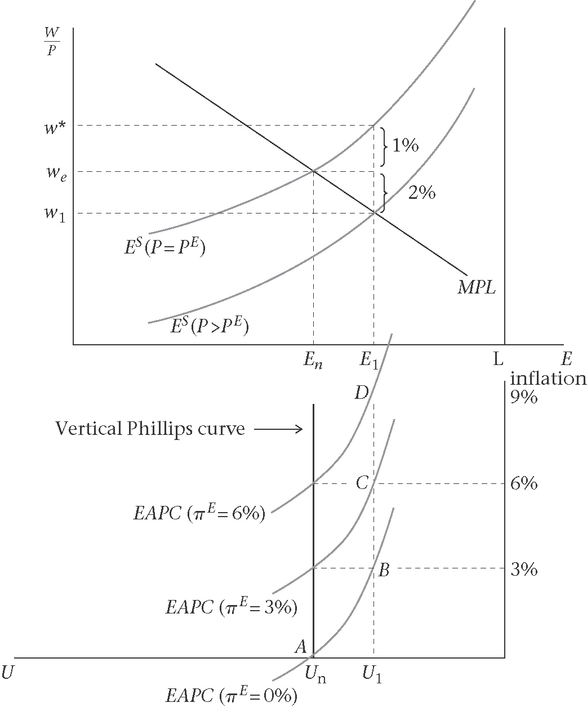

Adjustment to an aggregate demand shock using the IS/LM model

Figure 3.15: Permanent IS shocks: new medium-run equilibrium at Z
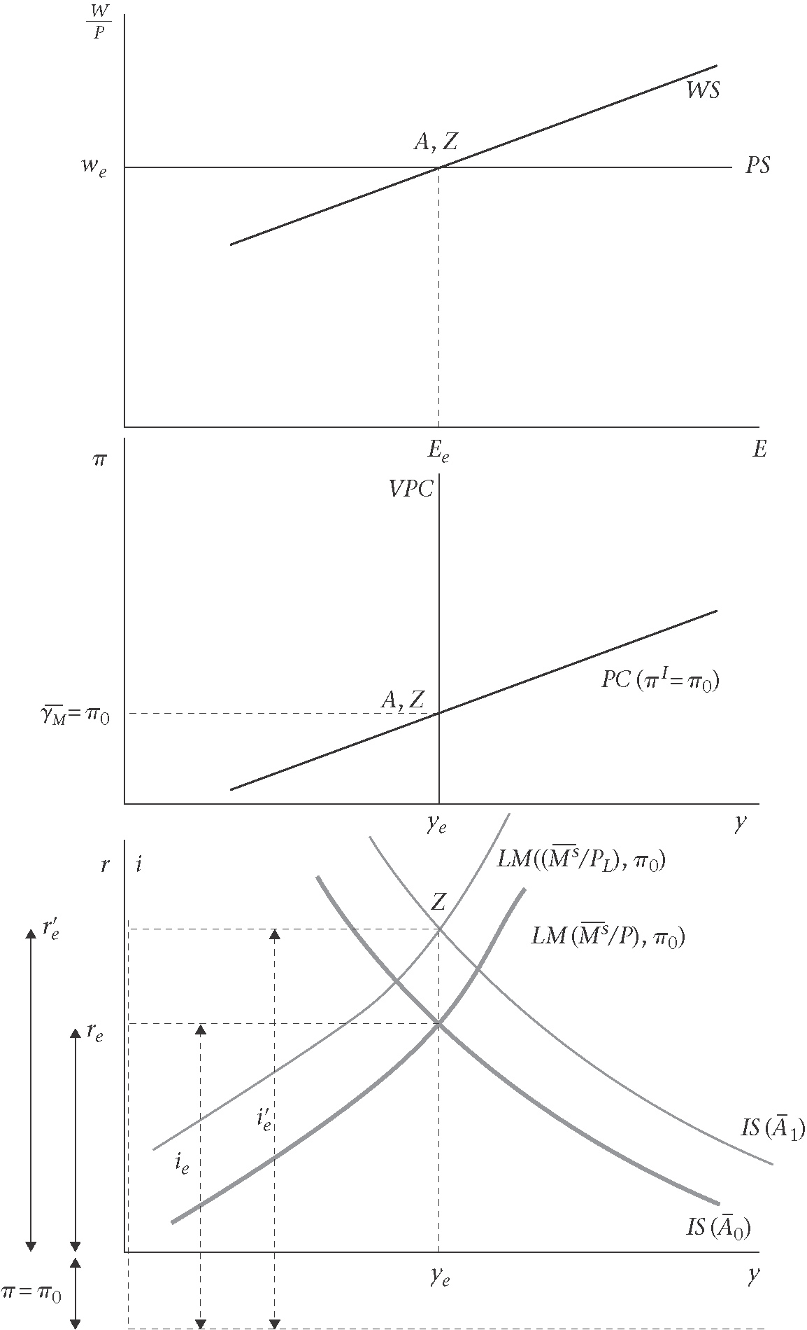

Figure 3.16: Sketch of the adjustment path to the new medium-run equilibrium at Z following a consumption boom
