CHAPTER 4: LABOUR MARKET AND SUPPLY-SIDE POLICIES
Introduction
This chapter
- explains how supply-side policies and labour market institutions affect the wage or price-setting curve and, hence, equilibrium unemployment.
- focuses on factors that can shift the WS curve and the PS curve.
- takes a closer look at the way in which the institutions of wage setting can affect equilibrium unemployment.
- explain the way in which a period of sustained unemployment due to weak aggregate demand can feed back to the supply side of the economy and result in a rise in equilibrium unemployment.

1. Supply-side structures, policies, and shock
- we refer to any shift in the WS or PS curve as a supply-side shift or a supply-side shock

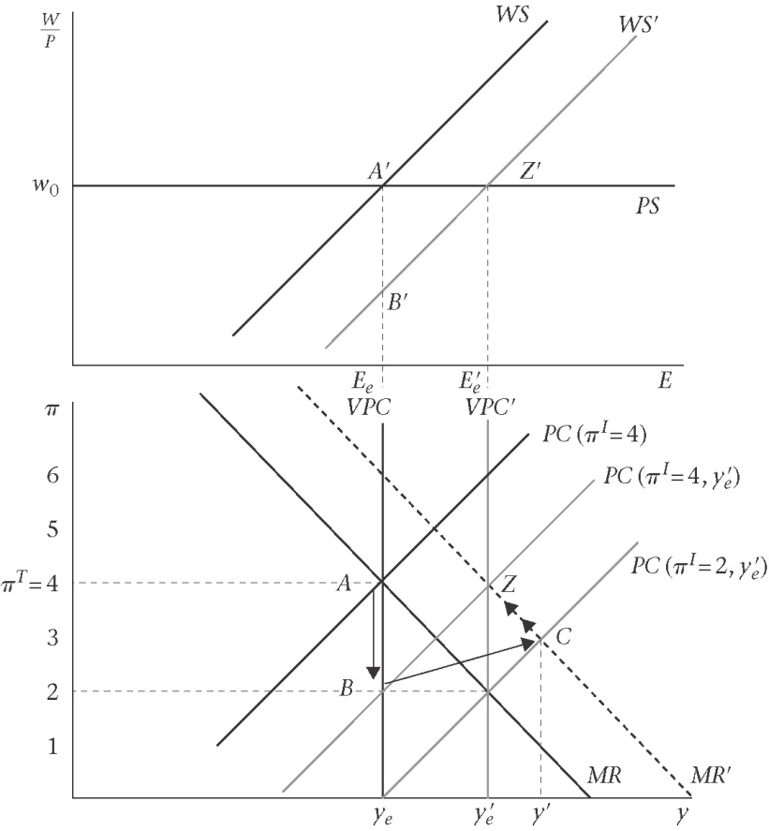
- downward shift of the WS curve (union power is weakened by a new legislation)- supply shock
  - WS → WS’
  - VPC → VPC’
  - PC shift as well to PC(π^{I}=4,y’_{e})
  - A → Z straight jump is unlikely (because lags in response and adjustment)
  - Instead A → B
    - Inflation falls at y_{e} (money wages rise by less than the previous periods inflation)
    - CB cut the interest rates (movement along the IS curve)
    - PC → PC(π^{I}=2,y’_{e})
  - CB adjusts to achieve inflation target π^{T}=4 and prefer point C
  - C → Z along the new MR, MR’

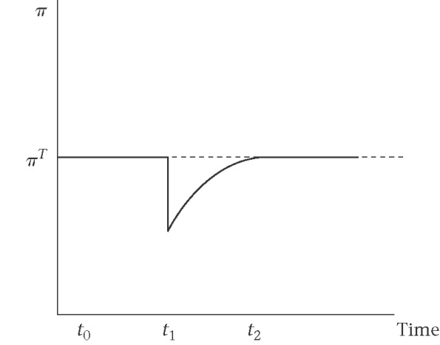
- Time path of inflation following a Ws curve shift

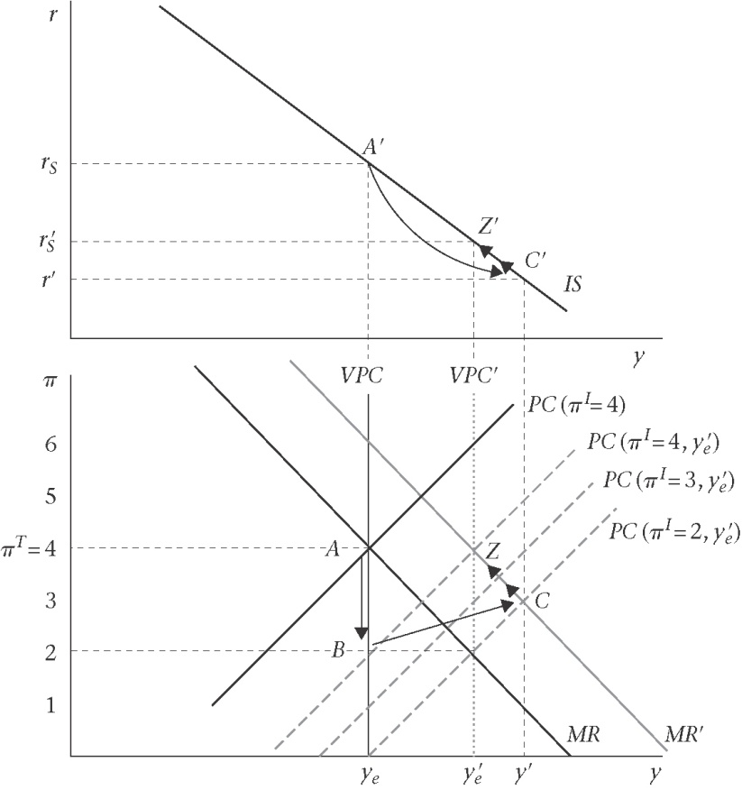
- Another way to look at the effect of a WS change on IS-PC and MR
- A supply shock differs from the inflation and demand shocks because it shifts the MR schedule.

2. Factors that shift the WS and PS curves
a. wage-push factors that shift the WS curve
b. price-push factors that shifts the PS curve

2.1 tax wedge – how are W and P being measured?
- tax wedge – the difference between the real consumption wage and the real product wage.
  - Real consumption wage
    - w = W/P_{c} where
P_{c} = P(1+ t_{v}), the consumer price index
t_{v} is indirect taxes
  - Real product wage – full cost of labour to firm (inclusive of income tax and non-wage labour costs such as social security contributions paid by employers and employees) divided by the price the firm gets for its product (i.e. excluding indirect taxes)

Producer price
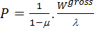
- 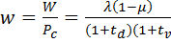

- a fall in income tax, implies an upward shift in the PS curve, indicating that the real wage is higher at any level of employment since the tax take is smaller.

2.2 Price push factors
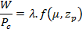
PS shift up when there is a
- fall in the tax, wedge, which is included in zp
- fall in the mark-up, u, due, for example, to a change in competitive conditions
- rise in productivity, A.

2.3 Wage-push factors
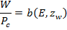
The z_{w}'s include institutional, policy, structural and shock variables.
WS shift down when
- there is a fall in the level of unemployment benefits
- unions are given less legal protection because this reduces the difference between the WS curve and the labour supply curve.
- unions are weaker, for example as measured by a lower proportion of trade union members among employees (lower trade union density)
- unions agree to exercise bargaining restraint in the context, for example, of a wage accord because this lowers the real wage that is acceptable to unions at a given unemployment rate
productivity increases
training programmes
wage accors, income policies and industrial relations legislation
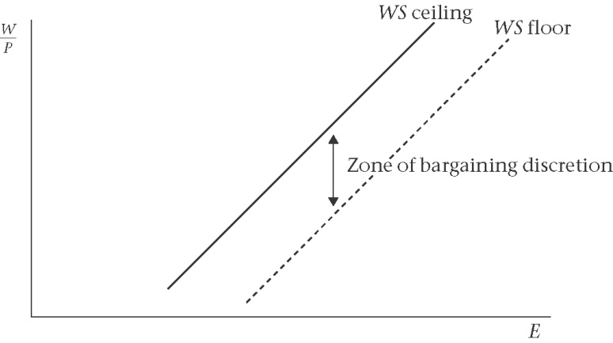

Zone of bargaining discretion between WS ceiling and WS floor

3. Union, wage setting arrangements and the ERU

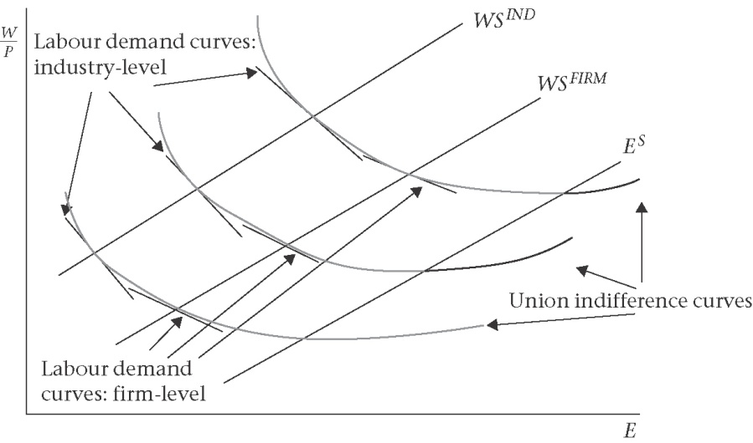
Deriving wage-setting curves under different institutional arrangements
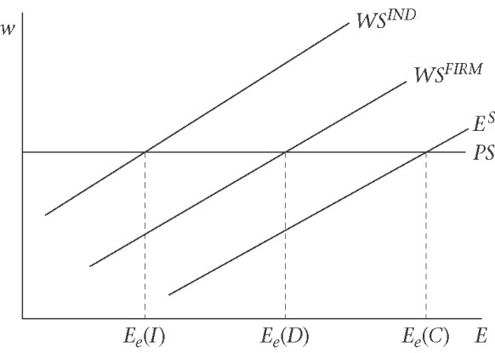
Equilibrium employment with centralized, industry-, and firm-level wage setting
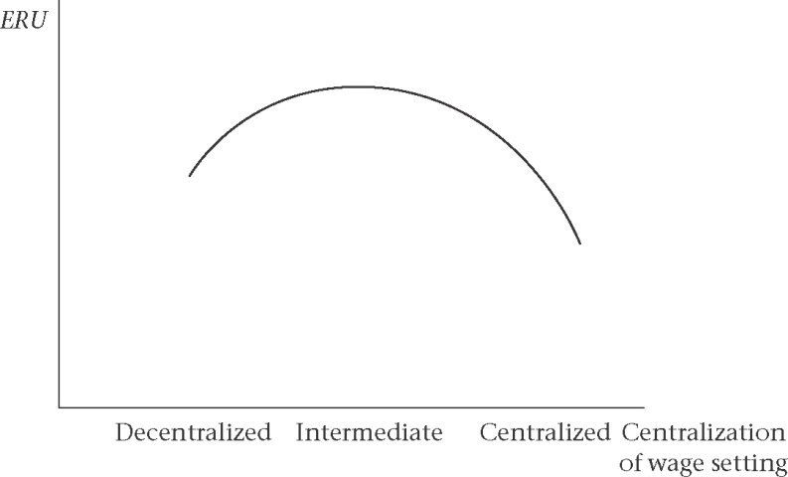

4. Introduction to hysteresis: actual U affects the ERU
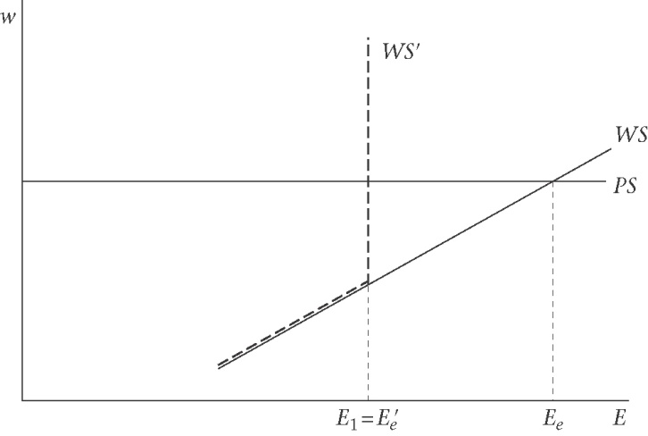
Hysteresis: the insider-otsider model

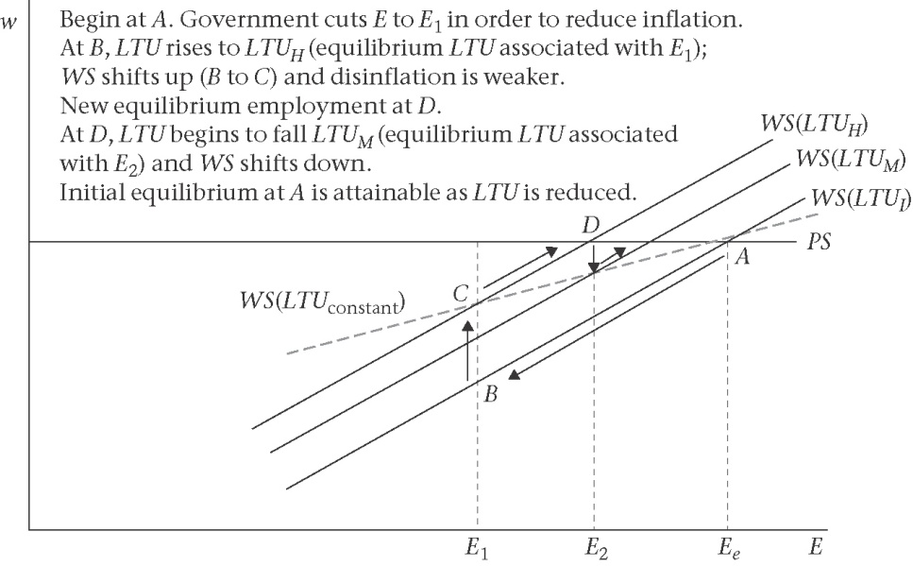
Unemployment persistence: the role of long-term unemployment
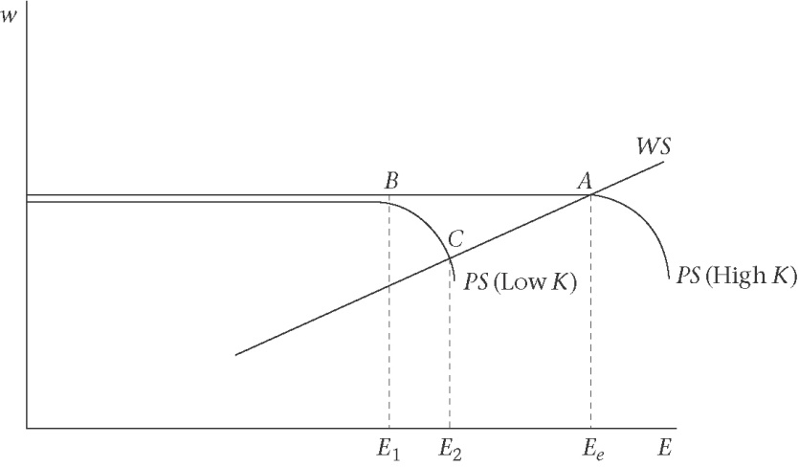
Unemployment persistence: the capacity scrapping effect
5. The Beveridge curve approach to unemployment

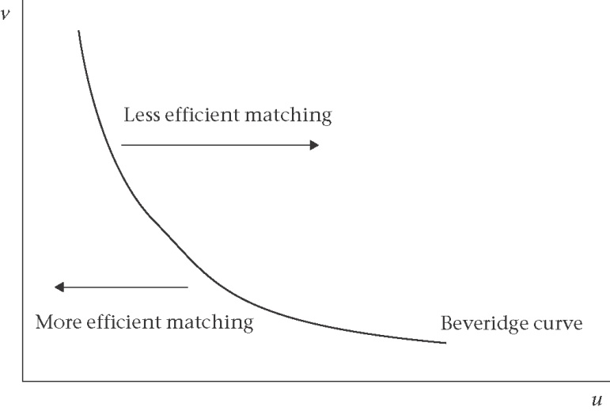
The Beveridge curve
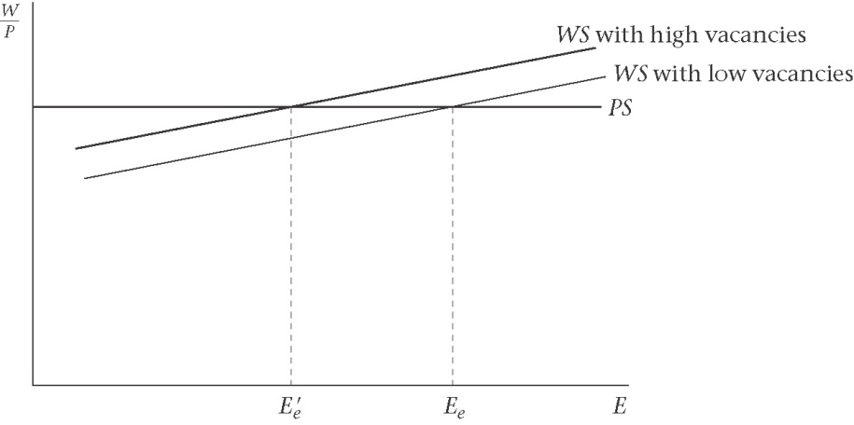
The WS-PS curve and vacancies
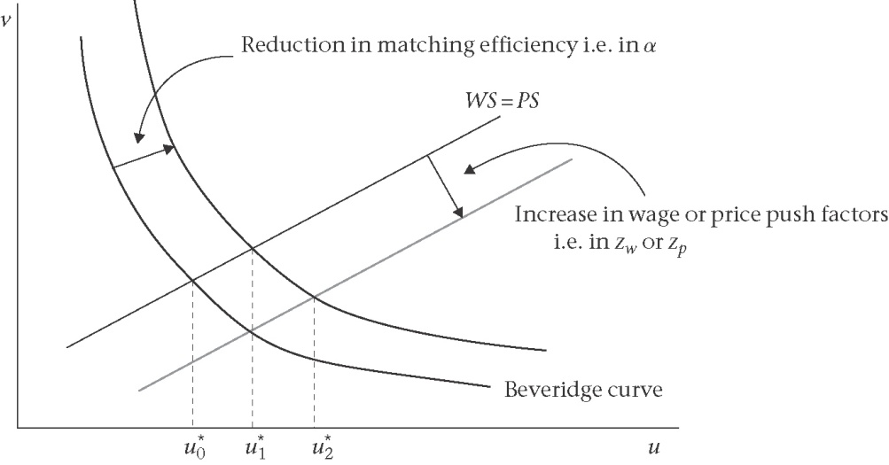
The Beveridge curve and the WS-PS equilibrium

