LECTURE 5 : MONETARY POLICY

5.1 Introduction
- The CB behaviour can be thought about in terms of a ‘reaction function’ that the CB uses to respond to shock to the economy, and steer it toward an explicit or implicit inflation target.
- Two main tasks of the ‘reaction function’;
- To provide a ‘nominal anchor’ for the medium run (ex: inflation or price level target)
- To provide guidance as to how the CB policy instrument (ex: interest rates) should be adjusted in response to different shocks, so that medium-run objective objective of price stability is met while minimizing output fluctuations.
- Most of CB in OECD economies and in many transition and developing countries have shifted towards inflation targeting regime.
Inflation, disinflation and deflation
- - rising inflation
- - very high inflation and hyperinflation
- - volatile inflation
- - constant inflation
- - deflation
5.2 Monetary Policy Paradigms
There are two paradigms of MP:
- Money supply model or LM paradigm
- The ultimate determinant of the price level is the money supply
- The instrument of MP is the MS
- The mechanism through which economy adjusts to new equilibrium with constant inflation following a shock is that embodied in the IS/LM model plus the inertia-augmented (or expectations-augmented) Philips curve.
- Interest rates reaction function or monetary rule (MR)
- The ultimate determinant of price level and inflation is policy
- The instrument of policy is the short-term nominal interest rate
- The mechanism through which the economy adjusts to a new equilibrium with constant inflation following a shock is encapsulated in an IRR
Q? How the IS shock is handled in this two paradigms??
The paradigm shift centres on two issues:
- The choice of MP instrument
- The choice of an active or passive policy
Ex: William Poole (1970) provide an early treatment of the issue by looking the relative important of LM versus IS shocks affects the optimal choice of MS versus an interest rates instrument.

5.3 The MP Rule in the 3-equation model
There are 6 key variables in central bank policy making:
(1) The central bank’s inflation target ($π^{T})$
(2) The central bank’s preferences $(β)$
(3) The slope of the Phillips curve $(α)$
(4) The interest sensitivity of aggregate demand (ex: slope of IS curve), $(a)$
(5) The equilibrium level of output $(y_{e})$
(6) The stabilizing interest rates $(r_{s})$

There are 4 steps for deriving a monetary policy rule;
(1) Define the CB utility function in terms of both output and inflation. This produces the policy makers indifference curves in output-inflation space.
(2) Define the constrainsts faced by the policy maker: the PC, which are also shown in output-inflation space
(3) Derive the optimal MR in output-inflation space: MR line
(4)Derive the IRR, which tells us the CB how to adjust the IR in response to current economic conditions
The Central Bank’s Utility Function
Assume the CB has to concerns: the rate of inflation $(π)$ , and the level of output $(y)$. The target rate of inflation is $(π^{T})$. Two types of the CB loss function:
Assume that the CB wants to minimize the loss function:
$$(π−π^{T})^{2}$$
Also assume that, the CB target level of output is the equilibrium level $y_{e}$, and it seeks to minimize the gap between $y$and $y_{e}$. Thus, the CB loss as aresult of output being different from its target of $y_{e}$ is:
$$(y−y_{e})^{2}$$
Thus, if the two loss functions are added together, we have the CB objective functions:
$L=(y−y_{e})^{2}+β(π−π^{T})^{2}$ (central bank loss function)

Where $β$is the relative weight attached to the loss function.
Three case: $β=1$, $β>1$, $β<1$

Figure 5.1: Central Bank Loss Functions: Utility declines with distance from the ‘bull’s eye’
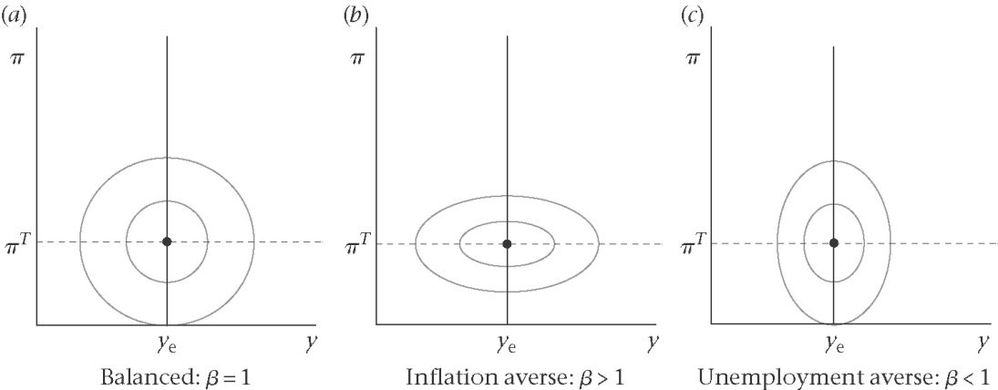

The Philips curve constrainst
The CB can control the level of output via its ability to use MP (by setting the IR) to control AD. However, the CB cannot control directly-only indirectly via y.
The output affects inflation via Philips curve:
$$π=π_{−1}+α\left(y−y_{e}\right)$$
Figure 5.2 : Loss circles and Philips Curves
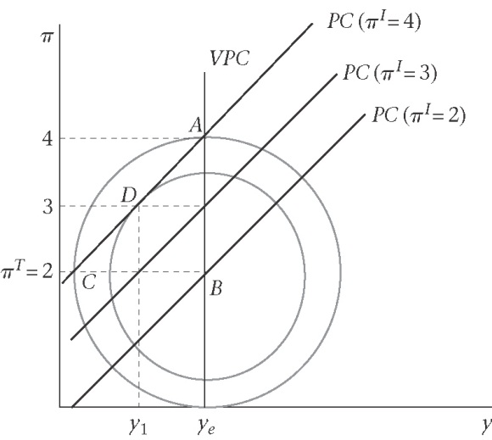

Deriving the Monetary Rule
For simplicity, assume the loss function in which $β=1$, so that the loss function (loss circles) are:
$$L=(y−y_{e})^{2}+(π−π^{T})^{2}$$
Using the simplest version of PC in which $α=1$, so that PC has 45⁰ line:
$$π=π_{−1}+y−y_{e}$$

To derive MR, we need two steps:
(1) Choose y to minimize L to derive the optimal value of y for each value of $π_{−1}$
(2) Substituting the PC into L and minimizing with respect to y, we have;

$$\frac{∂L}{∂y}=2\left(y−y_{e}\right)+2\left(π_{−1}+\left(y−y_{e}\right)−π^{T}\right)=0$$
$=\left(y−y_{e}\right)+\left(π_{−1}+\left(y−y_{e}\right)−π^{T}\right)=0$
Since $π=π_{−1}+y−y_{e}$,
= $\frac{∂L}{∂y}=\left(y−y_{e}\right)+\left(π−π^{T}\right)=0$
$⇒\left(y−y_{e}\right)=−\left(π−π^{T}\right)$ (MR equation)
MR equation show that the equilibrium relationship between the inflation rate chosen indirectly and the level of output chosen directly by CB to maximize its utility (minimize its loss) given its preferences and the constraints.

Figure 5.3: Deriving the MR line
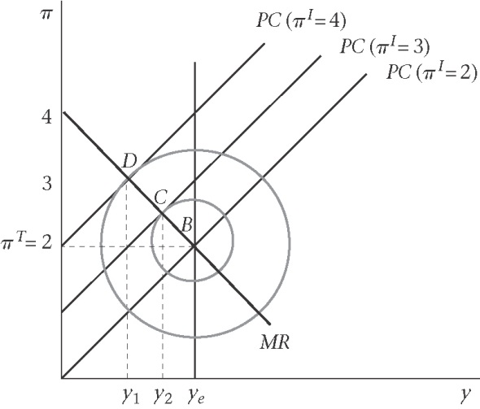

The slope of MR line are determined by three factors;
(1) Inflation-averse government: flat MR line
(2) High responsiveness of inflation to output: flat MR line
(3) Slope of PC: steeper PC make the MR line flatter
Figure 5.4 (Case 1): Inflation-averse government: flat MR line
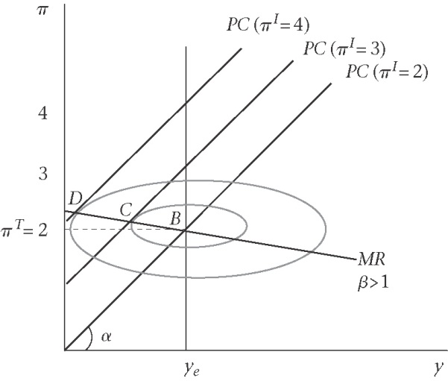
Figure 5.5 (Case 2): High responsiveness of inflation to output: flat MR line
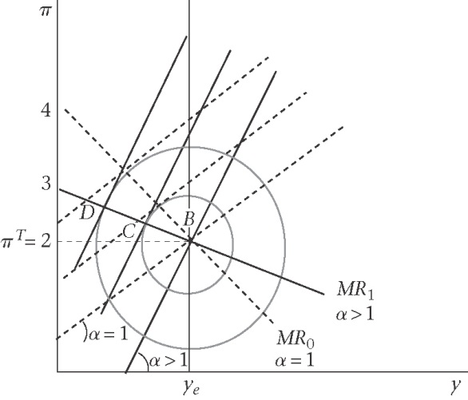

Figure 5.6: Comparing the response of the CB in two cases: steeper PC and a more inflation-averse CB
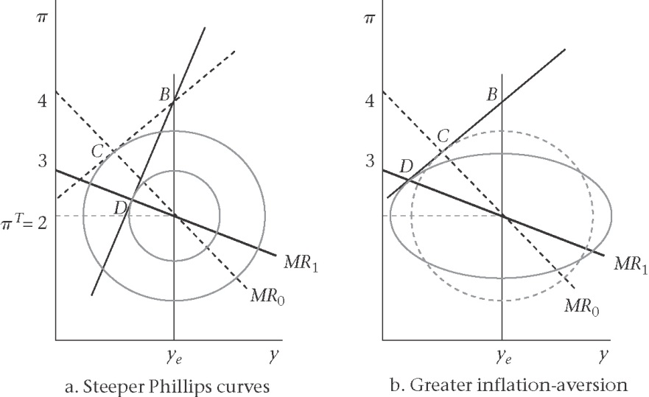

By assuming the CB chooses y to minimize
$$L={\left(y_{1}−y_{e}\right)}^{2}+β{\left(π_{1}−π^{T}\right)}^{2}$$
Subject to;
$π_{1}=π_{0}+α\left(y_{1}−y_{e}\right)$
$\frac{∂L}{∂y_{1}}=\left(y_{1}−y_{e}\right)+\text{αβ}\left(π_{0}+α\left(y_{1}−y_{e}\right)−π^{T}\right)=0$

$\left(y_{1}−y_{e}\right)=−\text{αβ}\left(π_{1}−π^{T}\right)$ (monetary rule, MR)

Using the IS-PC-MR Model

Figure 5.7: Permanent IS Shock

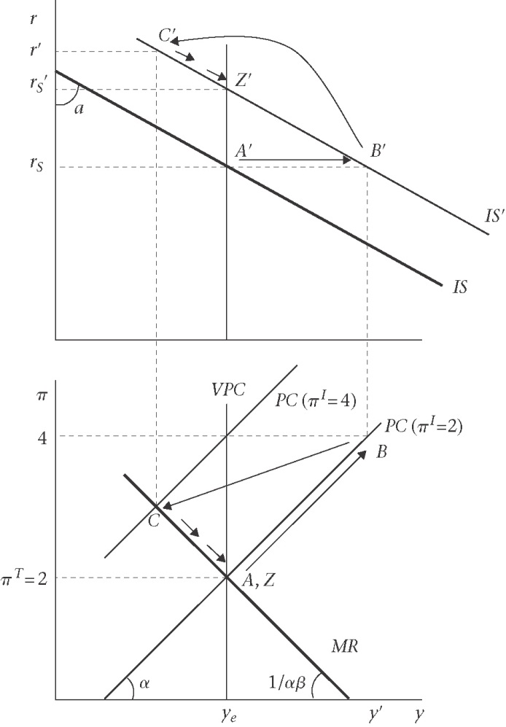

5.4 A Taylor Rule in the IS-PC-MR Model

Interest rate rules (IRR) - Taylor Rule
$π_{1}=π_{0}+α\left(y_{1}−y_{e}\right)$ (Phillips curve)
$y_{1}−y_{e}=−a\left(r_{0}−r_{s}\right)$ (IS)
$π_{1}−π^{T}=−\frac{1}{\text{αβ}}\left(y_{1}−y_{e}\right)$ (MR)
By substituting for $π_{1}$ using the PC in MR line, we get:
$π_{0}+α\left(y_{1}−y_{e}\right)−π^{T}=−\frac{1}{\text{αβ}}\left(y_{1}−y_{e}\right)$
$π_{0}−π^{T}=−\left(α+\frac{1}{\text{αβ}}\right)\left(y_{1}−y_{e}\right)$
If we substitute for $\left(y_{1}−y_{e}\right)$ using the IS, we get the interest rate rules as :
$r_{0}−r_{s}=\frac{1}{a\left(α+\frac{1}{\text{αβ}}\right)}\left(π_{0}−π^{T}\right)$ (IRR)
For example, we can set;
$r_{0}−r_{s}=0\text{.}5\left(π_{0}−π^{T}\right)$, if $a=α=β=1$.

Interest rates rules and lags
Since the CB can only choose $y_{1}$ and $π_{2}$ by its IR decision, its loss function is;
$L={\left(y_{1}−y_{e}\right)}^{2}+β{\left(π_{2}−π^{T}\right)}^{2}$
Given the double lag, the three equations are:
$π_{1}=π_{0}+α\left(y_{0}−y_{e}\right)$ (Philips curve)
$y_{1}−y_{e}=−a\left(r_{0}−r_{s}\right)$ (IS)
$π_{2}−π^{T}=−\frac{1}{\text{αβ}}\left(y_{1}−y_{e}\right)$ (MR)
By repeating the same steps, we can derive the IRR, which takes the form of a Taylor rule:
$r_{0}−r_{s}=\frac{1}{a\left(α+\frac{1}{\text{αβ}}\right)}\left[\left(π_{0}−π^{T}\right)+α\left(y_{0}−y_{e}\right)\right]$
And $r_{0}−r_{s}=0\text{.}5\left(π_{0}−π^{T}\right)+0\text{.}5\left(y_{0}−y_{e}\right)$ (Taylor rule in 3-equation-double lag model)
Figure 5.8: Taylor Rule Example
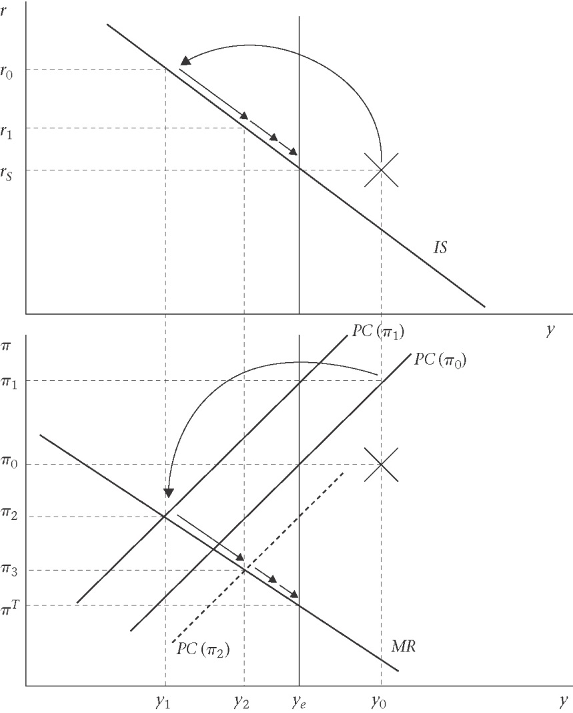
Figure 5.9: Deriving the Taylor Rule

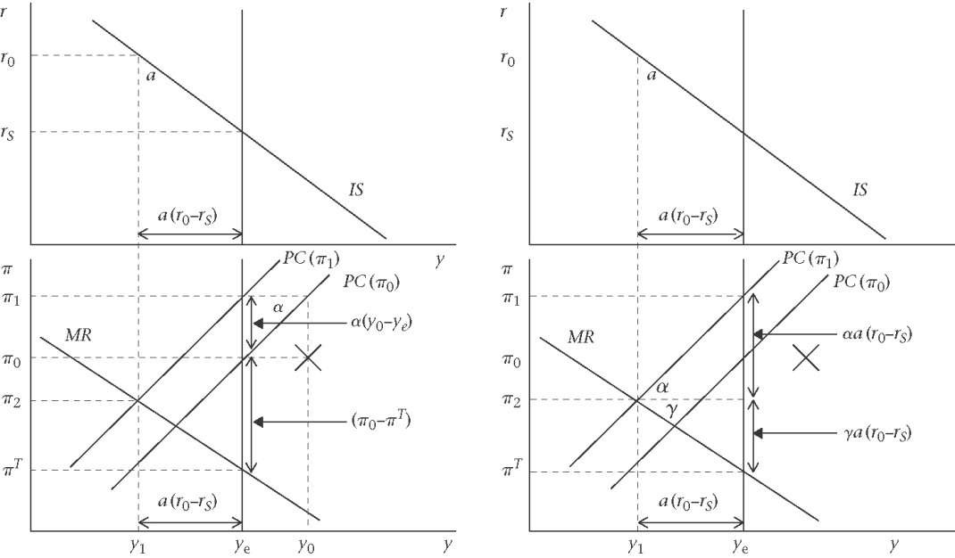

5.5 Problems with using an IRR
Three reasons that MP can fail to have its desired effect on output:
- Investment is insensitive to the real interest rate
- The long-run real interest rate does not move in line with changes in the short-term nominal interest rates
- The central bank wishes to stimulate demand but the nominal interest rate is close to zero

The Deflation Trap
Figure 5.11: The zero floor to nominal interest rate and the deflation trap
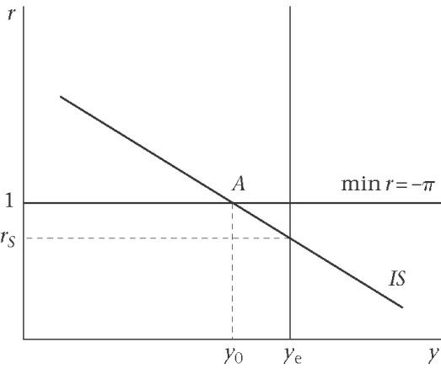
5.6 Credibility, time inconsistency, and rules versus discreation
Backward-looking Philips curves and credibility
Figure 5.12: Central bank announces a new target: credibility and inertia
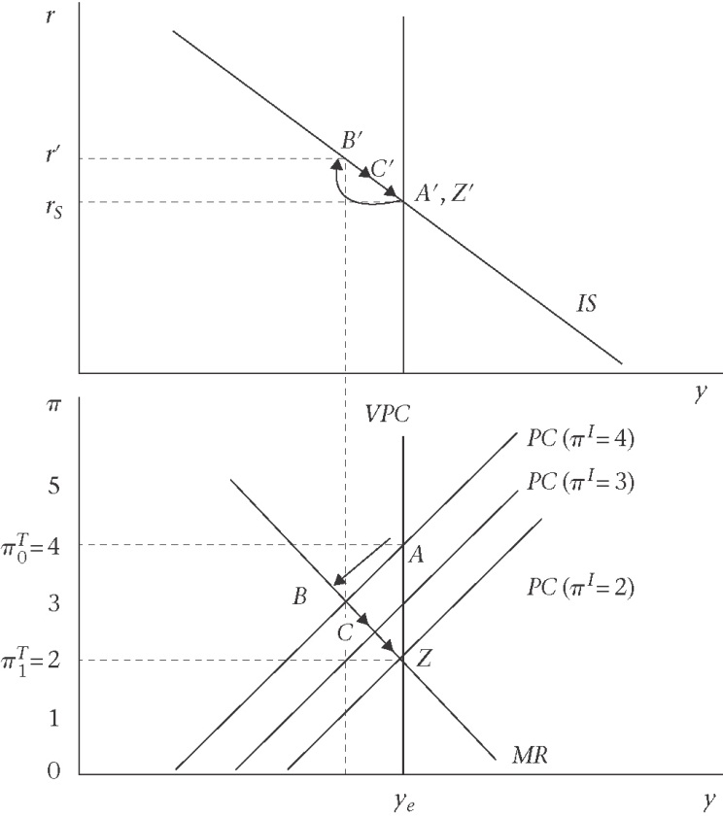
Introducing Inflation Bias
Assumed that the CB’s new objectice functions want to minimize;
$L={\left(y_{1}−y^{T}\right)}^{2}+β{\left(π_{1}−π^{T}\right)}^{2}$, where $y^{T}>y_{e}$. This is subject as before to the Philips curve;
$$π_{1}=π_{0−1}+α\left(y−y_{e}\right)$$
Minimizing the CB’s loss function implies:
$y−y^{T}+\text{αβ}\left(π_{−1}+α\left(y−y_{e}\right)−π^{T}\right)=y−y^{T}+\text{αβ}\left(π−π^{T}\right)$ = 0
So, the new monetary rule is:
$y−y^{T}=−\text{αβ}\left(π−π^{T}\right)$
This equation indeed goes through $\left(π^{T},y^{T}\right)$. Since equilibrium requires that $π_{−1}=π$, when $y=y_{e}$, we have:
$y_{e}=y^{T}−\text{αβ}\left(π_{−1}−π^{T}\right)$
$⇒π=π_{−1}=π^{T}+\frac{\left(y^{T}−y_{e}\right)}{\text{αβ}}$ (inflation bias)
Figure 5.13: The inflation bias
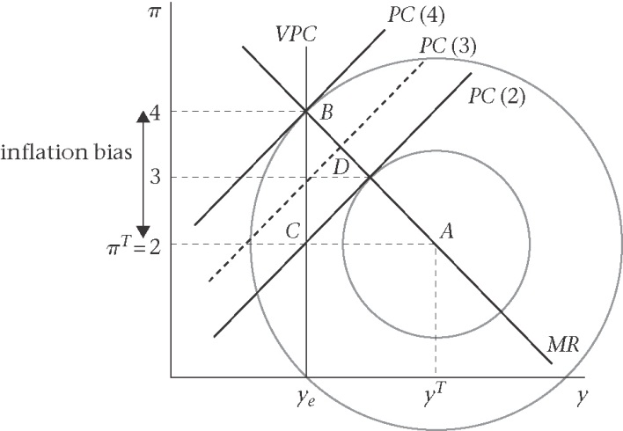
Figure 5.14: Inflation bias: Central Bank and government

