LECTURE 6 : FISCAL POLICY
6.1 Introduction
(i)Three roles of FP:
- To provide automatic stabilizers that insulate the economy to some extent from shocks to AD (ex: the structure of the tax, and social security systems)
- To stabilize the level of output around the equilibrium rate by using discretionary changes in G and/or T.
- To plan financing of G so as to maintain a sustainable burden of public debt (Budget hypothesis; tax-spend; spend-tax, or fiscal syncronization)
(ii)Three types of G financing
- Taxation
- Borrowing from the public (i.e. issuing bond)
- Borrowing from the central bank (i.e. new money creation)

(iii)Sustainability of public debt – it related to the FP rules
- Stabilization
- Solvency
6.2 The automatic stabilizers

(primary) budget deficit = cycli. adj. budget deficit + impact of automatics stabilizers
= discret. fiscal stimulus impulse + impact of aut. Stabilizers

$$g(y_{t})−t(y_{t})=\left[g(y_{e})−t(y_{e})\right]+a(y_{e}−y_{t})$$

6.3 Discretionary Fiscal Policy

The government budget identity

$G+\text{iB}=T+ΔB+ΔH$ (government budget identity)

The fiscal policy transmission mechanism
$↑g⇒↑y⇒↑{\left(\frac{M}{P}\right)}^{d}↑r⇒↓I$ (crowding-out effect)
Figure 6.1: Difference methods of financing an increase in government expenditure

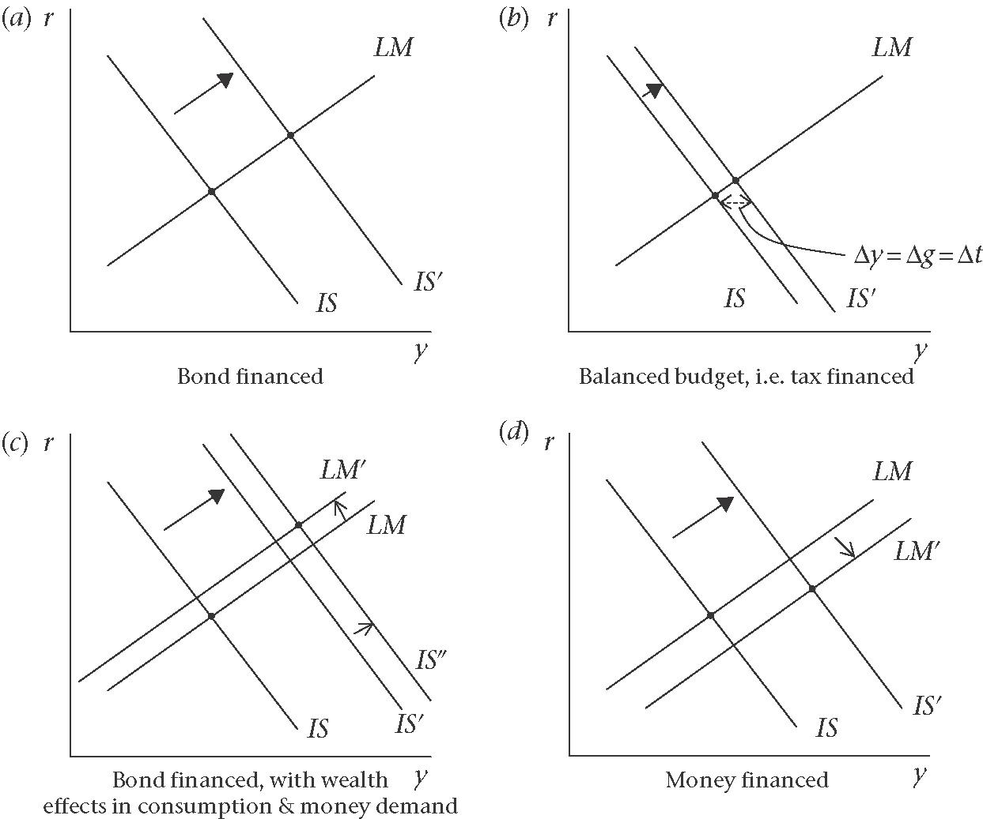

Tax finance and the balanced budget multiplier
Suppose there is a proportional tax : $t=t_{y}y$. At the new equilibrium following the increase in G, there will only be budget balance if:

$$Δg=Δt$$
$$=t_{y}Δy$$
$⇒\frac{Δy}{Δg}=\frac{1}{t_{y}}$ (i.e. if the multiplier effect of the changes in g is $\frac{1}{t_{y}}$. But we know that, the expenditure multiplier is equal to:
$\frac{Δy}{Δg}=\frac{1}{s_{y}+c_{y}t_{y}}$, which is smaller than $\frac{1}{t_{y}}$.

Now, suppose the G increases taxation by enough to finance the increased G, so that no deficit at the new short-run equilibrium. Thus, the first impact on output of the change in g:

$Δy=Δg+c_{y}Δg+c_{y}\left(c_{y}Δg\right)+\text{.}\text{.}\text{.}\text{.}\text{.}\text{.}$
The impact on output of the change in t:
$Δy=−c_{y}Δt−c_{y}\left(c_{y}Δt\right)−\text{.}\text{.}\text{.}\text{.}\text{.}\text{.}$
Since by the assumption of tax finance, $Δg=Δt$, it is clear that the net effect of the balanced budget expenditure programme is:
$Δy=Δg=Δt$
$\frac{Δy}{Δg}=1$ (balanced budget multiplier)

Bond Finance
A rise in G will not induce sufficient extra tax revenue to wipe out the deficit. Thus, there will be a continuing requirement to sell bonds to cover the gap between Exp. And Rev.
The effects of bond financing depend on whether G bonds are considered by private sector agents to represent net wealth in the economy.
Ex: If Bonds are wealth, then changes in the stock of wealth will influence C and Md (shift IS curve to right), and LM curve will shift to the left (because of an increased in Md).

Are bonds net wealth? The Ricardian equivalenve debate
If bonds are not considered as net wealth by H, two implications follow:
(i)The consequences of changes in W as the G’s debt rises disappear
(ii)The expansionary impact of the spending programme shrinks back to that of a balanced budget.

Ricardian Equivalence (RE)
H do not view bonds as net wealth if they take into account the fact that taxes in future will have to be raised to service the debt and to repay the principal on the debt.
RE depends on the following assumptions:
(i)the absence of liquidity constrainst on H (i.e. H are able to borrow against expected future income at the current interest rate)
(ii)the interest rate and time horizon faced by H and the G are the same
(iii)H have children or heirs and incorporate the utility of their heirs in their consumptions behavior (i.e. H behave ‘as if’ they last forever).

Money Financed Fiscal Expansion
An increase in expenditure is through an increase in the monetary base (i.e. $ΔH$). The G sells bonds to the CB and spends the newly printed money on its expenditure initiatives.

6.4 Deficits and debt

The budget identity without the possibility the G can borrow from the CB is as follows:
$\underset{\text{govt}\text{.}\text{exp}}{\underbrace{G}}+\underset{\text{int}\text{erest}}{\underbrace{\text{iB}}}=\underset{\text{taxrevenue}}{\underbrace{T}}+\underset{\text{newbonds}}{\underbrace{ΔB}}$ (G budget identity)

The actual deficits is $G+\text{iB}−T$ , and the primary deficit which excludes the interest payments on debt is $G−T$.
The actual deficit is equal to the change in the stock of G debt:
$$ΔB=(G−T)+\text{iB}$$
Change in debt = primary deficit + interest on outstanding debt
By defining the debt ratio as:
debt ratio$⇒b=\frac{B}{\text{Py}}$, where P is the price level;. and y is the national income.
Rewrite the budget identity equation (G budget identity) by dividing through by Py. This gives us the actual deficit to GDP $\left(\frac{ΔB}{\text{Py}}\right)$;
$$\frac{\text{actualdeficit}}{\text{GDP}}=\frac{ΔB}{\text{Py}}=\frac{G−T}{\text{Py}}+\frac{\text{iB}}{\text{Py}}$$
=$d+\text{ib}$
Where, the ratio of the primary deficit to national income is:
$$\frac{\text{primarydeficit}}{\text{GDP}}=d=\frac{G−T}{\text{Py}}$$
In order to pin down the determinants of the growth in the debt to GDP ratio $\left(Δb\right)$, we begin with the definition of $b$:
$$B=\text{bPy}$$
Use the approximation that:
$ΔB≃\text{Py}Δb+\text{by}ΔP+\text{bP}Δy$
And divide each side by $\text{Py}$ to give:
$\frac{ΔB}{\text{Py}}=\frac{bΔ\text{Py}}{\text{Py}}+\frac{bΔ\text{yP}}{\text{Py}}+\frac{Δ\text{bPy}}{\text{Py}}$
By writing the growth rate of prices (inflation), $\frac{ΔP}{P}$, as $π$ and the growth rate of output as $γ_{y}$. Using $r=i−π$, thus
$Δb=d+(i−π−γ_{y})b$
$=d+(r−γ_{y})b$
The four key determinants of the growth of the debt to GDP ratio:
(i)The primary deficit ratio, $d$
(ii)The real interest rate, $r$
(iii)The growth of real GDP, $γ_{y}$
(iv)the existing ratio of government debt to GDP, $b$

Figure 6.2: The government debt ratio. Case 1: Real interest rates exceeds the growth rate

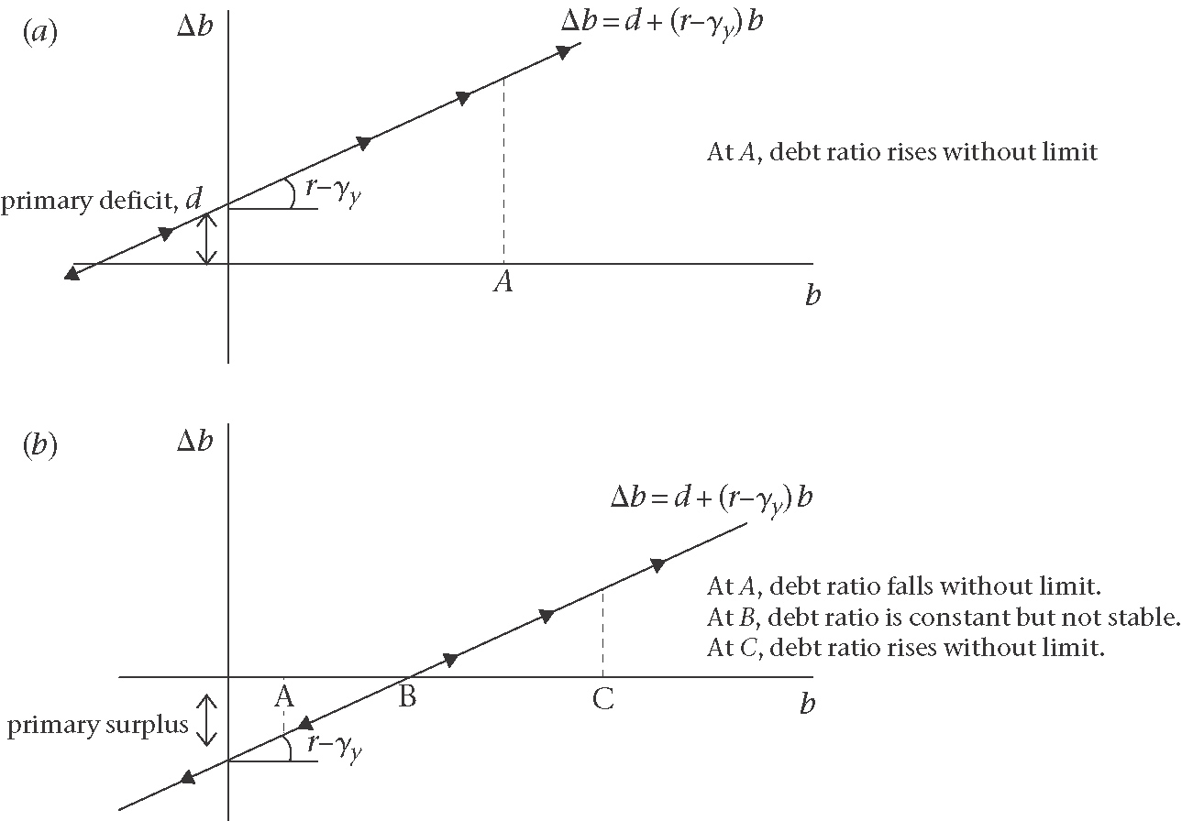

Figure 6.3: The government debt ratio. Case 2: Growth rates exceeds the real interest rate

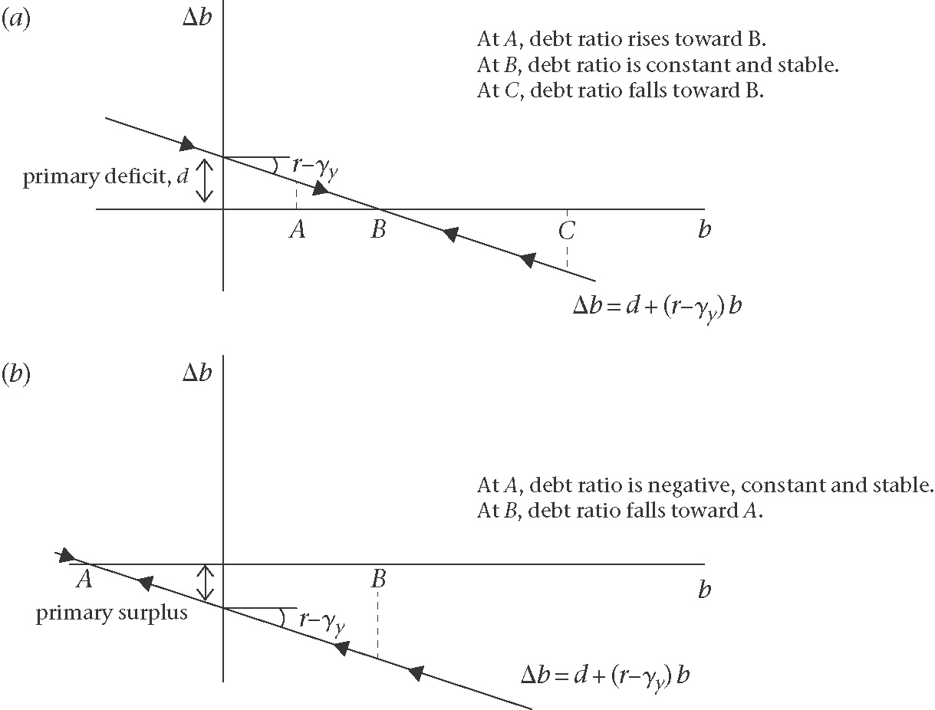

Figure 6.4: Switch from the situation where the growth rate is greater than the real interest rate to the growth rate less than the real interest rate
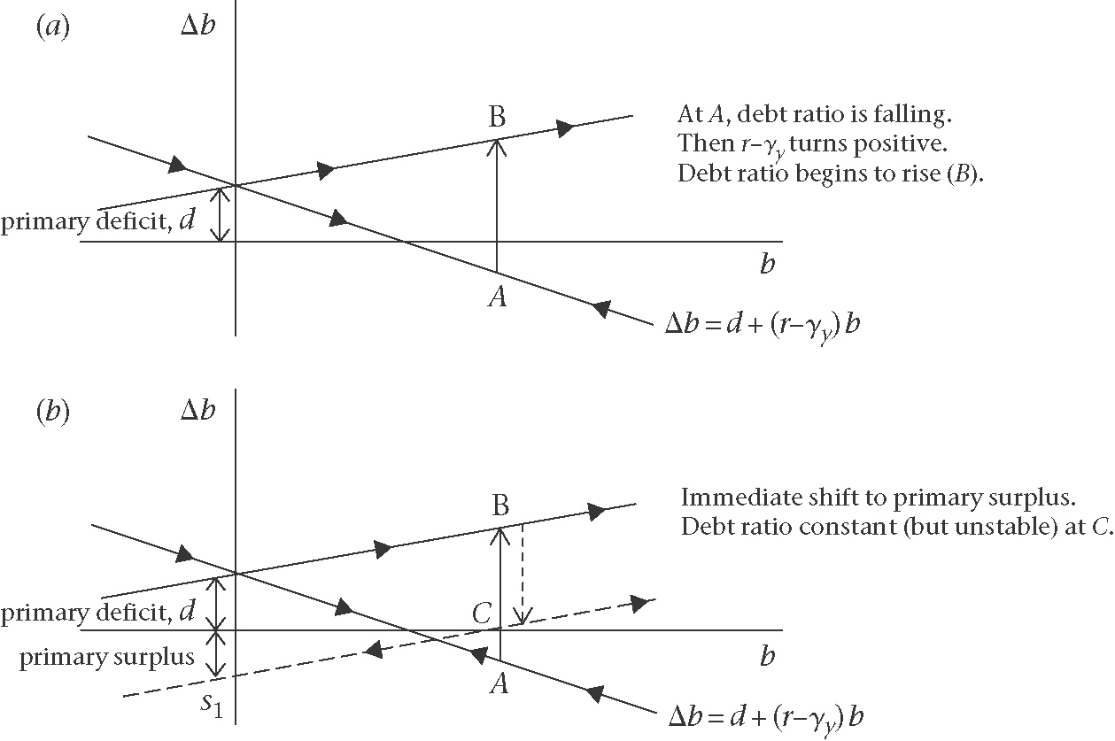

The cost of high and rising government debt
The cost of public debt differs according to whether the interest rate is higher or lower than the growth rate. If the growth rate is higher than the interest rate, then the economy is converging to a stable debt ratio-there is no problem with solvency.
The problematic situation is one which the real interest rate exceeds the growth rate.
The government’s intertemporal budget identity can also be interpreted as its solvency constraint and as the requirement for the absence of a default risk on its debt.
Since, $Δb=d+\left(r−γ_{y}\right)b$
This implies that for $Δb≤0$
$$b≤\frac{−d}{r−γ_{y}}$$
i.e. $\frac{\text{debt}}{\text{GDP}}≤\frac{{\text{primarysurplus}}/{\text{GDP}}}{\left(r−γ_{h}\right)}$
The costs of fiscal consolidation: cold turkey versus gradualism

Figure 6.5: Comparison between ‘cold turkey’ and ‘gradualist’ strategies to reduce government debt
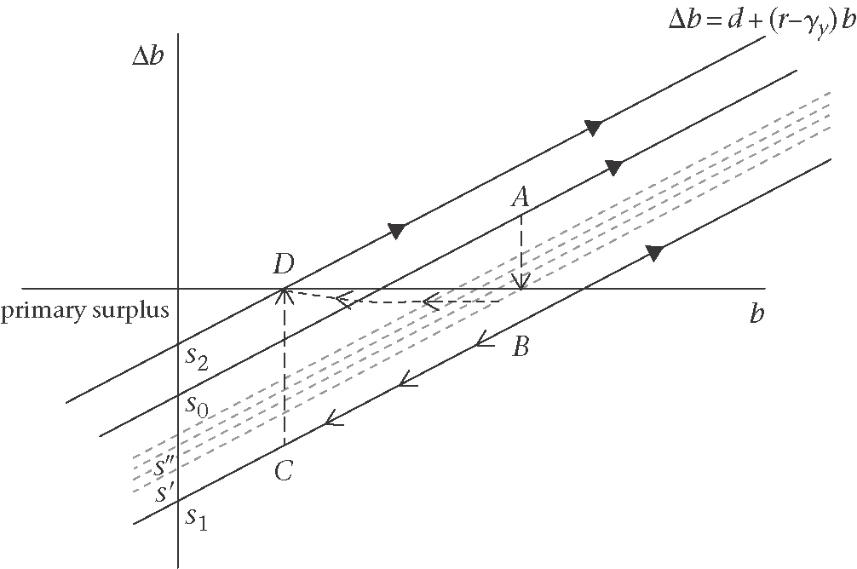

6.5 Monetizing the debt: seignorage and hyperinflation
The government’s budget constrainst in which the use of HPM is an alternative source of finance to bond:
$\underset{\text{govt}\text{.}\text{exp}}{\underbrace{G}}+\underset{\text{int}\text{.}\text{payments}}{\underbrace{\text{iB}}}=\underset{\text{taxrev}}{\underbrace{T}}+\underset{\text{newbonds}}{\underbrace{ΔB}}+\underset{\text{newHPM}}{\underbrace{ΔH}}$
Where, H is high-powered money, and broad money, M: $M=κH$, where $κ\left(\text{kappa}\right)$ is the banking (monetary base) multiplier.
$$ΔB=(G−T)+\text{iB}−ΔH$$
and dividing through by nominal GDP, we have:

$$\frac{ΔB}{\text{Py}}=\frac{G−T}{\text{Py}}+\frac{\text{iB}}{\text{Py}}−\frac{ΔH}{\text{Py}}$$
$=d+\text{ib}−\frac{ΔH}{H}\text{.}\frac{H}{\text{Py}}$
$=d+\text{ib}−γ_{H}h$
Where, $γ_{H}$ is the growth rate of high powers money, and $h$ is the ratio of HPM to nominal GDP $\left(\frac{H}{\text{Py}}\right)$. Following the same steps as in Section 3, the expression for the change in the debt ratio:
$Δb=d+\left(i−π−γ_{y}\right)b−γ_{H}h$
$=d+\left(r−γ_{y}\right)b−γ_{H}h$
The equation show that the growth of the debt to GDP ratio will be reduced to the extent that the deficit is being financed by new money creation.
In the medium-run equilibrium, by assuming the banking multiplier $κ\left(\text{kappa}\right)$ is constant, thus:
$$γ_{M}=γ_{H}=π$$

Higher inflation will reduce the growth of the debt ratio - assuming that $h$ remains constant. This led to use of the term inflation tax to refer to this method of financing government expenditure. It closely related term seignorage revenue, which is used to refer to the amount of real expenditure the G is able to finance through its ability to create HPM.
Thus, seignorage revenue is:
$$s=\frac{ΔH}{P}$$
$$=\frac{ΔH}{H}\text{.}\frac{H}{P}$$
$=γ_{H}\text{.}\frac{H}{P}$
In medium-run, equilibrium, $S=π\text{.}\frac{H}{P}$

As a proportion of real GDP, seinorage is:
$$\frac{S}{y}=γ_{H}\text{.}h$$

The G can finance more of its expenditure through seignorage by raising the growth rate of the money supply and hence by raising inflation. However, there is a limit to the extent to which seignorage can be used as a source of revenue (and as a method of reducing the debt ratio). This limit arises because as P goes up, the public becomes less willing to hold money.
Recall the condition for the equilibrium in the money market:

Money supply = money demand
${\left(\frac{M}{P}\right)}^{s}={\left(\frac{M}{P}\right)}^{d}$
$=L\left(i,y\right)$
$=L\left(r+π,y\right)$
The demand for money into seinorage expressions is:
$S=π\text{.}\frac{H}{P}$
$=π\text{.}\frac{M}{P}\text{.}\frac{1}{κ}$

6.6 Fiscal policy rules
(a) From budget constraint to prudent fiscal policy rule (PFPR)

$$Δb=d+\left(r−γ_{y}\right)b$$
$=\left(g/y−t/y\right)+\left(r−γ_{y}\right)b$ *
$$Δb=d+\left(i−π−γ_{y}\right)b$$
$=\left(d+\text{ib}\right)−\left(π+γ_{y}\right)b$ **
Equation ** can be rewritten in terms of the actual deficit as:
$\frac{\text{deficit}}{\text{GDP}}=\left(d+\text{ib}\right)=Δb+\left(π+γ_{y}\right)b$
Deriving a rule for prudent FP begins from the condition $Δb≤0$ for the debt ratio not to increase. This implied that:
$b≤\frac{{\left(t/y\right)}^{p}−{\left(g/y\right)}^{p}}{r^{p}−γ_{y}^{p}}$ ***
Where, $p$ refers to the long-run or permanent value. Let us assume that there is a given public expenditure programme that entails a long-run ratio G exp. to GDP, ${\left(g/y\right)}^{p}$. The question is how should this best be financed? For the debt ratio not to increase, rewriting equation *** , implies:
$${\left(t/y\right)}^{p}≥{\left(g/y\right)}^{p}+\left(r^{p}−γ_{y}^{p}\right)b$$

A prudent fiscal rule is to set the share of tax in GDP at a constant level equal to the ‘permanent’ or long-run level required to satisfy the constraint:
$\left({\bar{t}}/{\bar{y}}\right)={\left(t/y\right)}^{p}≥{\left(g/y\right)}^{p}+\left(r^{p}−γ_{y}^{p}\right)b$ (Prudent Fiscal Policy Rule-PFPR)
By substituting the PFPR into * implies that the debt ratio moves as follows:

$Δb≤\left[g/y−{\left(g/y\right)}^{p}\right]+\left[\left(r−r^{p}\right)−\left(γ_{y}−γ_{y}^{p}\right)\right]b$ ****

(b) How the PFPR deals with stabilization and structural problems
(c) Comparing existing fiscal rules with the PFPR

