`LECTURE 7 : CONSUMPTION

7.1 Introduction
- In a simple linear Keynesian consumption function, consumption depends on current income. Two types of consumption which is; autonomous consumption, and induced consumption (increase linearly with income with a MPC less than one).
- The MPC is related to the multiplier process through which AD shocks or changes in G are transmitted to the level of Y and E in the short run (ex: closed and open-economy multiplier).
- Consumption functions can be derived from the analysis of the optimizing behavior of H.
- Assumptions:
(i)People prefer a smooth pattern of consumption to one that jumps about from year to year
(ii)They are very far-sighted and have clear vision in the sense that there is no uncertainty about their future prospects
(iii)They are able to borrow on the same terms that they can lend
- Thus, the individual will be able to maximize the utility and enjoy a smooth flow of consumption over her life, which is refer to ‘lifetime’ or ‘permanent’ consumption.
- Individual also will save so as to repay the early accumulation of debt and to fund the continuation of the lifetime consumption level after retirement.
- Interest in consumption behavior has sharpened in recent years because of strong swing in consumer spending as a share of disposable income in a number of countries. Ex( US, UK). The savings ratio in both US and UK fell to historically low levels at the turn of the twenty-first century. [consumption led growth]

7.2 Introducing intertemporal smoothing in consumption model
Consumption refers to spending by the H sector on durable and non-durable goods and services.
The Keynesian consumption functions:
$$c=\bar{c}+c_{y}\left(y−t\right)$$
Two important things:
(i)Aggregate consumption is volatile rather than smooth because any changes in current income is reflected in a change in C
(ii)There is no difference between the effect on C of transitory changes in personal income and permanent changes. In the simple Keynesian model, the change in C is predicted by the change in measured income irrespective of whether it is expected to be temporary or permanent.
The Keynesian model seems to be extreme for three reasons:
(i)The preferences of consumer
(ii)Relates to the ability of people to look ahead and form view about their future income prospects
(iii)Hinge on the ability of people to borrow

Two alternatives views of consumption taking these factors;
(i)Permanent income hypothesis (PIH) by Milton Friedman in 1957
(ii)Life-cycle hypothesis (LCH) by Franco Modigliani and Richard Brumberg in 1954.
They suggested that C was a function not of measured income as in Keynesian but of average or expected income or of the value of lifetime resources.

Life cycle hypothesis (LCH)
Most people’s adult lives their incomes will follow a reasonably predictable pattern.
Life cycle : $\text{young}⇒\text{middle}$ $\text{age}$ $⇒\text{old}$ $\text{age}$
People use their ability to borrow and save to smooth consumption. When they are young they borrow (mortgages or car loans), and pay off these debts as their income rises. At middle-aged, they save money which they then use to support for retirement. Thus, this consumption smoothing is not predicted by the Keynesian consumption function.

Permanent income hypothesis (PIH)
PIH also focuses on consumption smoothing.
If income falls in a recession, it is not necessarily expect consumption to fall along with it, unless people’s expectation of ongoing future income have fallen as well. On the other hand, even if income does not change, if something happens to change people’s expectations about future wages, we would expect that consumption to change.
The discovery of any new information which leads to a changed assessment of permanent income can lead to a change in C:
$\text{news}→Δ\text{permanent}$ $\text{income}→Δ\text{consumption}$

Ricardian Equivalence
If the economy exhibits Ricardian equivalence, then that simply means that any change in $\left(g−t\right)$ will exactly mathched by an equal and opposite change in $c_{0}$.
$−{Δc}_{0}=Δ\left(g−t\right)$ [Ricardian equivalence in IS]

7.3 Consumer Preferences, income, and interest rates
7.3.1 Consumption and income: current, future, transitory, permanent
The basic ideas of the PIH can be explained using a two-period model. We assumed that H live for two periods only and that they enter the world with no wealth and leave it with no wealth (no bequest).
This idea allowed the H to smooth consumption pattern over two periods in which represented in H indifference curves.

Explanation of Figure 7.1
In Figure 7.1(a), both consumption this period and next period contribute to utility so that H will prefer to be on an indifference curve further from the origin. The indifference curves are convex to the origin, which reflects the preference for smooth consumption over the lifetime.
H is equally happy at points C and D on U₁. But, at point E with more balanced consumption pattern across two periods, the utility is higher (U₂) - the H is on a higher indifference curve.

In Figure 7.1(b), it shows the relationship between the household’s income in each period, the choices for consumption available to it in each period and the real interest rates. Labour income in each period is y₁ and y₂, and consumption in each period is c₁ and c₂. The real interest rate is r.
If wealth is zero at the start and the finish, the value today of lifetime consumption must be equal to the value today of lifetime income. If income in period two is not known, then y₂ is expected income. Thus, the intertemporal budget constraint is:
$c_{1}+\frac{c_{2}}{1+r}=y_{1}+\frac{y_{2}}{1+r}$ (present value of lifetime consumption = present value of lifetime income)
Figure 7.1(c) combines the indifference curves with the budget constraint. The H maximizes its utility by choosing a smooth pattern of C over the two periods at point F

Figure 7.1: Consumption in two-period model

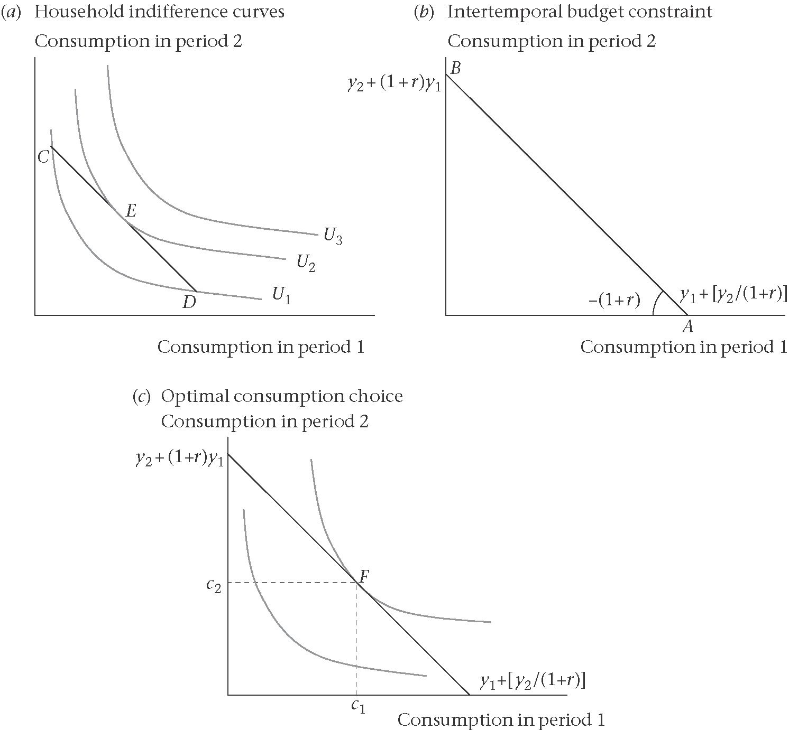

Figure 7.2: Consumption in a two-period model: the timing of income and consumption
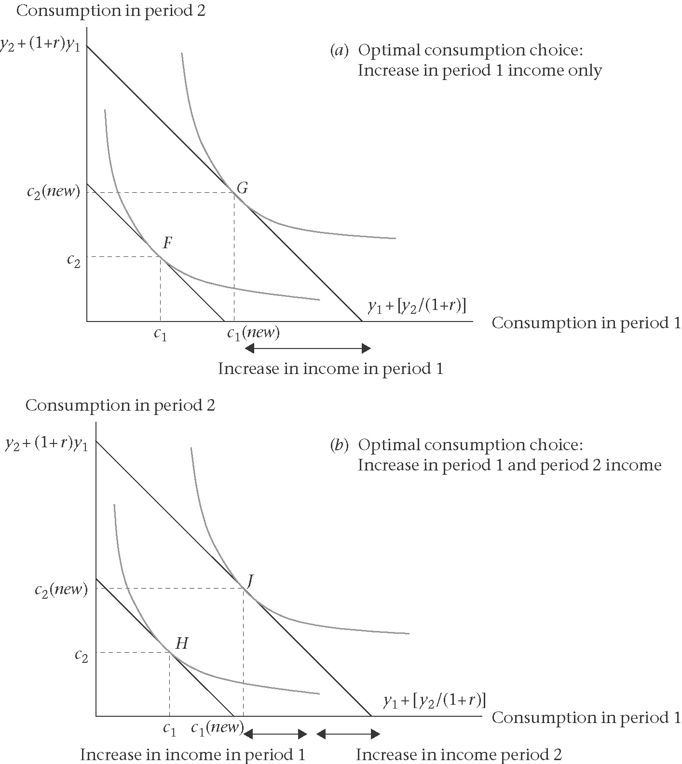

Figure 7.2(a) explores the implications of a rise in income in the first period only. A rise in period 1 income is depicted by an outward shift in the budget constraint.
Figure 7.2(b) shows a rise in income in both period one and period. Consumption in each period will rise by the average increase in income.
7.3.2 Consumption and interest rates
A change in the r will be reflected in a change in the slope. The budget constraint will swivel in a clockwise direction about the existing income endowment (point F in Figure 7.3) because higher r reduces the present value of period two income bringing the budget constraint closer to the origin along the horizontal axis and raises the value in period two of period one income.

Figure 7.3: Consumption in a two-period model: a rise in the interest rate
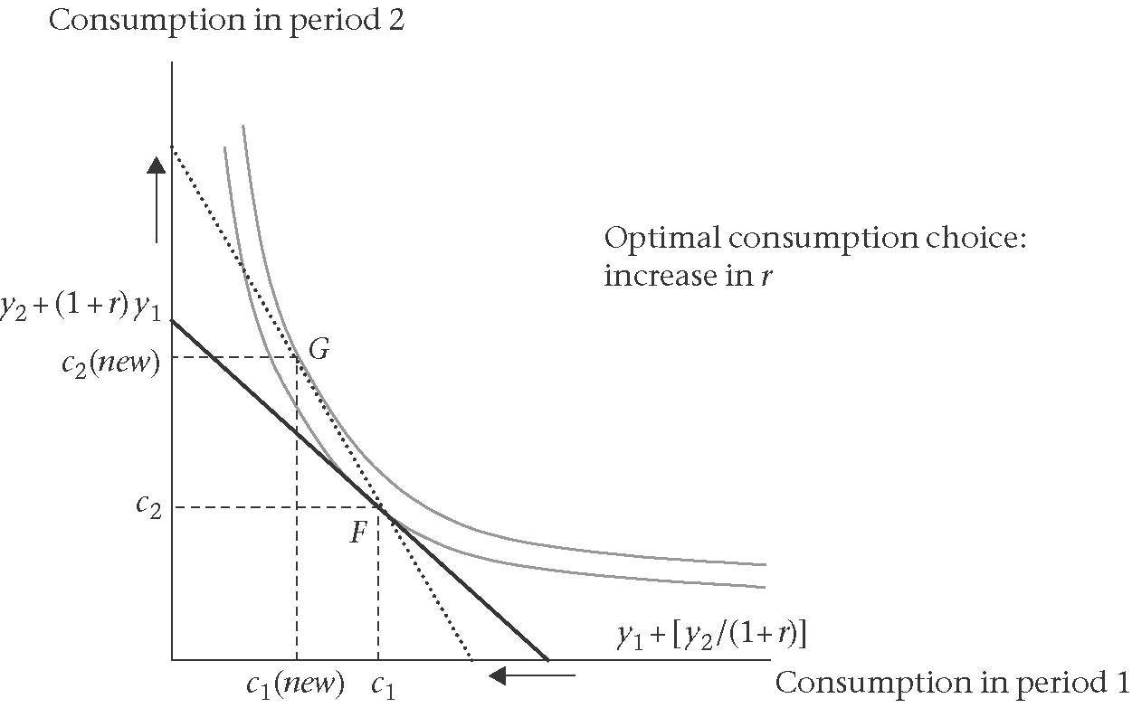

7.4 Modelling the Permanent Income Hypothesis
Consider a representative individual who faces no uncertainty, and whose utility in any period t depends solely on her consumption in that period. Her utility is given as:
$$u\left(c_{t}\right)=\text{ln}c_{t}$$
Suppose that the individual lives for T periods. Also assume that the real interest rate is zero, and individual is not impatient. Thus, her lifetime utility is just the sum of her utility from consumption in each of those T periods:
$$U=\sum_{t=1}^{T}{\text{ln}}c_{t}$$
Next, suppose the individual is not allowed to die in debt nor to leave any bequest, so that the present value of her lifetime consumption is equal to the sum of the initial wealth (A₀) plus the total lifetime income:
$$\sum_{t=1}^{T}{c_{t}}=A_{0}+\sum_{t=1}^{T}{y_{t}}$$
For the consumption path to be ideal (maximizing total lifetime utility), for any period t, the individual need to decrease consumption marginally in that period, and increase it in the following period, so that should have no effect on total lifetime utility. Since the marginal utilities of consumption in period t is 1/(c_{t}) and period t+1 is 1/(c_{t+1}), the condition for an optimum is:
$$\frac{1}{c_{t}}−\frac{1}{c_{t+1}}=0$$

Which can be rearranged to obtain
$c_{t+1}=c_{t}=a$ constant

This indicates that, the representative individual consumes exactly the same in every period, regardless of when she receives her income.

7.5 Adding interest rates and time preferences

Suppose we now assume that our individual is impatient and that real interest rates are non-zero. Then our individual, who lives for $T$ periods, has lifetime utility given by:

$$U=\sum_{t=0}^{T}{\frac{1}{{\left(1+ρ\right)}^{t}}}\text{ln}c_{t}$$
Where, $ρ$ is her rate of time preference (a measure of her impatience)
We still assume that the individual is not allowed to die in debt nor to leave bequests, so that the present value of her total lifetime consumption is equal to the sum of her initial wealth $\left(A_{0}\right)$plus the present value of her lifetime labour income:

$$\sum_{t=0}^{T}{\frac{1}{{\left(1+r\right)}^{t}}}c_{t}=A_{0}+\sum_{t=0}^{T}{\frac{1}{{\left(1+r\right)}^{t}}}y_{t}$$
Assuming a constant real interest rate $r$.

Since the marginal utilities of consumption in $t$ and $t+1$ are $\frac{1}{\left[{\left(1+ρ\right)}^{t}c_{t}\right]}$, and $\frac{1}{\left[{\left(1+ρ\right)}^{t+1}c_{t+1}\right]}$, this condition for an optimum is:

$\frac{1}{{\left(1+ρ\right)}^{t}c_{t}}−\frac{1+r}{{\left(1+ρ\right)}^{t+1}c_{t+1}}=0$, which can be rearranged to obtain

$$\frac{c_{t+1}}{c_{t}}=\frac{1+r}{1+ρ}$$
By subtracting $\frac{c_{t}}{c_{t}}=1$, from each side, this can also be written in terms of changes as:
$\frac{Δc}{c}=\frac{r−ρ}{1+ρ}$ [discrete time Ramsey equation]

7.6 The optimal consumption path
An individual allocating her consumption efficiently between periods will need to be indifferent as to whether she takes any unit of consumption in period t or period t+1. Thus, a simple model of optimal consumption suggest that along the optimal consumption path;
$\frac{Δc}{c}=\frac{r−ρ}{1+ρ}$ [discrete time Ramsey equation]
The ‘objective’ the rate of interest (r), is the increase in C that we get next period if we forgo one unit of consumption this period.
The ‘subjective’ rate of time preference $\left(ρ\right)$ is the extra that you would be prepared to pay now to bring forward a unit of consumption to the present period from the next period.
If $r>ρ$, it is worth-while for individual to consume less at time t so as to consume more at t+1.

The path of consumption over lifetime will then just depend on the individual’s rate of time preference, $\left(ρ\right)$, and the present value of their wealth, $Ψ_{t}$:
$c_{t}={ρΨ}_{t}$ [Ramsey consumption function]
$Ψ_{t}$ (called psi ‘sigh’) is the sum of the value of non-human wealth (NHW) and the present value of human wealth (HW) (labour income over the remaining lifetime discounted at the interest rate, r)
$Ψ_{t}={\text{NHW}}_{t}+{\text{PV}}_{t}\left(\text{HW}\right)$
It is assume that an individual can always borrow at the prevailing interest rate, $r$, in order to implement their lifetime consumption plan.

It is useful to write this expression in a slightly difference way:
$$c_{t}=\left(r+ρ−r\right)Ψ_{t}$$
$\underset{\text{permanentincome}}{\underbrace{{rΨ}_{t}}}+\left(ρ−r\right)Ψ_{t}$
The term $rΨ$ is known as ‘permanent income’ because it is the amount that can be consumed whilst leaving the value of wealth unchanged.

Thus, Ramsey consumption function ties up with the Ramsey equation, and with the PIH.
If $ρ=r$, then consumption in the current year and every subsequent period is equal to permanent income. This is in line with the Ramsey equation for $ρ=r$ since consumption is constant (i.e. $Δcc=0$.
If $ρ≠r$, the individual either consuming now at a level above or below their ‘permanent income’, and hence consumption is either falling or rising.
Example: If $ρ>r$; the C function tells us that, the C this period is equal to permanent income plus an extra bit representing consumption out of wealth. By shifting some C from the future to the current period, the individual will have a decline in C in the future. From the Ramsey equation; if $ρ>r$ then $Δcc<0$.
If $ρ=r$, we have the prediction of constant consumption over the lifetime. In simple PIH: consuming one’s permanent income is consistent with intertemporal utility maximization if the interest rate and the rate of time preference coincide. Thus,
$c_{t}={rΨ}_{t}$ [PIH consumption function]
$=$ permanent income

7.7 Consumption as a ‘random walk’
Friedman basic idea in the PIH stated that C was not driven by current income but rather by expected or average income. Permanent income was a weighted average of past income (backward-looking expectations hypothesis).
But if PIH is coupled with rational expectations hypothesis (was done by Robert Hall), then we get a dramatically different story. Ex: In every period the H incorporates into its C decision all of the information available about its permanent income, and its desired level of C is constant.
Thus, apart from random error, C next period would be expected to be just the same as C this period:
$$c_{t+1}=c_{t}+ε_{t+1}$$
$\text{news}→Δ\text{permanent}$ $\text{income}→Δ\text{consumption}$

7.7.1 The Hall (1978) result
Consider the following utility function:
$$u\left(c_{t}\right)={\text{ac}}_{t}−\frac{b}{2}c_{t}^{2}$$
Two implications from this utility function: (1)the coefficient on $c^{2}$ must be negative for C smoothing to be desirable, and (2)we have switched from the log utility function to the quadratic because for C to follow a random walk, quadratic utility function is necessary.
Thus, the representative individual maximize her expected lifetime utility as indicated by the presence of the expectation operator, $E$, which has the subscript zero to indicate that the expectations are formed at time zero:
$$U=E_{0}\left[\sum_{t=1}^{T}{\frac{1}{{\left(1+ρ\right)}^{t}}\left({\text{ac}}_{t}−\frac{b}{2}c_{t}^{2}\right)}\right]$$
The lifetime resource constraint this time is given by:
$$E_{0}\left[\sum_{t=1}^{T}{\frac{1}{{\left(1+r\right)}^{t}}c_{t}}\right]=E_{0}\left[A_{0}+\sum_{t=1}^{T}{\frac{1}{{\left(1+r\right)}^{t}}y_{t}}\right]$$
The individual will only be at an optimum when, in any period, she should not change her expected utility by reducing her consumption in $t$ a little and instead consume $\left(1+r\right)$ times as much in period $t+1\text{.}$ In this case, the marginal utilities are $\left(a−{\text{bc}}_{t}\right)/{\left(1+ρ\right)}^{t}$, and $\left[a−\text{bE}\left(c_{t+1}\right)\right]/{\left(1+ρ\right)}^{t+1}$, so the condition for an optimum is:
$$\frac{\left(a−{\text{bc}}_{t}\right)}{{\left(1+ρ\right)}^{t}}−\frac{\left[a−\text{bE}\left(c_{t+1}\right)\right]\left(1+r\right)}{{\left(1+ρ\right)}^{t+1}}=0$$
Which may be rearranged to give:
$$E\left(c_{t+1}\right)=\frac{a}{b}\frac{\left(r−ρ\right)}{\left(1+ρ\right)}+c_{t}\frac{\left(1+ρ\right)}{\left(1+r\right)}$$
From the definition of an expected value, this can be written equivalently as:
$c_{t+1}=\frac{a}{b}\frac{\left(r−ρ\right)}{\left(1+ρ\right)}+c_{t}\frac{\left(1+ρ\right)}{\left(1+r\right)}+ε_{t+1}$
Where, $E\left(ε_{t+1}\right)=0$. For the special case, where the interest rate equals the rate of time preference, $\left(i\text{.}e\text{.}\text{.}r=ρ\right)$, this simplifies to;
$c_{t+1}=c_{t}+ε_{t+1}$ [the Hall equation]
This says that consumption follows a random walk, changing only subject to random shocks. Thus, under these assumptions,
$$ε_{t+1}=E_{t+1}\bar{y}−E_{t}\bar{y}$$
Where, $\bar{y}$ is simply the expected value of average future income per period. Thus, the Hall results says that consumption will only change between periods if expectations of future income change, and then the change in consumption will be equal to the change in future average income.

7.8 Empirical consumption functions

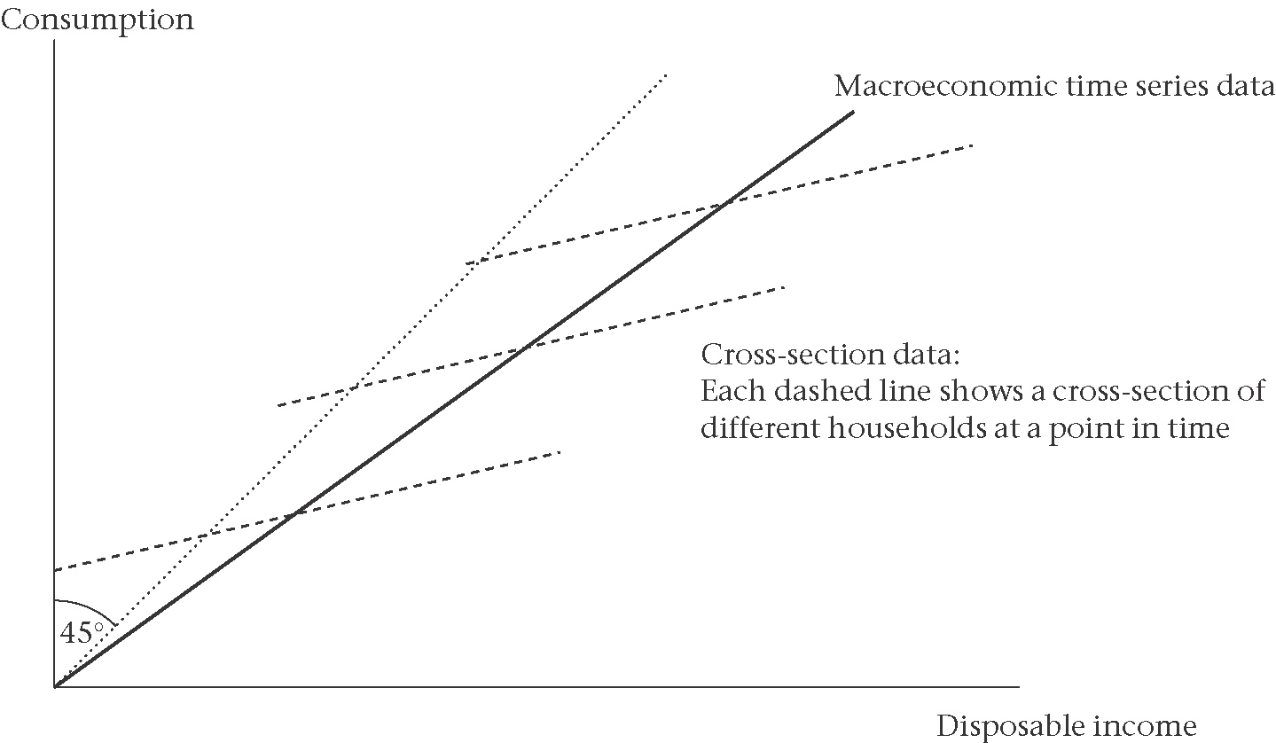

7.8.1 Aggregate data
7.8.2 Microeconomic data

7.9 Rational consumption and the IS equation
7.9.1 Uncertainty and precautionary savings

7.9.2 Limits to borrowing: liquidity constraints

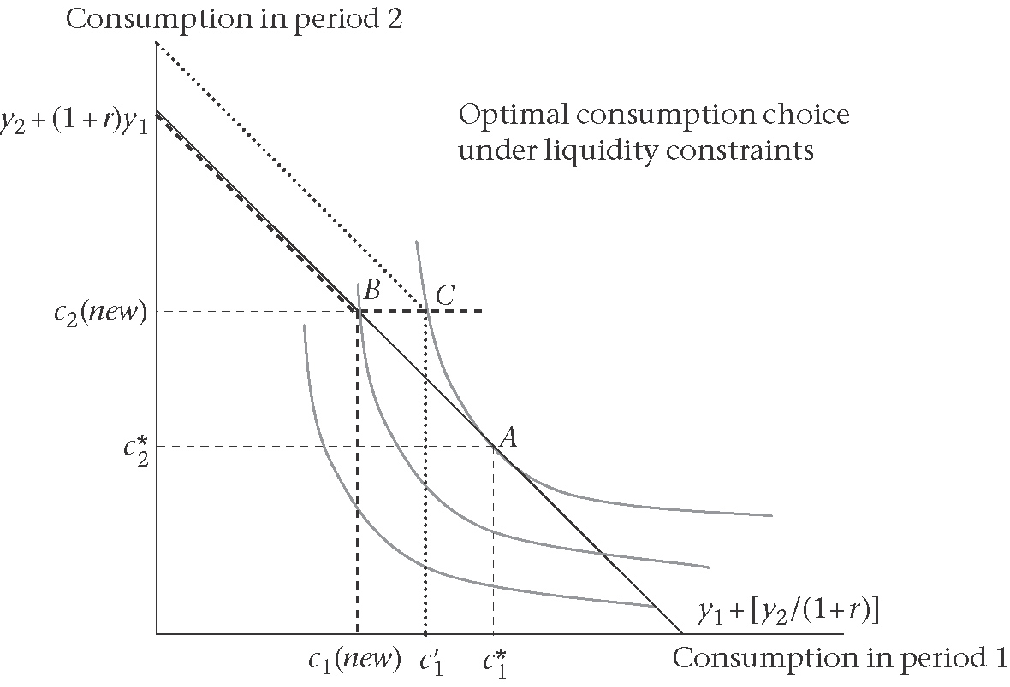

7.10 Estimating an aggregate consumption function

The estimated aggregate consumption function shows the role of life-cycle, precautionary, and credit constraint factors:
$$c=c\left[y,r,Δu,{\left(\frac{Δy}{y}\right)}^{E},Ψ\right]$$

