LECTURE 8: INVESTMENT
8.1 Introduction
- Investment (fixed capital formation) means expenditure on man-made aids to production such as plant and machinery, dwellings and other buildings, and infrastructure such as roads - capital expenditure.
- Investment is a flow concept that measures such expenditure over a period of time (such as a year).
- In contrast, capital stock is the value of the stock of plant, machinery etc., and reflects investment spending over many previous periods.
- Two main reasons for studying investment. First, the combinations of firms’ investment demand and household saving supply determines how much of an economy’s output in invested (thus, investment demand is potentially important to the behavior of standard of living over LR. Second, investment is highly volatile; thus investment demand may be important to short-run fluctuations.

8.2 Investment in the theory of the firm
Firms aim to maximize profits, so they undertake the project is the return higher than costs. The slight complication here is that the outlay on investment typically precedes the return, which may be lumpy and spread over a number of years. Thus, need to calculate the ‘Present Value’ (V) of the expected flow of profits, $\left(Π\right)$, where $Π_{1},Π_{2},\text{.}\text{.}\text{.}\text{.}$ is the flow of profits in period 1, etc…
By assuming the interest rates are constant at $r$, the value of $X$ in years’ time is the same as that of $X/{\left(1+r\right)}^{n}$ today. Thus, the present value of our stream of expected profit, $Π$, from an investment project by:
$$V=\frac{Π_{1}}{\left(1+r_{1}\right)}+\frac{Π_{2}}{\left(1+r_{1}\right)\left(1+r_{2}\right)}+\text{.}\text{.}\text{.}\text{.}\text{.}=\sum_{t=1}^{T}{\frac{Π_{t}}{R_{t}}}$$
Where $R_{t}=\left(1+r_{1}\right)\left(1+r_{2}\right)\text{.}\text{.}\text{.}\text{.}\text{.}\left(1+r_{t}\right)$, where the interest rate can vary over time.
Firm decisions
(i)If the cost > PV of the flow profits from the machine, not to buy the machine but instead put the money in the bank or in bonds.
(ii)If the PV of the profit > the cost, then the investment is profitable.
There are two important components drive investment:
(i)If expected future profitability rises, then expected net returns $Π$ will rise. More I project will become viable, more I to take place (IS curve shift to the right).
(ii)It the real interest rate rise, then the PV of all investment projects falls; I will fall (movement in a north-westerly direction along the IS curve).

8.3 A simple model of investment
Net investment is equal to the change in the capital stock, $K$:
$$I_{t}=K_{t}−K_{t−1}$$

Figure 8.1: Optimal capital stock: a rise in the interest rate
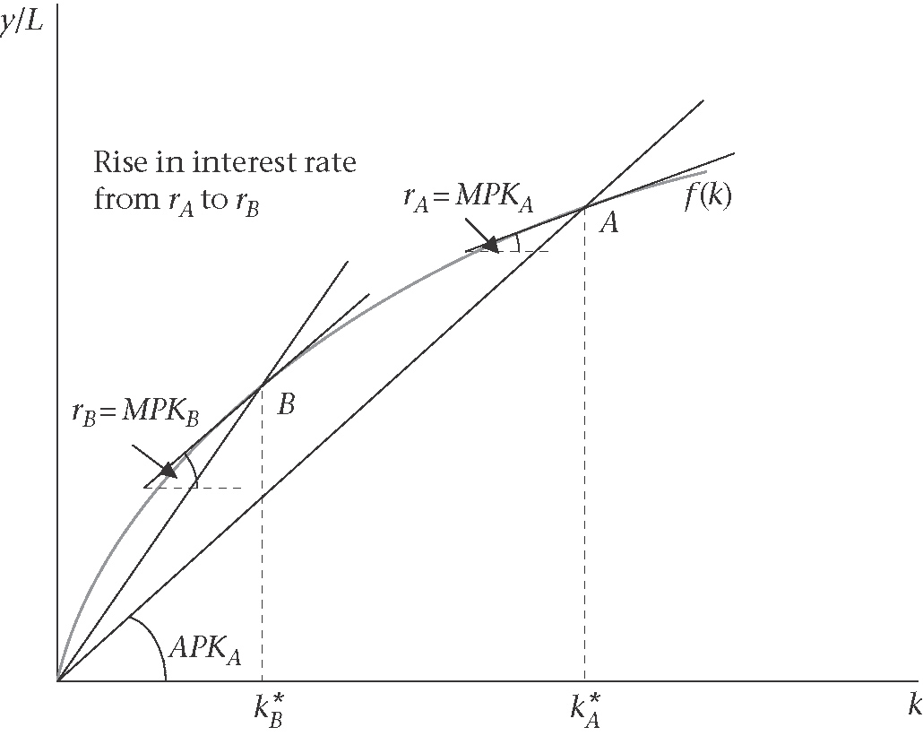
Suppose there is a desired capital stock at any moment of time, $K_{t}^{}$. Because of costs of adjusting from the existing to the desired capital stock, a simple assumption is that investment makes up each period some proportion, $α<1$, of the difference between the two:
$$I_{t}=α\left(K_{t}^{}−K_{t−1}\right)$$
The production function linking capital and labour to output;
$y=F\left(K,L\right)$ is concave (diminishing return to capital)
By dividing each side of production by $L$; $yL=F\left(KL,1\right)=f(k)$, where $k=KL$
The profit-maximizing firm will choose the capital stock such that the marginal product of capital is equal to the real interest rates: $\text{MPK}=f^{'}\left(k\right)=r$. An increase in r implies a lower desired capital stock. Moving from point A to point B is associated with a rise in the MPK and APK.

This can be written;
$${\left(\frac{K_{t}}{y_{t}}\right)}^{}=ν\left(r_{t}\right)$$
$⇒K_{t}^{}=ν\left(r_{t}\right)y_{t}$

Where, $ν$ is the capital to output ratio, and $ν^{'}\left(r\right)<0$. If the level of output (y) is not fully known at the time investment decisions are made, then it is plausible to assume that:
$K_{t}^{}=ν\left(r_{t}\right)y_{t}^{E}$, where $y^{E}$ is the expected level of output. Thus, putting the last two equations together, we have:
$$I_{t}=α\left(K_{t}^{}−K_{t−1}\right)$$
$=α\left[ν\left(r_{t}\right)y_{t}^{E}−K_{t−1}\right]$
This illustrates, how investment is a function of the r via its role in determining the desired capital stock.
Two more assumptions need to derive the simple accelerator model.
(i)Assuming $α=1$, so that investment (I), fully make up the difference between $K^{}$ and $K$ each period.
(ii)Capital output ratio is constant, so $ν\left(r_{t}\right)=\bar{ν}$.

With two assumptions, we have:
$$I_{t}=K_{t}^{}−K_{t−1}^{}$$
$\bar{ν}\left[y_{t}^{E}−y_{t−1}^{E}\right]$ [accelerator investment function]
Investment in period t is completely determined by the constant capital output ratio, and by expected growth in output.

8.4 A more general approach to the investment function
Investment based on microfoundations concerned;
‘What is the profit stream derived from some particular level of the capital stock, (K), where K was brought in period t=0. To simplify, suppose no employment (labour) – output is produced simply using capital stock, so that $y=f(K)$, and there is no depreciation.
Thus, In any one period t, the profit function from $K$ is
$$\text{Pf}\left(K\right)$$
In order to calculate the PV of the stream of profits, starting from t=0, each period’s profit is discounted by the real rate of interest, ${\left(1+r\right)}^{t+1}$, so that the discounted PV is:
$$V_{0}=\frac{1}{\left(1+r\right)}\text{Pf}\left(K\right)+\frac{1}{{\left(1+r\right)}^{2}}\text{Pf}(K)+\frac{1}{{\left(1+r\right)}^{3}}\text{Pf}(K)+\text{.}\text{.}\text{.}\text{.}$$
$=\frac{\text{Pf}\left(K\right)}{r}$
If the cost of the investment is C(I), the firm chooses I to maximize $V_{0}−C(I)=\left[\text{Pf}{\left(K\right)}/r\right]−C(I)$, subject to the definition $I_{t}=K_{t}−K_{t−1}$.
That is, the firm chooses I to maximize;

$$\frac{\text{Pf}\left(I+K_{−1}\right)}{r}−C(I)$$
The character of the I function that can be derived from this maximization problems depends on the assumptions that are made. There are three assumptions;
(i)The distinction between perfect and imperfect competition market
(ii)The present or absence of the adjustment costs (relates to the cost of investment)
(iii)The efficiency of the market

8.4.1 Perfect competition, no adjustment costs, and an efficient capital market
P is taken constant, and since there are no adjustment costs, the only cost of investment is the cost of purchasing the capital goods: $C(I)=P_{I}I$. The net profit to the firm is equal to $V_{0}$ less the cost of investment, $P_{I}I$. So, in period t=0, the firm chooses investment (I) to maximize:
$$\frac{\text{Pf}\left(I+K_{−1}\right)}{r}−P_{I}I$$
$⇒\frac{Pf^{'}\left(K\right)}{r}−P_{I}=0$
$⇒\frac{Pf^{'}\left(K\right)}{{\text{rP}}_{I}}=1$
Where, $⇒\frac{Pf^{'}\left(K\right)}{{\text{rP}}_{I}}=q$ [definition of marginal q]

But this profit maximization condition still does not tell us how much investment should take place. Let us call $K^{}$ the optimal level of the capital stock. If we know the functional form of $f(K)$, the formula:
$$q\left(K^{}\right)=\frac{Pf^{'}\left(K^{}\right)}{{\text{rP}}_{I}}=1$$
Enables us to find $K^{}$ explicitly. The condition that $q=1$ implies that:
$$f^{'}\left(K^{}\right)=\frac{{\text{rP}}_{I}}{P}$$

To find $K^{}$ explicitly, let us take the example of a specific production function: $y=f(K)=K^{1/2}$. Thus,
$$f^{'}\left(K^{}\right)=0\text{.}5{\left(K^{}\right)}^{{−1}/2}={{\text{rP}}_{I}}/P$$
So, $K^{}=1/{{\left(2{{\text{rP}}_{I}}/P\right)}^{2}}$
Now, to see how much should be invested, we have investment (I);
$$I=K^{}−K_{−1}$$
$=1/{{\left(2{{\text{rP}}_{I}}/P\right)}^{2}}−K_{−1}$
More generally;

$$I=I\left(r,P_{I},P\right)$$

8.4.2 Perfect competition, an efficient capital market, depreciation and adjustment costs: Tobin’s Q model of investment

The cost of adjusting the capital stock (over and above the cost of purchasing the new capital goods, $\left(P_{I}I\right)$ can be thought of as including the costs of training workers to operate the new equipment and the disruption to current production caused by installing and testing new equipment. A simple model of adjustment costs is $\left(a/2\right)P_{I}I^{2}$. We therefore, have the cost of investment as follows:
$$C(I)=P_{I}I+\left(a/2\right)P_{I}I^{2}$$
Assume that K depreciates by $δ$each period, so that; $I_{t}=K_{t}−\left(1−δ\right)K_{t−1}$. The production functions is linear, so that $y=f_{K}K$, where $f_{K}$ is the constant marginal productivity of capital.

The firm chooses I to maximize:
$$\frac{{\text{Pf}}_{K}K}{1+r}+\frac{{\text{Pf}}_{K}K\left(1−δ\right)}{{\left(1+r\right)}^{2}}+\text{.}\text{.}\text{.}\text{.}\text{.}\text{.}\text{.}−P_{I}I+\left(a/2\right)P_{I}I^{2}=\frac{{\text{Pf}}_{K}\left[I+\left(1−δ\right)K_{−1}\right]}{r+δ}−P_{I}I+\left(a/2\right)P_{I}I^{2}$$
Which implies that

$$\frac{{\text{Pf}}_{K}}{r+δ}−P_{I}−{\text{aP}}_{I}I=0$$
$⇒\frac{Pf_{K}^{'}}{r+δ}=P_{I}\left(1+\text{aI}\right)$
$⇒I=\frac{1}{a}\left[\frac{Pf_{K}^{'}}{P_{I}\left(r+δ\right)}−1\right]$
Using the definition of ‘marginal q’ above now including depreciation, we have:
$I=\frac{1}{a}\left[q−1\right]$ (Tobin’s Q model)

Each factor that can influence the investment is:
(i)Adjustment costs
(ii)Value of the marginal product of capital
(iii)Price of capital goods
(iv)Real interest rate
(v)depreciation rate

$$q=\frac{Δ\text{MV}}{\text{RC}}$$
RC is the replacement cost of firms entire capital stock, which is the purchase of additional capital goods.

8.4.3 Imperfect competition, efficient capital markets, and no adjustment costs
Under imperfect competition, the P of the firm’s product is not fixed exogenously: Firms set prices so as to maximize their profits, and the P that they set will depend on the expected level of DD that they face. Thus, imperfectly competitive firms face downward-sloping DD curve.

Assume firms operate under conditions of monopolistic competition, and faces the demand curve as:
$$y_{i}=P_{i}^{−η}\left(A/n\right)$$
Where, A is aggregate demand, $η$ is the elasticity of demand, there are n sectors. Also assume that $y=f(K)=K\text{.}$
The discounted PV expression for firm i:
$$V_{0}=\frac{P_{i}f(K)}{\left(r+δ\right)}$$
The firm chooses investment to maximize:
$$\frac{P_{i}f(K)}{\left(r+δ\right)}−P_{I}I$$
So, the condition for profit maximization is:
$\frac{1}{r+δ}\frac{∂\left[P_{i}f\left(K\right)\right]}{∂I}−P_{I}=0$ [***]
We need to incorporate the imperfectly competitive setting by substituting for the firm’s price, $P_{i}$ in the maximizing condition, using the expression for the demand curve:
$$y_{i}=P_{i}^{−η}\left(A/n\right)$$
$$⇒P_{i}=y_{i}^{−\frac{1}{η}}{\left(A/n\right)}^{1/η}$$
We proceed in two steps, concentrating first on $∂\left[P_{i}f{\left(K\right)}/∂I\right]$:
$$\frac{∂\left[P_{i}f\left(K\right)\right]}{∂I}=\frac{∂}{∂I}\left[y_{i}^{−\frac{1}{η}}{\left(A/n\right)}^{1/η}K\right]$$
$=\frac{∂}{∂I}\left[K^{−\frac{1}{η}}{\left(A/n\right)}^{1/η}K\right]$
$=\frac{∂\left[K^{1−\frac{1}{η}}{\left(A/n\right)}^{1/η}\right]}{∂I}$
Starting from equation [***], we have:
$$\frac{1}{r+δ}\frac{∂\left[P_{i}f(K)\right]}{∂I}−P_{I}=\frac{(A/n)^{1/η}}{r+δ}\frac{η−1}{η}K^{−\frac{1}{η}}−P_{I}=0$$
$⇒K^{}={\left[\frac{\left(η−1\right)}{η\left(r+δ\right)P_{I}}\right]}^{η}\frac{A}{n}$
Linking this condition for the optimal capital stock, $K^{}$, with the investment definition and bearing in mind there are no costs of adjustment, we have:
$$I=K^{}−\left(1−δ\right)K_{−1}^{}$$
$=n^{−1}{\left[\frac{\left(η−1\right)}{η\left(r+δ\right)P_{I}}\right]}^{η}\left[A−\left(1−δ\right)A_{−1}\right]$

