LECTURE 9: THE OPEN ECONOMY IN THE SHORT RUN

1. OPENING THE GOOD MARKET

1.1 Goods market equilibrium
$y^{D}=y$ [goods market equilibrium]
$y^{D}=c(y,t,r,\text{wealth})+I(r,A)+g$ [planned expenditure-closed economy]
$\text{Abs}=c+I+g$ [domestic absorption]
$$y^{D}=(c+I+g)−m+x$$
$=\text{Abs}+(x−m)$
$=\text{Abs}+\text{BT}$ [planned expenditure- open economy]
$x=\bar{x}$
$m=m_{y}y$
$\text{BT}=x−m=\bar{x}−m_{y}y$
The level of income at which trade is balanced (BT=0) is:
$y_{\text{BT}}=\frac{1}{m_{y}}\bar{x}$
By assuming there is a linear tax function: $t=t_{y}y$, we have $c=c_{0}+c_{y}\left(y−t_{y}y\right)$. The equilibrium goods market conditions becomes:
$y=\text{Abs}+\text{BT}$
$=c_{0}+c_{y}\left(y−t_{y}y\right)+I+g+\bar{x}−m_{y}y$ {*}
By rearranging, the goods market equilibrium is:
$y=\frac{1}{s_{y}+c_{y}t_{y}+m_{y}}\left(c_{0}+I+g+\bar{x}\right)$ {**}
As compared with the closed economy, the multiplier $\frac{1}{s_{y}+c_{y}t_{y}+m_{y}}$ is lower because of the $m_{y}$.
If we multiply the left hand side of the goods market equilibrium condition by the denominator of the multiplier, we have:
$\left(s_{y}+c_{y}t_{y}+m_{y}\right)y=c_{0}+I+g+\bar{x}$ {***}

Figure 9.1: Equilibrium output (planned injections=planned leakages); balanced trade output
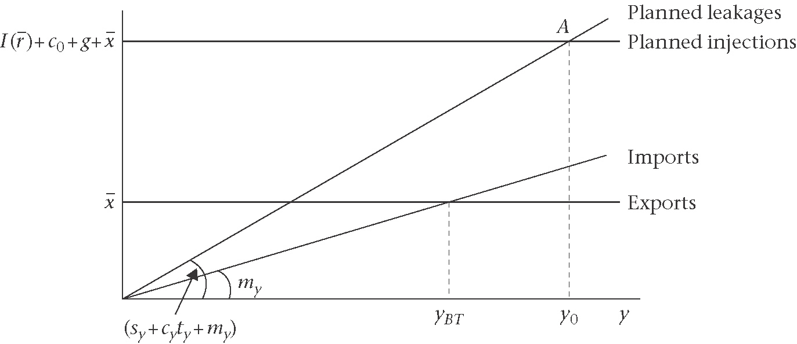

Figure 9.2: A rise in export improves the trade balanced
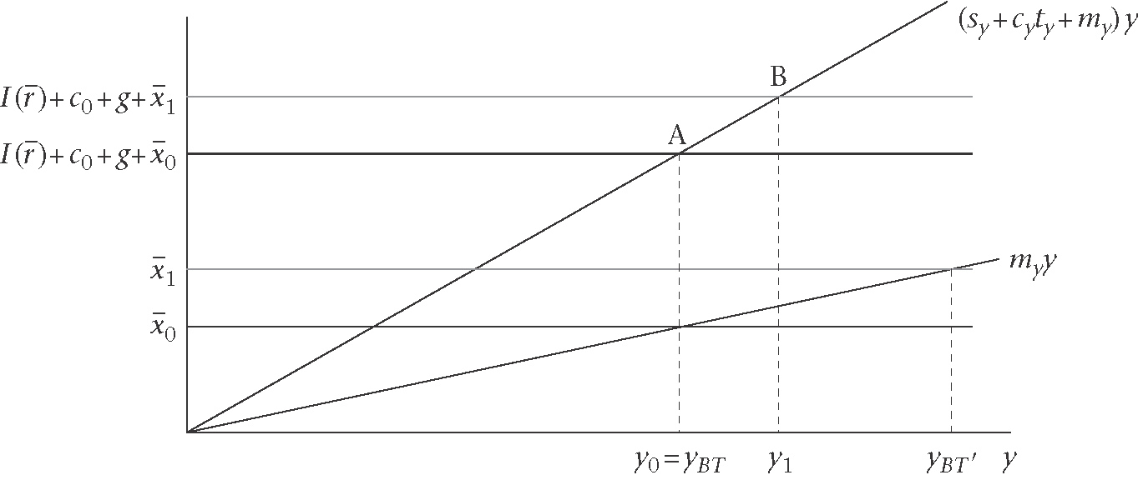
1.2 Sector financial balances
Three sectors balances are of interest:
- The private sector financial balance (private savings net of its investment)
- The G sector financial balance (taxation net of G expenditure)
- Trade balance (net investment abroad)

The Derivation
$$s_{y}y+c_{y}t_{y}y−c_{0}−I−g=\bar{x}−m_{y}y$$
$$s_{y}(y−t_{y}y)+s_{y}t_{y}y+c_{y}t_{y}y−c_{0}−I−g=\bar{x}−m_{y}y$$
$(s_{y}y^{\text{disp}}−c_{0}−I)+\left(t_{y}y−g\right)=\bar{x}−m_{y}y$ {****}
Where $y^{\text{disp}}=\left(1−t_{y}\right)y$.

1.3 Real and nominal exchange rate
$θ=\frac{P^{}e}{P}$ [price competitiveness, real exchange rate]
$P_{e}^{}$= price of foreign goods expressed in home currency (where, P* is the foreign price level; e is the nominal exchange rate). e = [no. units of home currency/one unit of foreign currency].
$P=$ price of home goods

1.4 Price setting in the open economy
One commonly used to measure of competitiveness is called relative unit labour costs or RULC.
RULC = [foreign unit labour costs expressed in home currency (ULC*e) /home unit labour costs (ULC)]

1.5 Evidence on international integration of good markets
$P_{j}=P_{j}^{}e$ [Law of one price]
$P_{j}=P_{j}^{}e$ for all goods j
$P=P^{}e$
$⇒θ=1$ [absolute purchasing power parity]

$P_{x}=P=\frac{1}{1−μ}⋅$unit cost [export price]
$P_{m}=P^{}e$ [import price]

1.6 Exports and imports: volume and price effects
$X=P_{x}X_{\text{volume}}$ [exports in nominal terms]
$=P_{X}×σ\left(\frac{P^{}e}{P}\right)×y^{}$
Where, $σ\left(\frac{P^{}e}{P}\right)$ is home’s share, and $y^{}$ is world output.

To get the export function in real terms, we divide each side by the domestic price level, P:

$x=σ\left(\frac{P^{}e}{P}\right)×y^{}$
$=σ\left(θ\right)×y^{}$ [export function]
The value of import M in home currency terms is the price index, $P_{m}=P^{}e$ times the volume of imports, $m_{\text{volume}}$. The volume depends on the MPI, which will be a negative function of competitiveness, and on the level of domestic output.

$M=P_{m}$ $m_{\text{volume}}$ [imports in nominal terms]
$=P_{m}$ $m_{y}\left(θ\right)$ $y$
Where, $m_{y}\left(θ\right)$ is marginal propensity to import; and $y$ is home output.

To derive the import function in real terms, we divide each side by $P$.

$m=\frac{P_{m}}{P}×$ $m_{y}\left(θ\right)×y$
$=\frac{P^{}e}{P}×m_{y}\left(θ\right)×y$
$=θ×m_{y}\left(θ\right)×y$ (import function)
This means that the balance of trade is:
$\text{BT}=σ\left(θ\right)×y^{}−θ×m_{y}\left(θ\right)×y$ (balance of trade)
$=x\left(θ,y^{}\right)−θ×m\left(θ,y\right)$
What determine the trade balance?

The relative price effect of a change in $θ$ is to use the concept of the terms of trade. The TOT is defined as the price of exports divided by the price of imports:
$\frac{P_{x}}{P_{m}}=\frac{P}{P^{}e}=\frac{1}{θ}$ [terms of trade]

1.7 Output and trade balance in the short run
The condition for goods market equilibrium in the open economy can be enriched by the new import and export functions in which import and export depend on the real exchange rate:
$$y=y^{D}$$
Where
$$y^{D}=c\left(y\right)+I\left(r\right)+g+x\left(θ,y^{}\right)−θm\left(θ,y\right)$$

In summary, aggregate demand for domestic output is:
$$y^{D}=f\left(y,r,θ,y^{}\right)$$

The open economy version of the IS curve : the ISXM

The equation for the ISXM curve is:
$y=\frac{1}{s_{y}+c_{y}t_{y}+{θm}_{y}\left(θ\right)}\left[c_{0}+I(r)+g+σ\left(θ\right)y^{}\right]$ [open economy ISXM]
The difference between the closed economy IS curve and the open economy ISLM curve highlighted by answer to the following questions:
(1)Why is the ISXM steeper than IS curve?
(2)How does the ISXM curve shift with a change in the real exchange rate?
(3)How does the ISXM curve shift with a change in world output, $y^{}$

The trade balance is:
$$\text{BT}=x−m$$
$=σ\left(θ\right)y^{}−{θm}_{y}\left(θ\right)y$
Then, the level of output at which trade is balanced, $y_{\text{BT}}$ as;
$y_{\text{BT}}=h\left(θ,y^{}\right)$ [$y_{\text{BT}}$ line]

Figure 9.3: Real depreciation $\left(↑θ\right)$: impact on output and the trade balance

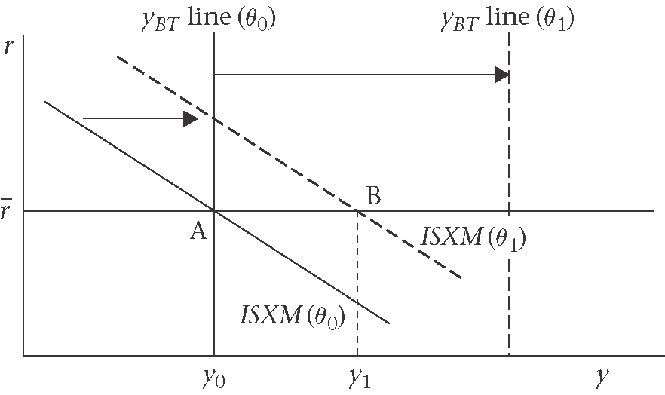

2. Opening financial markets
Four assumptions:
- Perfect international capital mobility
- Home country is assumed to be small (ex: behavior cannot affect the world interest rates)
- Two assets that household can hold – bonds and money
- Perfect substitutability between foreign and home bonds

2.1 Uncovered interest parity condition
Assuming that there is no difference in risk between the bonds issued by the two governments, two factors will affect the expected return on home as compared with foreign bonds:
(i)any difference in interest rates
(ii)a view about the likely development of the exchange rate
$i−i^{}=\frac{e_{t+1}^{E}−e_{t}}{e_{t}}$ [UIP]
Where, $i−i^{}$ is an interest gain (loss), and $\frac{e_{t+1}^{E}−e_{t}}{e_{t}}$ is expected depreciation (appreciation).
UIP$→$the condition that the interest rate differential in favour of bonds denominated in currency A must be equal to the expected exchange rate depreciation of currency A over the period for which the interest differential is expected to persists.

2.2 Using the UIP condition

Figure 9.4: Paths of the UK interest rate and UK pound exchange rate: the interest rate on UK bonds exceeds that on US bonds for 1 period
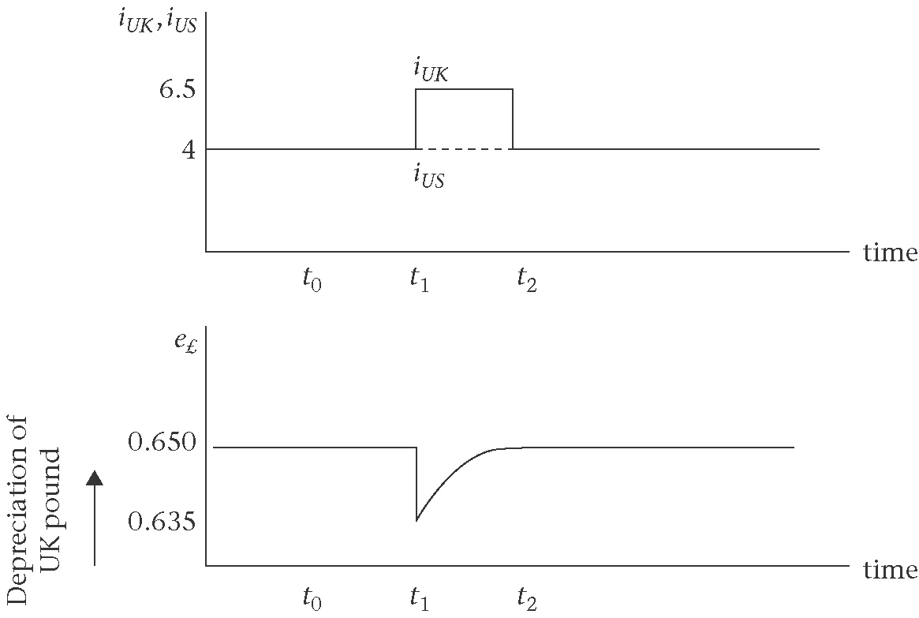

Figure 9.5: The uncovered interest parity condition
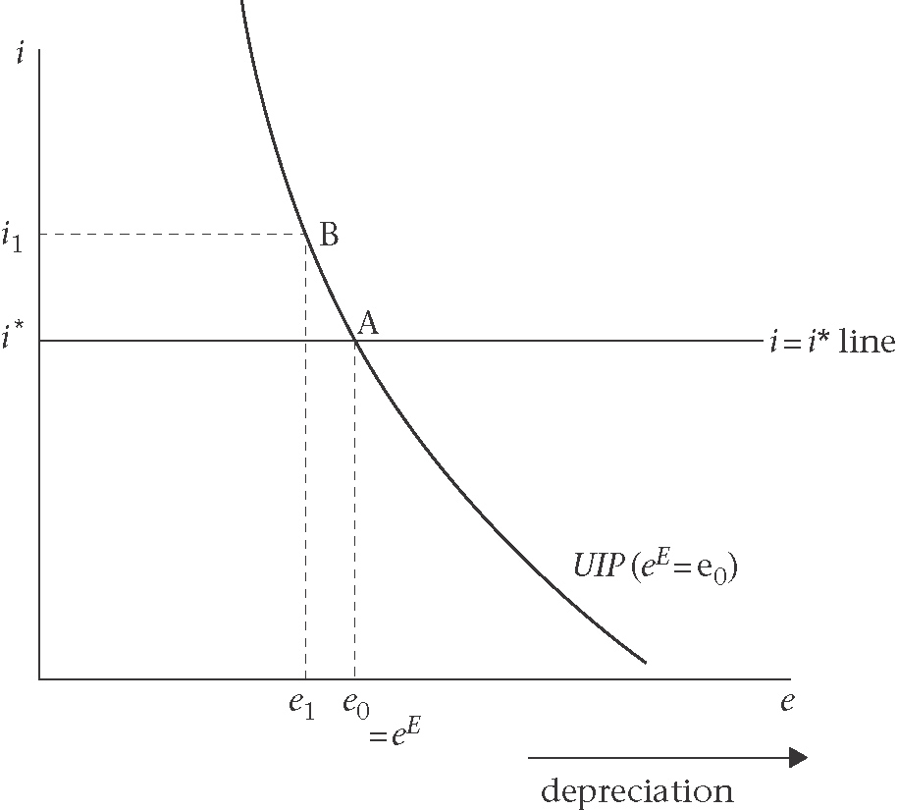
Figure 9.6: The UIP condition: fall in the world interest rate

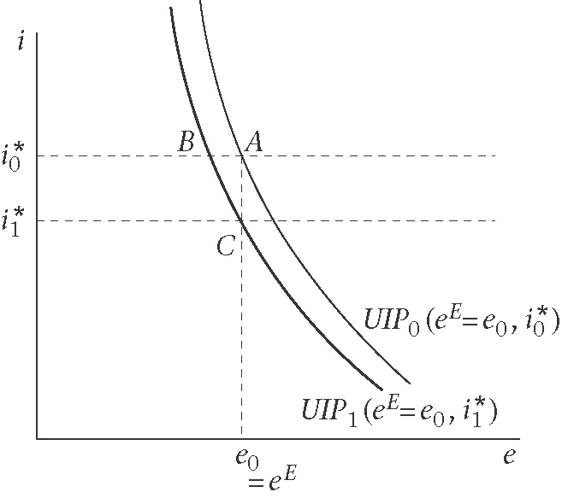
The key features of the UIP diagram:
- Each UIP curve must go through the point $\left(e^{E},i^{}\right)$
- For a given world interest rate, any change in the expected exchange rate shifts the UIP
- For a given expected exchange rate, any change in the world interest rate shifts the UIP curve
3. Fixed and flexible exchange rate regimes
Figure 9.7: The foreign exchange rate
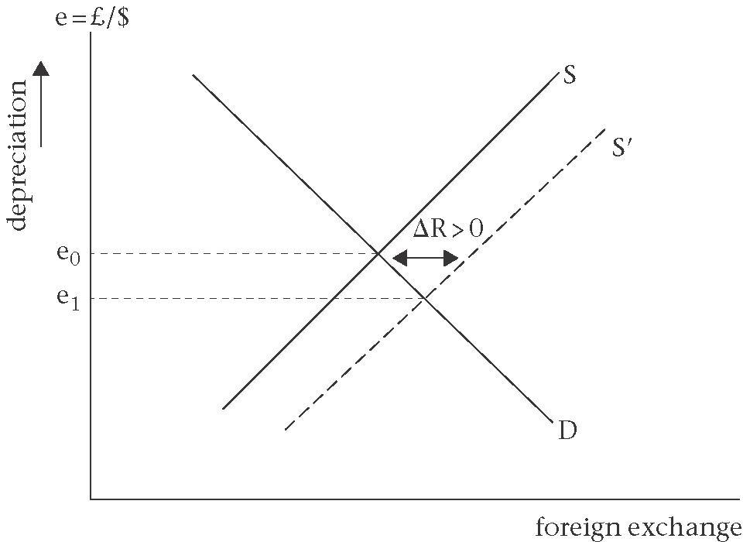

Figure 9.8: Fall in the demand for money: consequences under flexible (top panel) and fixed (bottom) exchange rate

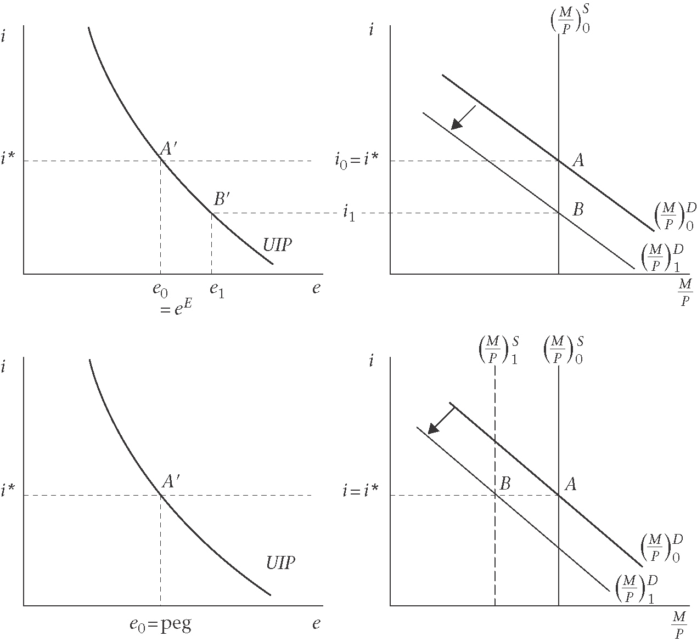
4. Trade balance and balance of payments

The current account: consists of the trade balance plus net interest and profit receipt.
The capital account: records changes in the stock of various types of foreign assets owned by home residents and home assets owned by overseas residents and changes in official foreign exchange reserves oh the central bank.

$\text{BP}=[(X−M)+$ net interest receipts] + (capital inflows-capital outflows)
$=\left(\text{BT}+\text{INT}\right)+\left(F−ΔR\right)=0$

If we rearrange the BOP equilibrium by putting the increase in foreign exchange reserves on the left hand side, we have:

$$ΔR=\left(\text{BT}+\text{INT}\right)+F$$

4.1 Why is the balance of payments equal to zero?
The BOP identity requires that:
$$\text{BP}=\left(\text{BT}+\text{INT}\right)+\left(F−ΔR\right)=0$$
4.2 Do current account imbalances matter?
4.3 What is a balance of payments crisis?

5. The Mundell-Fleming model for the short run
Three assumptions:
(i)Prices and wages are fixed
(ii)The home country is small
(iii)Perfect capital mobility and perfect asset substitubility
The Mundell-Fleming models consists of four elements:
(1)The open economy version of the goods market equilibrium condition for the home economy – ISXM curve
(ii)The money market equilibrium condition –LM curve
(iii)The financial market arbitrage equilibrium or uncovered interest parity condition – the UIP
(iv)The condition for financial integration when expectations are fulfilled in the foreign exchange market -$i=i^{}$ line.

5.1 The Mundell-Fleming model and monetary policy
5.1.1 Fixed exchange rates
Figure 9.9: Expansionary monetary policy: fixed exchange rate
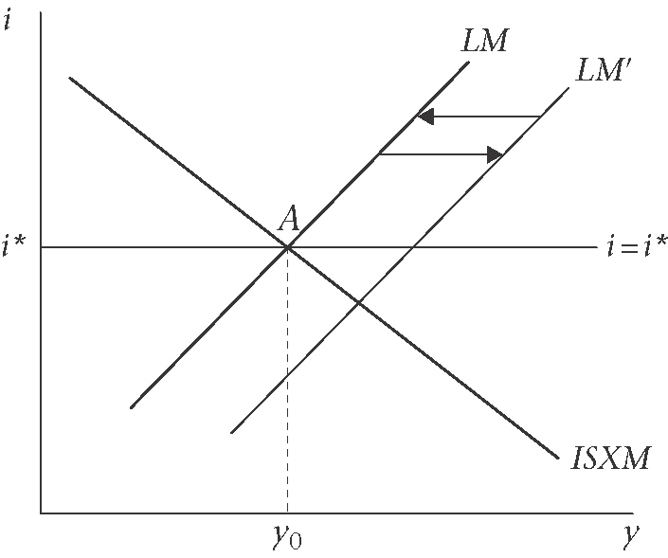

5.1.2 Flexible exchange rates
Figure 9.10: Expansionary monetary policy: flexible exchange rate
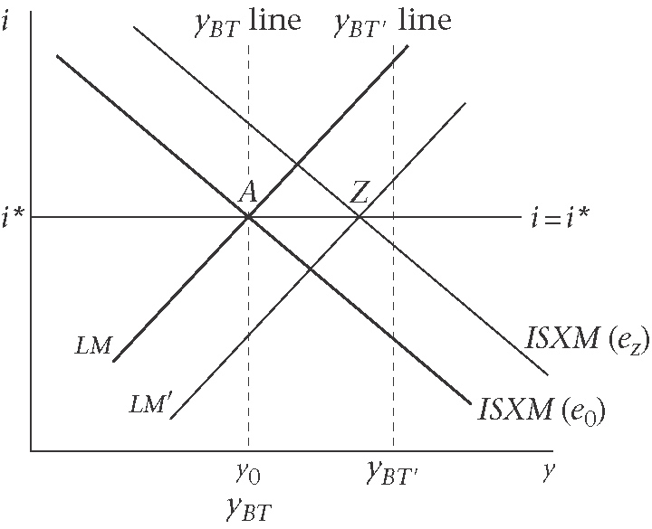
Figure 9.11: Expansionary monetary policy: adjustment under flexible monetary policy
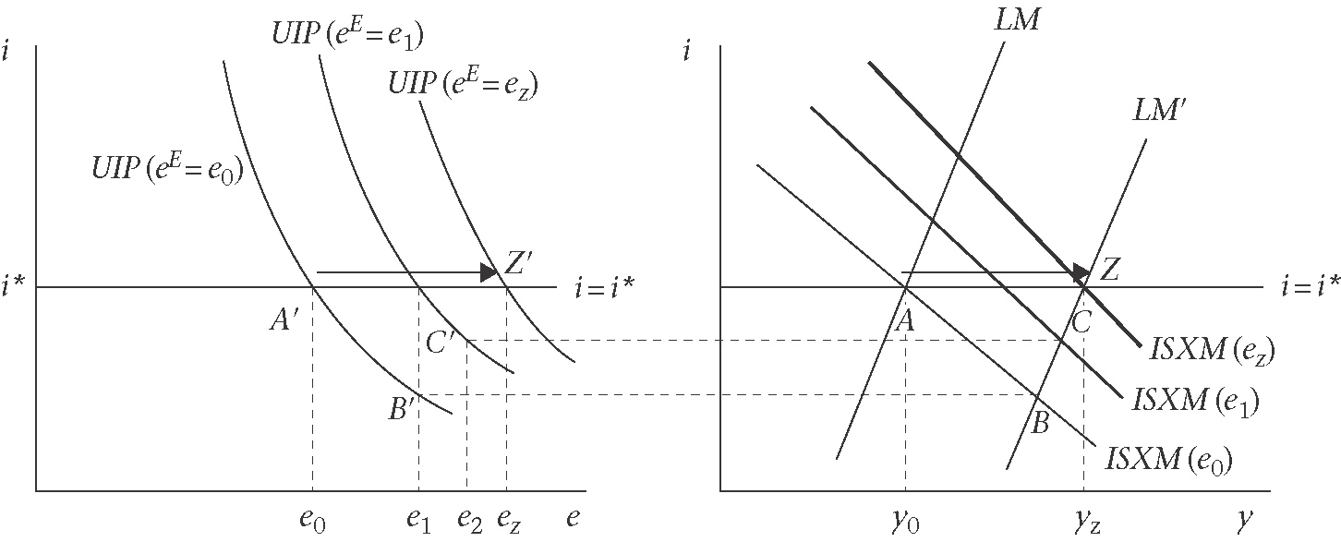
(a)Slow adjustment of exchange rate expectations (adaptive expectations) and slow adjustment of output and employment : A to B to C…to Z
(b)Immediate adjustment of exchange rate expectations to the new short-run equilibrium (rational expectations) and rapid adjustment of output: A to Z
5.1.3 The exchange rates overshooting: example of contractionary monetary policy

Figure 9.12 : Contractionary monetary policy: an example of exchange rate overshooting
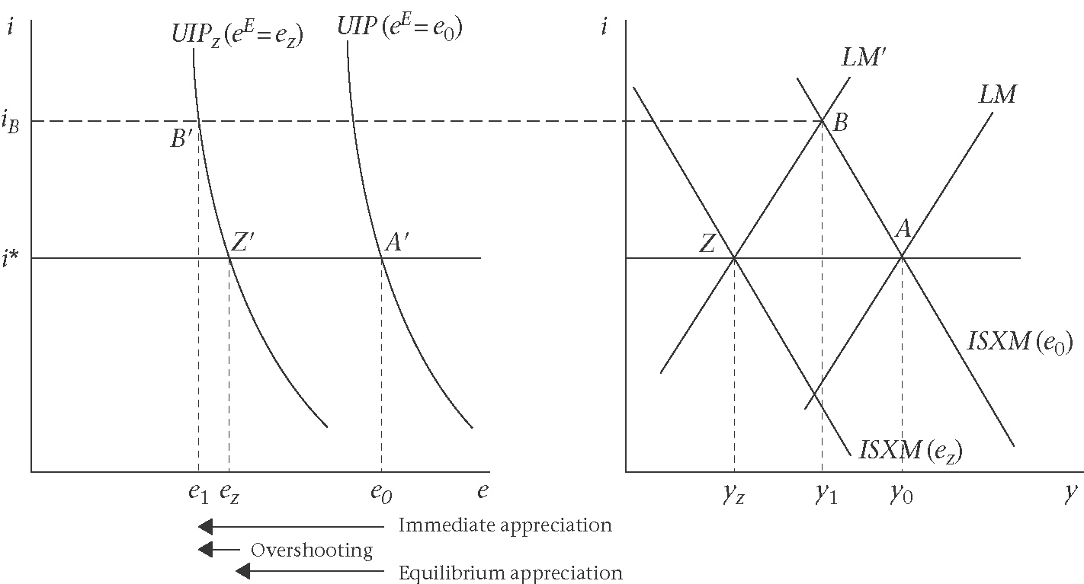

5.2 The Mundell-Fleming model and Fiscal Policy
5.2.1 Fixed Exchange Rate
Figure 9.13: Expansionary fiscal policy: fixed exchange rate
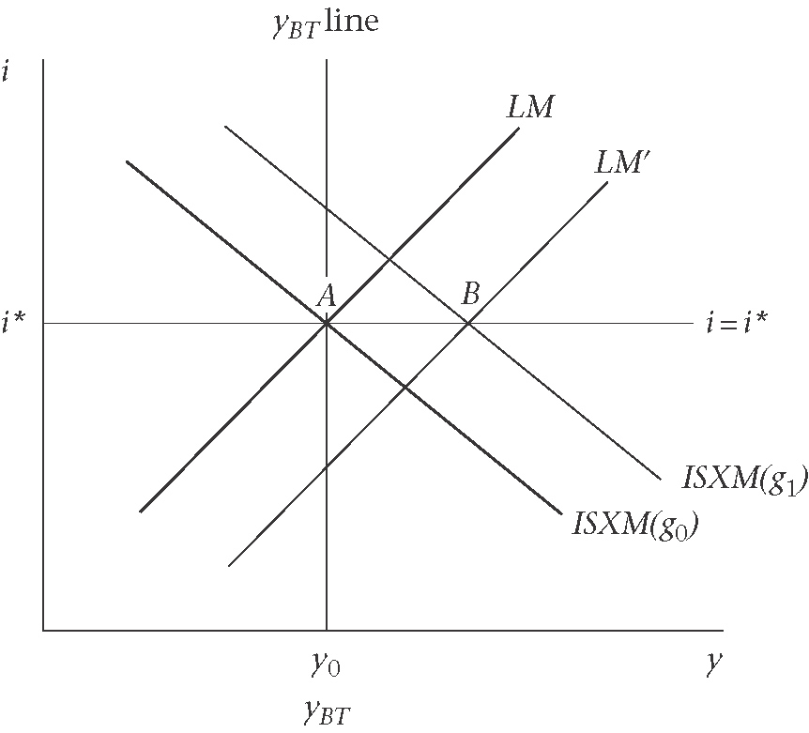
5.2.2 Flexible Exchange Rate
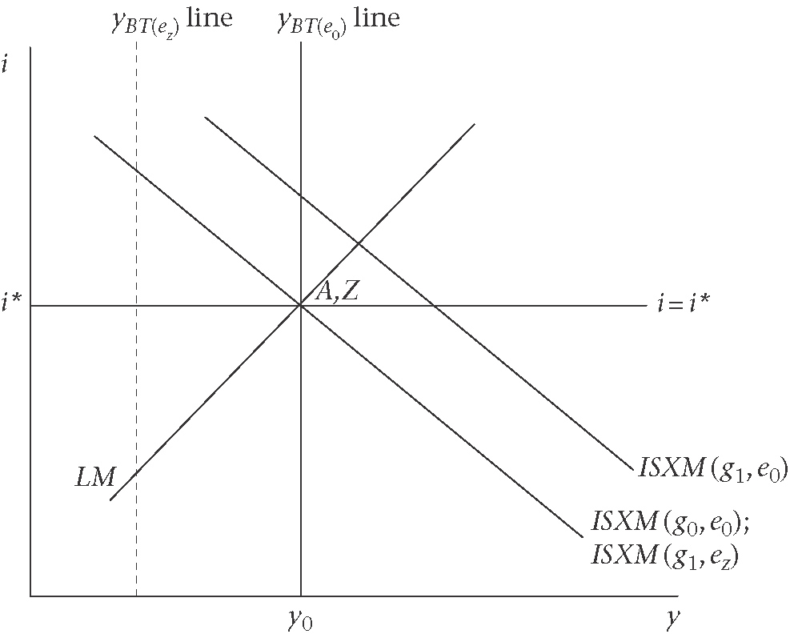

6. Extensions
6.1 Evidence on financial integration
6.2 Imperfect capital mobility

Figure 9.15: Imperfect capital mobility and flexible exchange rate: a monetary expansion
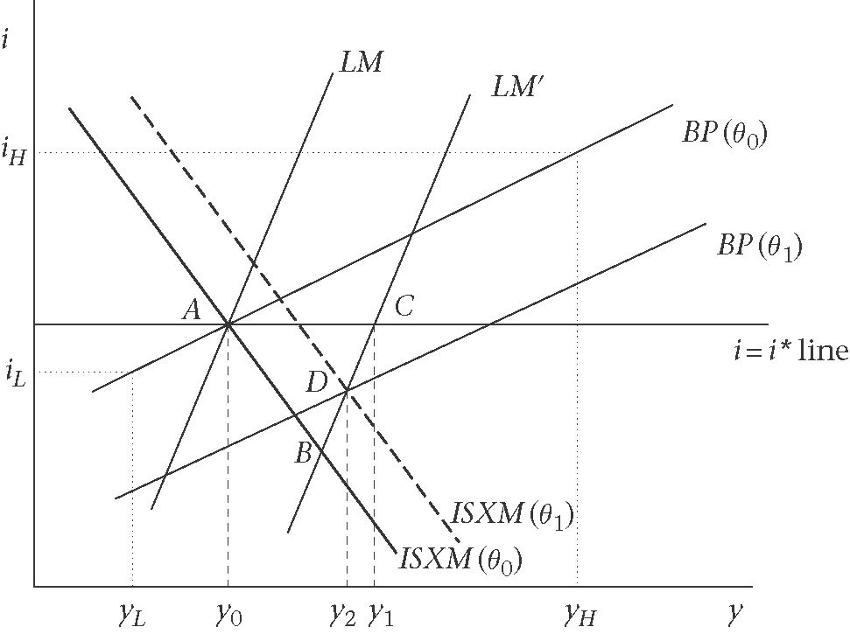

6.3 The large open economy
Figure 9.16: Flexible exchange rate large open economy
(a)Expansionary monetary policy (b)Expansionary fiscal policy
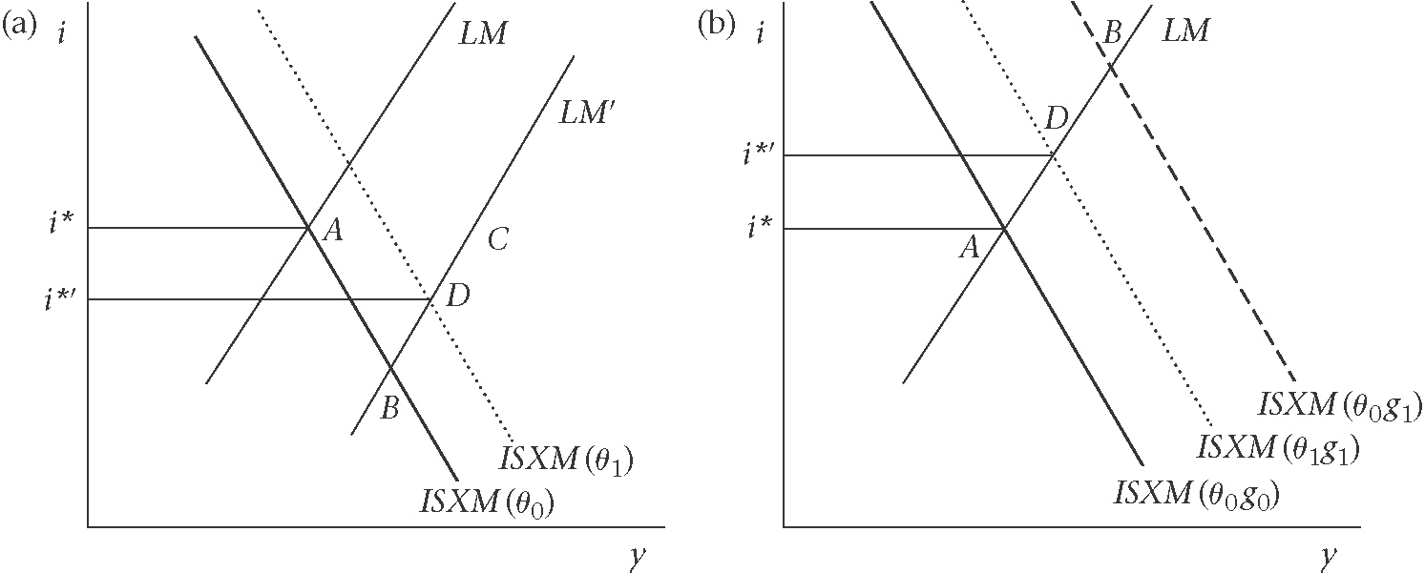
6.4 Perfect asset substitubility and the risk premium

6.5 Unplanned increase in risk

Figure 9.17: Risk premium: short-run implications under fixed and flexible exchange rate

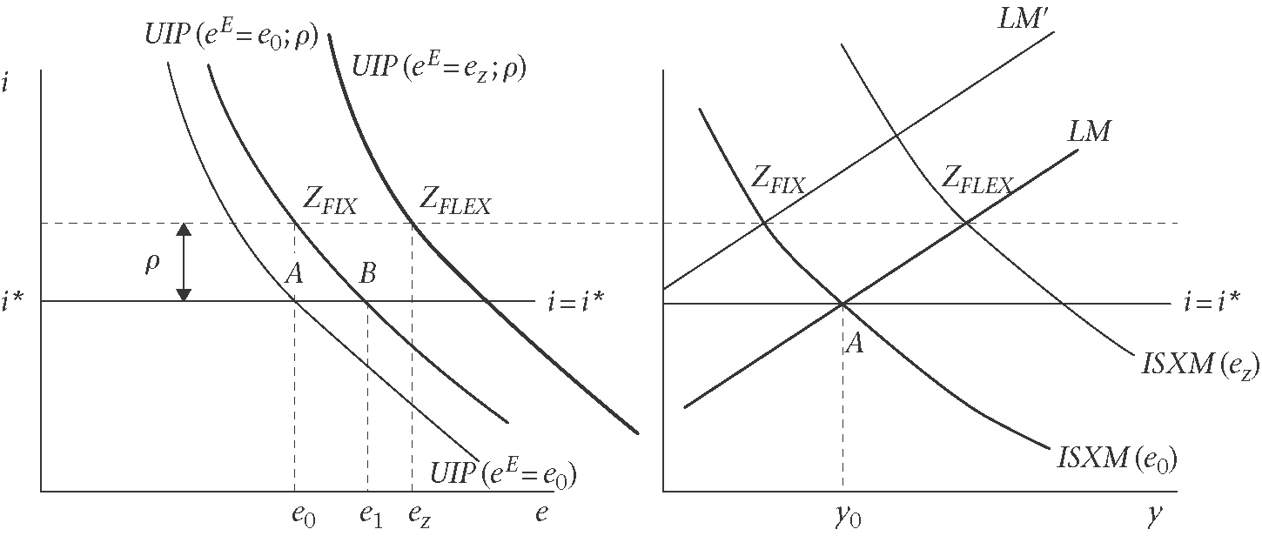
$Z_{\text{FIX}}$ is the new equilibrium under fixed exchange rates
$Z_{\text{FLEX}}$ is the new equilibrium under the flexible exchange rates

