EPPE6024: Macroeconomics
Lecture 11

Economic Fluctuation
- Facts about Business Cycles
- Short run vs Long run
- AD-AS in the short run and long run
- Analyzing the short-run and long-run effects of shocks
- Two prominent models of aggregate supply in the short run

Fact about Business Cycles
- GDP growth averages 3–3.5 percent per year over the long run with large fluctuations in the short run.
- Consumption and investment fluctuate with GDP, but consumption tends to be less volatile and investment more volatile than GDP.
- Unemployment rises during recessions and falls during expansions.
- Okun’s Law: the negative relationship between GDP and unemployment

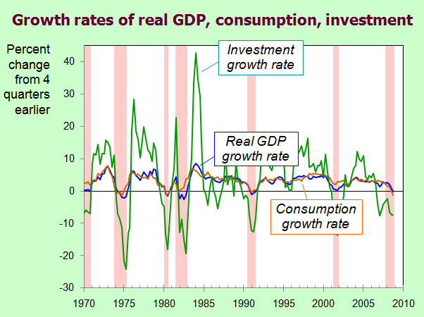
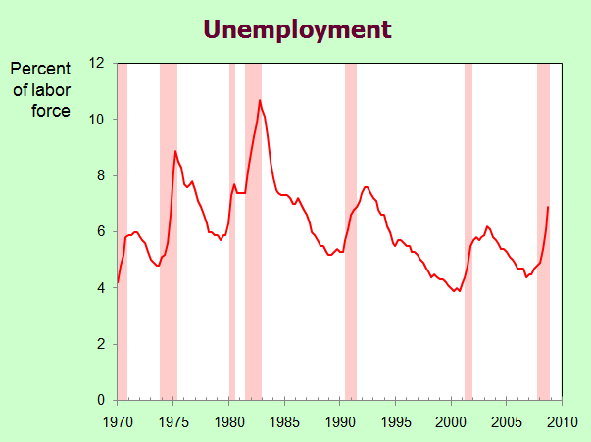
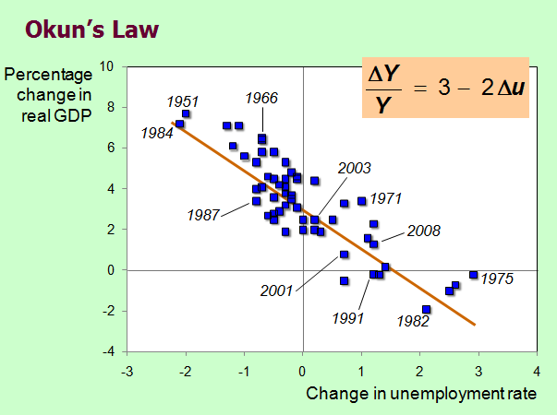
- Long run
Prices are flexible, respond to changes in supply or demand.
- this model is not necessarily appropriate for analyzing the short-run behavior of the economy. The main reasons for thinking this are twofold: first, this model does not easily explain large fluctuations in output; second, there is a lot of casual evidence that, in the short run, prices are not fully flexible. When prices are sticky, we can no longer rely on the adjustment of prices to ensure that markets are in equilibrium.
- Short run
Many prices are “sticky” at a predetermined level.

Recap of classical macro theory

- Output is determined by the supply side:
  - supplies of capital, labor and technology
- Changes in demand for goods & services (C, I, G ) only affect prices, not quantities.
- Assumes complete price flexibility.
- Applies to the long run.

When prices are sticky…

…output and employment also depend on demand, which is affected by:
  - fiscal policy (G and T )
  - monetary policy (M )
  - other factors, like exogenous changes in
C or I
- Firms set prices and then meet all demand. It thus no longer need be the case that the markets for capital and labor are in equilibrium. The short-run supply of goods and services represented by the short run aggregate supply curve, which is horizontal.

The model of
aggregate demand and supply

- The paradigm most mainstream economists
and policymakers use to think about economic fluctuations and policies to stabilize the economy
- Shows how the price level and aggregate output are determined
- Shows how the economy’s behavior is different
in the short run and long run

Aggregate demand
- The aggregate demand curve shows the relationship between the price level and the quantity of output demanded.
- For this chapter’s intro to the AD/AS model,
use a simple theory of aggregate demand based on the quantity theory of money.

The Quantity Equation as Aggregate Demand
- Recall the quantity equation
M V = P Y
- For given values of M and V,
this equation implies an inverse relationship between P and Y …

The downward-sloping AD curve
An increase in the price level causes a fall in real money balances (M/P ),
causing a decrease in the demand for goods & services.

Shifting the AD curve
An increase in the money supply shifts the AD curve to the right.

Aggregate supply in the long run
- In the long run, output is determined by
factor supplies and technology

Y = F (K, L)

Y is the full-employment or natural level of output, at which the economy’s resources are fully employed. “Full employment” means that
unemployment equals its natural rate (not zero).

The long-run aggregate supply curve

Ȳ does not depend on P, so LRAS is vertical.
Y
P
LRAS

Long-run effects of an increase in M
AD₂
P
Y
Ȳ

AD₁
LRAS
P₁
P₂

Aggregate supply in the short run
- Many prices are sticky in the short run.
- For now, we assume
  - all prices are stuck at a predetermined level in the short run.
  - firms are willing to sell as much at that price level as their customers are willing to buy.
- Therefore, the short-run aggregate supply (SRAS) curve is horizontal:

The short-run aggregate supply curve
P
Y
Ȳ

SRAS₁
P₁

The SRAS curve is horizontal:
The price level is fixed at a predetermined level, and firms sell as much as buyers demand.
Short-run effects of an increase in M
Y
P
P₁

SRAS₁
AD₂
Y₁ Y₂

AD₁

From the short run to the long run
Over time, prices gradually become “unstuck.” When they do, will they rise or fall?
  - In the short-run equilibrium, if Y > Ȳ, then over time P will rise
  - In the short-run equilibrium, if Y < Ȳ, then over time P will fall
  - In the short-run equilibrium, if Y = Ȳ, then over time P will remain constant
- The adjustment of prices is what moves the economy to its long-run equilibrium.

The SR & LR effects of ΔM > 0
AD₁
Y
Ȳ Y₁

AD₂
P
P₁
SRAS₁
LRAS₁
A
C
B

The effects of a negative demand shock
AD₂
Y
Y₁ Ȳ

AD₁
P
P₁
SRAS₁
LRAS₁
B
A
C

- AD shifts left, depressing output and employment in the short run.
- Over time, prices fall and the economy moves down its demand curve toward full-employment.

Supply shocks
- A supply shock alters production costs, affects the prices that firms charge. (also called price shocks)
- Examples of adverse supply shocks:
  - Bad weather reduces crop yields, pushing up
food prices.
  - Workers unionize, negotiate wage increases.
  - New environmental regulations require firms to reduce emissions. Firms charge higher prices to help cover the costs of compliance.
- Favorable supply shocks lower costs and prices.

Stabilization policy

- def: policy actions aimed at reducing the severity of short-run economic fluctuations.
- Example: Using monetary policy to combat the effects of adverse supply shocks…

Stabilizing output with monetary policy

Y
AD₁
P
Y
Ȳ

P₂
AD₂
SRAS₂
LRAS
SRAS₁
P₁
A
B
C

- The adverse supply shock moves the economy to point B.
- But the Central Bank accommodates the shock by raising aggregate demand.
- results: P is permanently higher, but Y remains at its full-employment level.

Two prominent models of aggregate supply in the short run:
- Sticky-price model
- Imperfect-information model
- Both models imply:

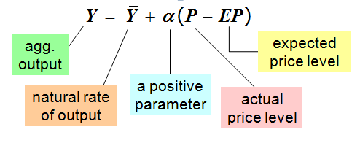
- Other things equal, Y and P are positively related, so the SRAS curve is upward-sloping.

The sticky-price model
- Reasons for sticky prices:
  - long-term contracts between firms and customers
  - menu costs
  - firms not wishing to annoy customers with frequent price changes
- Assumption:
  - Firms set their own prices
(e.g., as in monopolistic competition).

- An individual firm’s desired price is:

where a > 0.

Suppose two types of firms:
  - firms with flexible prices, set prices as above
  - firms with sticky prices, must set their price before they know how P and Y will turn out:

- Assume sticky price firms expect that output will equal its natural rate. Then,
- To derive the aggregate supply curve, first find an expression for the overall price level.
- s = fraction of firms with sticky prices. Then, we can write the overall price level as…

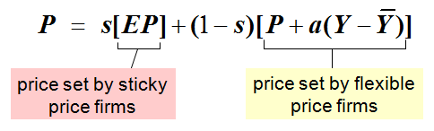

- Subtract (1−s)P from both sides:

- Divide both sides by s :

- High EP → High P
If firms expect high prices, then firms that must set prices in advance will set them high.
Other firms respond by setting high prices.
- High Y → High P
When income is high, the demand for goods is high. Firms with flexible prices set high prices.
The greater the fraction of flexible price firms, the smaller is s and the bigger is the effect of ΔY on P.
- Finally, derive AS equation by solving for Y :

The imperfect-information model
Assumptions:
  - All wages and prices are perfectly flexible,
all markets are clear.
  - Each supplier produces one good, consumes many goods.
  - Each supplier knows the nominal price of the good she produces, but does not know the overall price level.
  - Supply of each good depends on its relative price: the nominal price of the good divided by the overall price level.
  - Supplier does not know price level at the time she makes her production decision, so uses EP.
  - Suppose P rises but EP does not.
    - Supplier thinks her relative price has risen,
so she produces more.
    - With many producers thinking this way,
Y will rise whenever P rises above EP.

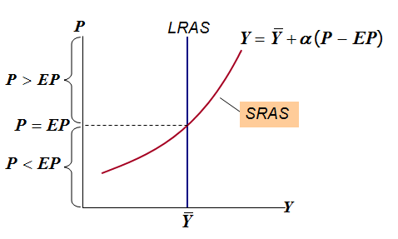
Both models of aggregate supply imply the relationship summarized by the SRAS curve & equation.

Summary & implications of both models
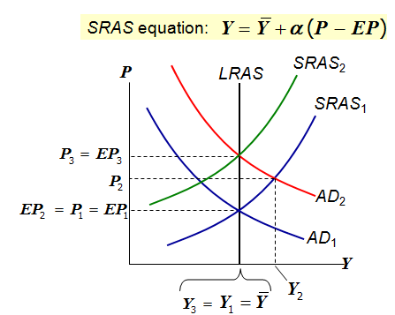

- Suppose a positive AD shock moves output above its natural rate and P above the level people had expected.
- Over time, EP rises, SRAS shifts up, and output returns to its natural rate.

