EPPE6024: Macroeconomics
Lecture 2

National Income: Where It Comes from and Where It Goes.
- Gross Domestic Product (GDP) measures both a nation’s total output of goods and services and its total income.

- Four questions to be addressed

- How much do the firms in the economy produce? What determines a nation’s total income?

- Who gets the income from production? How much goes to compensate workers, and how much goes to compensate owners of capital?

- Who buys the output of the economy? How much do households purchase for consumption, how much do households and firms purchase for investment, and how much does the government buy for public purposes?

- What equilibrates the demand for and supply of goods and services?
What ensures that desired spending on consumption, investment, and government purchases equals the level of production?

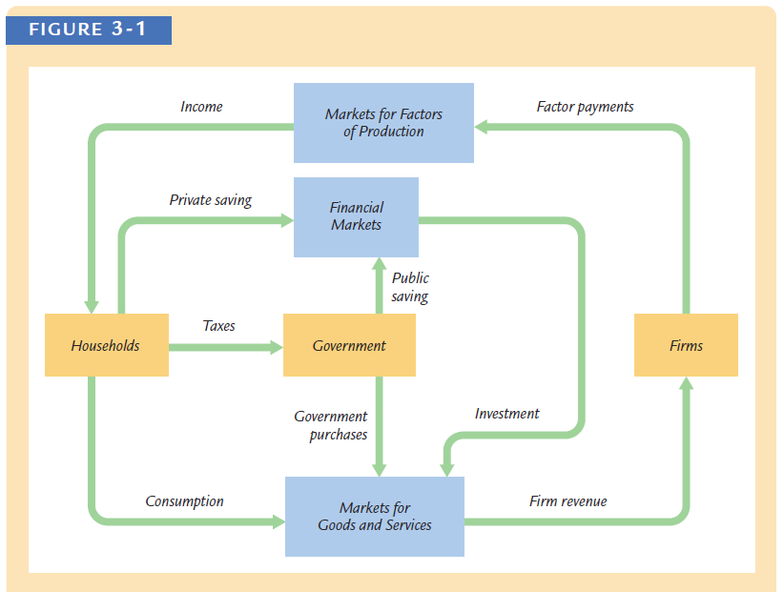
- What Determines the Total Production of Goods and Services?

- The Factors of Production

- input to produce goods and services

- commonly we use capital (K) and labor (L)

- for now we take K and L as given

- - fixed capital

- - fixed labor

- The Production Function

- The available production technology determines how much output is produced from given amounts of capital and labor

- Y=F(K, L).

- most of the production function we assume constant return to scale

- thus zY=F(zK, zL)

- The Supply of Goods and Services

-

- How Is National Income Distributed to the Factors of Production?

- The factors of production and the production function together determine the total output of goods and services and therefore they also determine national income.

- Factor Prices

- The Decisions Facing the Competitive Firm

- assume a typical firm is competitive

- the competitive firm takes the prices of its output and its inputs as given by market conditions.

Y = F(K, L),

- The firm sells its output at a price P, hires workers at a wage W, and rents capital at a rate R.

- Profit = Revenue − Labor Costs − Capital Costs
= PY − WL − RK.

Profit = PF(K, L) − WL − RK.

- The Firm’s Demand for Factors

- marginal product of labor (MPL) - the extra amount of output the firm gets from one extra unit of labor, holding the amount of capital fixed.
- MPL = F(K, L + 1) - F(K, L).

- From the Marginal Product of Labor to Labor Demand

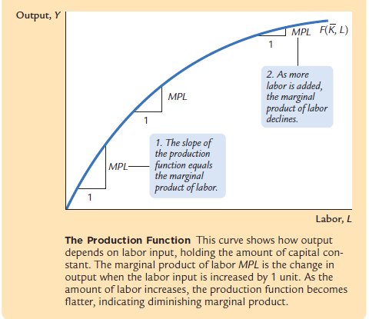

- Most production functions have the property of diminishing marginal product: holding the amount of capital fixed, the marginal product of labor decreases as the amount of labor increases.

- When the competitive, profit-maximizing firm is deciding whether to hire an additional unit of labor, it considers how that decision would affect profits.

- compares the extra revenue from increased production with the extra cost of higher spending on wages.

- Δ Profit = Δ Revenue - Δ Cost

= (P × MPL) - W.

P × MPL = W.

MPL = W/P.

- To maximize profit, the firm hires up to the point at which the marginal product of labor equals the real wage.

- The Marginal Product of Capital and Capital Demand

- MPK = F(K + 1, L) − F(K, L).

- Profit = Δ Revenue - Δ Cost

= (P × MPK ) - R.

MPK = R/P.

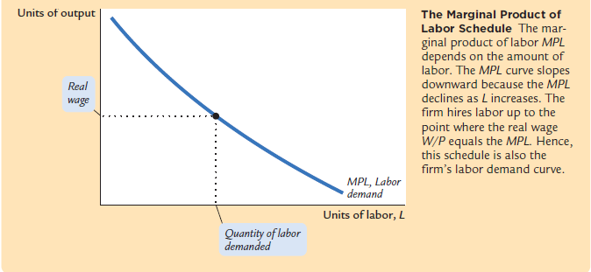

- The Division of National Income

- The income that remains after the firms have paid the factors of production is the economic profit of the owners of the firms.

Economic Profit =Y − (MPL × L) − (MPK × K).

can be arranged as follows:
Y = (MPL × L) + (MPK × K) + Economic Profit.

- How large is economic profit?

- If the production function has the property of constant returns to scale, then economic profit must be zero.

- That is, nothing is left after the factors of production are paid. This conclusion follows from a famous mathematical result called Euler’s theorem, which states that if the production function has constant returns to scale, then

F(K, L) = (MPK × K) + (MPL × L).

- We have been assuming that there are three types of agents: workers, owners of capital, and owners of firms. Total income is divided among wages, return to capital, and economic profit. In the real world, however, most firms own rather than rent the capital they use

- Accounting Profit = Economic Profit + (MPK × K ).

- The Cobb–Douglas Production Function

- Capital Income = MPK × K = αY

- Labor Income = MPL × L = (1 – α)Y,

where α is a constant between zero and one that measures capital’s share of
income. It determines what share of income goes to capital and what share goes to labor.

- Cobb-Douglas production function ➔ F(K, L) = AK^{α}L^{1− α},

- Property of cob-Douglas production function

- Has a constant return to scale

zY = F(zK,zL)

F(zK,zL) = A(zK)^{α}(zL)^{1− α}

Prove that F(zK, zL) ➔ zY
- the marginal productivity of a factor is proportional to its average productivity.

Y = AK^{α}L^{1− α}

MPL = (1- α)AK^{α}L^{-α}

MPK = αAK^{α -1}L^{1- α}

An increase in the amount of capital raises the MPL and reduces the MPK. Similarly, an increase in the amount of labor reduces the MPL and raises the MPK. A technological advance that increases the parameter A raises the marginal product of both factors proportionately.

MPL = (1- α)AK^{α}L^{α}

= (1- α)AK^{α}L^{1-α}L⁻¹ L

= (1- α)Y/L

MPK = αAK^{α-1}L^{1-α}

= (1- α)Y/K

The MPL is proportional to output per worker, and the MPK is proportional to output per unit of capital. Y/L is called average labor productivity, and Y/K is called average capital productivity. If the production function is Cobb–Douglas, then the marginal productivity of a factor is proportional to its average productivity.

The total amount paid to labor, which we have seen is MPL × L, equals
(1 − α)Y. Therefore, (1 − α) is labor’s share of output. Similarly, the total amountpaid to capital, MPK × K, equals α Y, and α is capital’s share of output. The ratio of labor income to capital income is a constant, (1 − α)/ α, just as Douglas observed. The factor shares depend only on the parameter α, not on the amounts of capital or labor or on the state of technology as measured by the parameter A.

- What Determines the Demand for Goods and Services?

- Y = C + I + G.

- Consumption

- C = C(Y-T)

- The marginal propensity to consume (MPC) is the amount by which consumption changes when disposable income increases by one dollar.

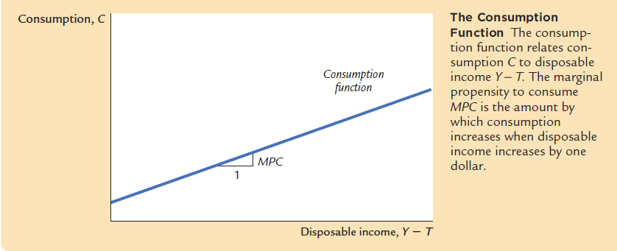

- Investment

- The quantity of investment goods demanded depends on the interest rate, which measures the cost of the funds used to finance investment.

- I = I(r)

Real interest rates vs nominal interest rates
r = r_{n} - π

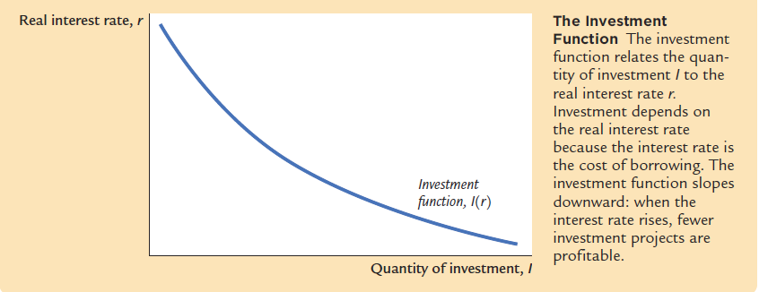

- Government Expenditures

-

- What Brings the Supply and Demand for Goods and Services Into Equilibrium?

- Equilibrium in the Market for Goods and Services: The Supply and Demand for the Economy’s Output

Y = C + I + G
C = C(Y-T)
I = I(r)

Y = C(Y-T) + I(r) + G

- This equation states that the supply of output equals its demand, which is the sum of consumption, investment, and government purchases.

- Equilibrium in the Financial Markets:The Supply and Demand for Loanable Funds

- Through discussion on interest rate = cost of borrowing

Y – C – G = I ➔ national saving

S = (Y– T – C) + (T - G) = I

(Y– T – C) ➔ private saving

(T - G) ➔ public saving

Y – C(Y-T) – G = I(r)

