EPPE6024: Macroeconomics
Lecture 3

Money and Inflation
- Introduction
- Money, prices and output
- Function of money
- Theory of demand for money
- Quantity theory of money
- Keynes’ liquidity preference theory
- Friedman theory of money
- Differences between Keynesian and Friedman Theory
- Empirical studies on money
- Methodology for estimating money, price and output relationship

Introduction
Money, price and output
Definition of money
- For economists
- anything that is generally accepted in payment for goods or services or in the repayment of debts.
- also called money supply
- narrow money (currency) vs broad money (including checks, saving deposit etc.)
- from conventional perspective
- Money – wealth, income etc,

Functions of money
- medium of exchange
- for payment of goods and services
- encourage efficiency in economy – reduce transaction cost
- barter system suffers from high transaction costs. People have to satisfy double coincidence of wants. They have to find someone who has good or service they wants and who also wants the good or service they have to offer.
- for a commodity to effectively function as money, it has to meet several criteria
- easily standardized
- widely accepted
- divisible
- easy to carry
- does not deteriorate quickly

- unit of account
- measure value in the economy
- reduce transaction costs
- reduce the numbers of prices that need to be considered if good is priced in term of other good
- without money, the number of prices that need to be considered in terms of other goods
- N(N-1)/2
e.g. N = 50
A B C D E
A= 2B, B=3C, C = 4D
- number of prices = 50(49)/2 = 1225

- store of value
- repository of purchasing power over time
- other assets like bond, equity, land and house can also act as store of value but they differ in term of liquidity
- money is chosen because it is the most liquid asset of all. It is the medium of exchange
- A store of value of money depends on the price level
- During inflation money loses value
- period of extreme inflation – hyperinflation
Eg German after world war I, inflation rate sometimes exceeding 1000% per month.

Commodity money to fiat money
- Commodity money - gold
- high transaction cost
- hard to carry, measure during transaction
- Government intervened by minting gold coin with known purity and weight.
- Government introduced gold certificates, a piece of paper that can be redeemed for a certain quantity of gold
- gold certificates- lighter than gold, easier to use in transaction
- gold backed government bills becomes the monetary standard
- later on gold backing become irrelevant. People do not care about converting into gold as long as everyone accepts the bills.
- the bills serve as money- social convention – everyone values money

Seigniorage
- revenue from printing money
- government prints money to raise revenue besides taxes and selling bond.
- printing money → increase money supply → inflation
- printing money is like imposing an inflation tax
- money that people hold will have less value to buy goods)

Quantity theory of money
- developed by classical economist in the 19th and early twentieth centuries.
- how the nominal value of aggregate income is determined.
- interest rate have no effect on the demand for money
- Irving Fisher – The purchasing power of money (1911)
- examines the link between the total quantity of money and the total amount of spending on final goods and services produced in the economy. The concept that provides the link between money and and nominal income is called the velocity of money
V = P * Y
M
V = velocity of money
P = price
Y = aggregate output

P*Y = nominal aggregate income (or nominal GDP)

e.g; P*Y = RM 5 trillion and M = RM 1 trillion,
thus
V = RM 5 trillion = 5 =
RM 1 trillion
= the average a dollar bill is spent in buying the total amount of goods and
services

- By rearranging the equation, an equation of exchange can be obtained

MV = PY
- an identity – a relationship that is true by definition
- if M increases, PY will not increase if V falls that leaves (MV) and thus PY unchanged
- to convert an identify equation into a theory, we need to know what determines the velocity
- Irving Fisher – V is determined by institutional as well as technological factors (i.e. use of credit card instead of money)
- Fisher took the view that the institutional and technological features of the economy would affect velocity only slowly over time. Thus velocity can reasonably be constant in the short run.
- Assuming that velocity is constant in the short run, the equation of exchange can be transformed into the quantity theory of money.
- Classical economists thought that wage and price were completely flexible
- Y remains at full-employment level, thus constant in the short run
- thus if M doubles, P must also doubles since V and Y constant
- The theory states movement in the price level result solely from changes in the quantity of money
- Extension

MV = PY

In period t = 0 → Ln M₀ + Ln V₀ = Ln P₀ + Ln Y₀ [1]
In period t = 1 → Ln M₁ + Ln V₁ = Ln P₁ + Ln Y₁ [2]

[2] – [1]
Ln M₁ – ln M₀ = Ln (M1/M0)

→ Ln (M₁/ M₀) + Ln (V₁/ V₀) = Ln (P₁/ P₀) + Ln (Y₁/ Y₀)

Ln (X₁/X₀) ➔ approximation of (X₁-X₀)/X₀

- Quantity theory of money demand
- When money market is in equilibrium, the quantity of money that people hold equals the quantity of money demanded.
M = (1/V)* PY
- M^{d} = k * PY , where k = (1/V)
- k is constant. Thus the demand for Money is purely a function of income. Interest rates have no effect on the demand for money.
- in term of real money demand
M^{d} = k Y
P

Consumer price index

Measuring money
- M1
- M2
- M3

Is velocity a constant?
- US vs Malaysia

- US
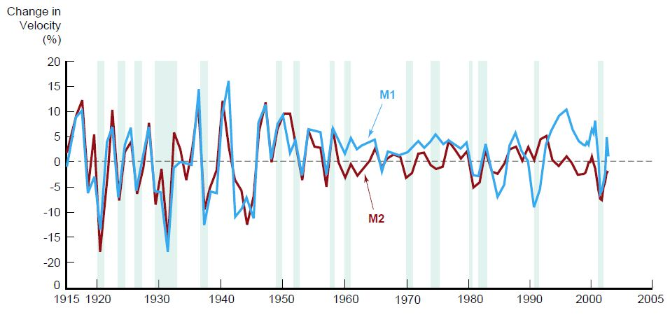
- Malaysia
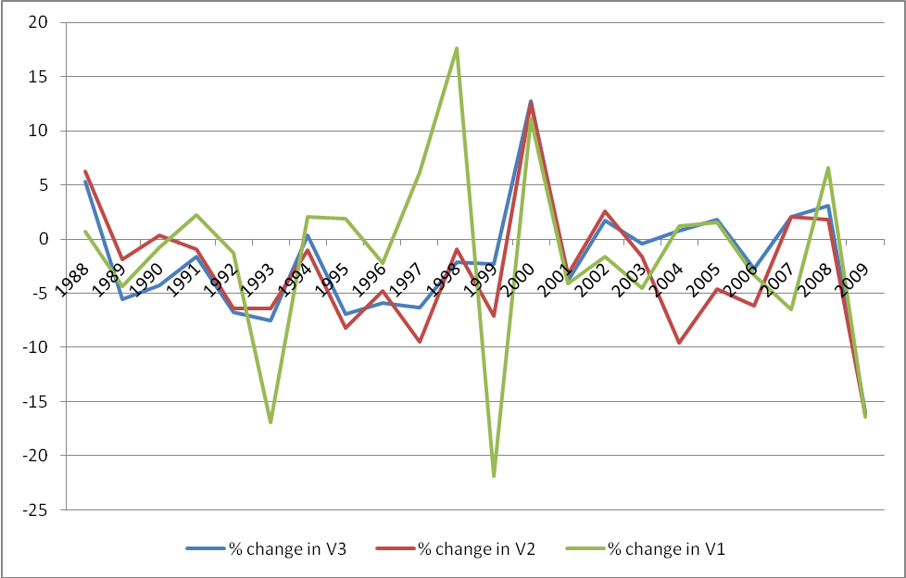

Keynes’s Liquidity preference Theory
- asked why do individuals hold money
- 3 reasons; a) transaction motive; b) precautionary motive and c) speculative motive
- Transaction and precautionary purposes of the demand for money are proportional to income
- Speculative component of money demand is negatively related to interest rates
- Individuals decide whether to hold their wealth in the form of money or bond
- expected return on money is zero (eg current account)
- expected return on bond;
a) interest payment – depends on interest rates
b) expected rate of capital gain– depends on current price of bond

PV_{B} = C₁ + C₂ + C₃ + FV
(1+r) (1+r)² (1+r)³ (1+r)³

- Face value = FV = 10,000
- Maturity period = n = 3 years
- Interest rate = r = 10%
- Coupon rate = C = 15%

PV_{B} = C₁ + C₂ + … + C_{n} + FV
(1+r) (1+r)² (1+r)^{n} (1+r)^{n}

- if return on money > return on bond, individuals will decide to hold money
- if the interest rate is expected to rise, price of bond is expected to falls and there is negative gain on capital.
- Keynes assumes that individuals believe that interest rates gravitate to some normal value.
- if interest rate < normal interest rates, the interest rate is expected to rise and the price of bond is expected to fall and bond holder will suffer capital losses

r

r_{n} = normal interest rate

r
- Liquidity preference function
- nominal vs real
- M^{d} = f ( i , Y )
P (-) (+)

- M^{d}/P = real money demand, i = interest rate and Y = real income

- Implication - velocity of money is not constant
- P Y = Y
M^{d} f(i, Y)

- V = PY = Y
M^{d} f(i, Y)

- when i rises, f(i, Y) falls and V will increase
- expected change in normal interest rate can also influence the velocity

Further development in the Keynesian Approach
- William Boumal and James Tobin – Boumal Tobin demonstrated money balances held for transaction and precautionary motives are also sensitive to the interest rates.

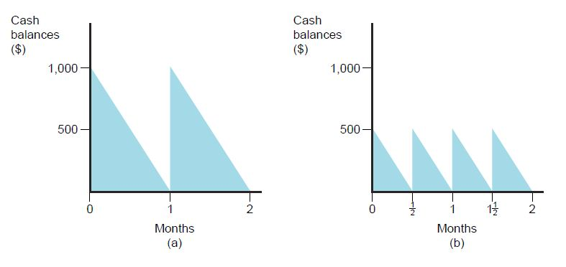
- Analysis- income per month = 1000, interest rate = 1%
Case a)
- an individual has 1000 at the beginning of the month for consumption and has no cash left at the end of the month
- his holdings of money average = 1000/2 = 500,
Thus V = PY/M = 12,000/500 = 24
Case b)
- an individual use 500 at the beginning of the month and the balance is used to buy a bond.
- in the middle of the month the bond is sold for 500 cash which is spent until the end of the month
- his holdings of money average = 500/2 = 250,
Thus V = PY/M = 12,000/250 = 48
- return on bond = ½ * 500 * 1% = 2.50
- the lower his average cash balance, the more interest he will earn
- there is however a transaction cost incurred when buying and selling a bond (brokerage fees). Thus if the benefit of holding bond is higher relative to the transaction cost, more bond and less cash will be held.
- there is also an opportunity cost of holding cash. The higher the interest rates the higher the opportunity cost of holding cash.
- Similar effect on the demand for money for precautionary purposes

- Speculative motive of money demand
- Keynes assumes that an individual holds only money if the return on money is higher than the return on bond. Diversification is a rare case.
- Tobin - individuals evaluate risk and return on investment. Individuals are risk averse. They have a tendency to hold cash if holding bond produce higher risk. They can also do diversification by holding cash and other assets simultaneously.

Friedman’s modern quantity theory of money
- Milton Friedman (1956)- “The Quantity Theory of Money: A Restatement”
- M^{d} = f (Y_{p} , r_{b} - r_{m}, r_{e} - r_{m}, π - r_{m})
P (+) (-) (-) (-)

M^{d}/P = demand for real money balance
Y_{p} = permanent income (wealth) – expected average long run income
r_{b} = expected return on bond
r_{m} = expected return on money
r_{e} = expected return on equity (stocks)
π = expected inflation (return on goods)

assume that you get monthly salary 3000
3000 x 12 month = 36,000
If suddenly you get extra income of 500 in september

- permanent income has much smaller short run fluctuations (temporary)
- however average long run income does change very much
- implication- the demand for money will not fluctuate much with business cycle movement.

- Individuals hold wealth in various forms besides money
- bond – with expected return on bond
- stocks– with expected return on stocks (dividend)
- goods (eg house, land) – depend on expected inflation

- return on money depends on 2 factors
- the services provided by banks on deposits. Positive relationship
- the interest payments on money balances. Positive relationship

Differences between Keynesian and Friedman Theory
- divided into two
- the role of interest rate on money demand
- Keynes – there is only one interest rate – for bond. Interest rate is important in the money demand function. Negative relationship.
- Friedman
– more than one interest rates/returns (bond, stocks and goods)
- viewed money and goods as substitutes. Implication- change in the quantity of money has a direct effect on aggregate spending
- expected return on money is not constant. In competitive market, a rise in the interest rate will also increase returns on deposits (assuming no restriction in payments on deposits).
- if there is restrictions in pecuniary payments on deposits, banks can still compete on the quality dimension.
- as a results: r_{b} – r_{m} is relatively constant
- Thus Fridman theory says that change in the interest rates should have little effect on the demand for money.
- Friedman money demand function was essentially one in which permanent income is the primary determinant of money demand
M^{d}/ P = f(Y_{P})

- Stability of the demand for money function
- Keynes – interest rates fluctuate substantially, money demand function is not stable. Velocity is not constant and thus unpredictable.
- Friedman – interest rates have little effect on money demand function. Thus money demand function is stable and thus the velocity is predictable.
V = Y/ f(Y^{P})
- Because Y and Y_{P} are predictable, a stable money demand function implies that velocity is predictable as well.
- if velocity is predictable, a change in the quantity of money will have a direct effect on aggregate spending. A restatement of the quantity theory of money – money is important to aggregate spending.

Empirical evidence of money, price and output
- Interest rate and money demand
- money is sensitive to a change in the interest rate. No indication of liquidity trap.
MS
MS’
i
Md

M

- Stability of money demand
- in US – money demand function is stable before 1970s, but unstable after that because of the development/ innovation in the financial system.

- refer to Carl E. Walsh : Monetary Theory and Policy, 2nd Edition

Methodology for estimating money, price and output relationship
- OLS – partial equilibrium
- Cointegration and VECM
- Long run relationship (Cointegration)- there are are two
1. Engle Granger cointegration
2. Johansen cointegration
- Short run relationship (when long run relationships exist) (VECM) – Granger causality in term of VECM
- Granger causality (in absence of long run relationship)
- All must undergo stationary test (unit root tests)
- VAR
- SVAR
- Structured VAR (Adrian Pagan)

