Asia-Pacific Journal of Information Technology and Multimedia issue(volume) year: firstpage – lastpage
https://doi.org/10.17576/apjitm-year-issuevolume-articleno

Title in English

Title in Malay Language (Tajuk dalam Bahasa Melayu)

First Author Name, Second Author Name*

Affiliation, Country

*Corresponding author: emailauthor@mail.com

Received 17 September 2023
Accepted 17 November 2023, Available online 1 December 2023

ABSTRACT

Content of abstract around 150 – 250 words.

Keywords: three to five keywords

ABSTRAK

Kandungan abstrak dalam Bahasa Melayu dalam 150 – 250 patah perkataan

Kata kunci: tiga hingga lima kata kunci

INTRODUCTION

Paragraph 1 …………………………………………………………………………………… …………………………………………………………………………………………………………………………………………………………………………………………………………………………………………………………………………………………………………………………………………………………………………………………………………………………………………………………………………………………………………….

Paragraph 2 …………………………………………………………………………………… ……………………………………………………………………………………………………………………………………………………………………………………………………………………………………………………………………………………………………………………………………………………………………………………………………………………………………………………………………………………………………………………………………………………………………………………………………………………………………………………………………………………………………………………………………………………………………………………….

RELATED WORK

Paragraph 1 …………………………………………………………………………………… ………………………………………………………………………………………………………………………………………………………………………………………………………………………………………………………………………………………………………………………………………………………………………………………………………………………………………………………………………in Table 1.

TABLE 1. Title of table
Category | Age | Gender | Quantity
Undergraduate | 19-23 | Male | 8
Postgraduate | 19-25 | Female | 16
Total of participant |  |  | 28

Paragraph 2 …………………………………………………………………………………… ………………………………………………………………………………………………………………………………………………………………………………………………………………………………………………………………………………………………………………………………………………………………………………………………………………………………………………………………………in Figure 1.

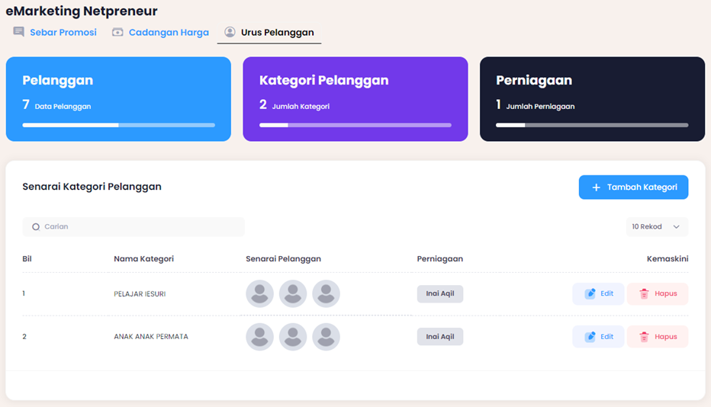
FIGURE 1. Title of figure

Paragraph 3 …………………………………………………………………………………… ………………………………………………………………………………………………………………………………………………………………………………………………………………………………………………………………………………………………………………………………………………………………………………………………………………………………………………………………………

METHODOLOGY

Paragraph 1 …………………………………………………………………………………… ………………………………………………………………………………………………………………… According to James (2024), ………………………………………………… …………………………………………………………………………………………………………………………………………………………………………………………………………………………………………………………………………………………………

Paragraph 2 …………………………………………………………………………………… …………………………………………………………………………………………………………………………………………………………………………………………………… ……………………………………………………………………………………………………………………………………………………………………………………………………………………………………………………………………………… (Charles & Lisa 2023).

Paragraph 3 …………………………………………………………………………………… …………………………………………………………………………………………………………………………………………………………………………………………………… ……………………………………………………………………………………………………………………………………………………………………………………………………………………………………………………………………………… (Paul et al. 2022).

Paragraph 4 …………………………………………………………………………………… …………………………………………………………………………………………………………………………………………………………………………………………………… …………………………………………………………………………………………………
- …………………………………………………………………………………
- ……………………………..
- ………………………………………..
- …………..

Paragraph 5 …………………………………………………………………………………… ……………………………………………………………………………………………………………………………………………………………………………………………………

CONCLUSION

Paragraph 1 …………………………………………………………………………………… ………………………………………………………………………………………………………………………………………………………………………………………………………………………………………………………………………………………………………………………………………………………………………………………………………………………………………………………………………

ACKNOWLEDGEMENT

Paragraph 1 …………………………………………………………………………………… …………………………………………………………………………………………………
REFERENCES

Charles, B., & Lisa, P. 2023. Title of Article, Journal Title Volume Number, No. of issue (year): page range. URL or Name of Database.
James, K. 2024. Title of Article, Journal Title Volume Number, No. of issue (year): page range. URL or Name of Database.
Paul, A., Mark, B., Kevin, C. 2022. Title of Article, Journal Title Volume Number, No. of issue (year): page range. URL or Name of Database.

