PENYETARAAN MUET –CEFRYANG DIGUNAPAKAI OLEH PPCU UKM
English  Competency | Type of Exam | CEFR BANDS
 |  | A1-A2 | Low B1 | Mid  B1 | High  B1 | Low  B2 | Mid  B2 | High  B2 | Low  C1 | Mid  C1 | High  C1 | Low  C2 | Mid  C2
MUET | MUET | B1/B2 | B3.0 |  | B3.5 | B 4.0 |  | B4.5 | B5.0 |  | B5.+
IELTS | IELTS | 3-3.5 | 4.0 | 4.5 | 5.0 | 5.5 | 6.0 | 6.5 | 7.0 | 7.5 | 8.0 | 8.5 | 9.0
TOEFL iBT | TEOFL iBT | 29 | 30-31 | 33 | 40 | 46 | 60 | 79 | 94 | 102 | 110 | 115 | 118
 | TOEFL Essentials (Online) | 4.5 | 5 | 6.5 | 7.5 | 8 | 8.5 | 9.5 | 10.5 | 11.5 | 12 | 12.5 | 13.5
Pearson Test of  English | PTE Academic/ PTE Academic Online | 35 | 36 | 43 | 47 | 51 | 59 | 63 | 67 | 71 | 79 | 83 | 87
Cambridge English  Qualifications and  Tests | - B1 Preliminary, B2 First, C1 Advanced, C2 Proficiency | 133 | 140 | 147 | 154 | 160 | 169 | 176 | 194 | 102 | 109 | 116 | 123
 | - Linguaskill Online
 | - Occupational English Test (OET) Conventional / Online | - | - | - | - | 200 | 250 | 300 | 350 | 400 | 450 | 500 | 550

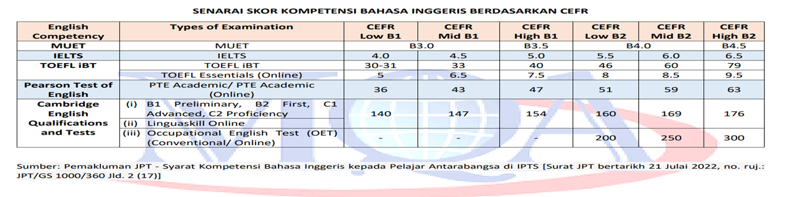
11 Sept 2023/ncm

