Ignition Stability of Hydrogen in Noble Gases Atmosphere in Compression Ignition Engine

(Kestabilan Pencucuhan Hidrogen dalam Persekitaran Gas Adi dalam Enjin Pencucuhan Mampatan)

Norhidayah Mat Taib^{,a,b} , Wan Mohd Faizal Wan Mahmood^{a,b} & Hasan Koten^{c}, Mohd Radzi Abu Mansor^{,a,b,*}

ªDepartment of Mechanical and Manufacturing Engineering,
^{b}Centre of Automotive Research
Faculty of Engineering & Built Environment, Universiti Kebangsaan Malaysia, Malaysia
^{c}Department of Nanoscience and Nanoengineering, Istanbul Medeniyet Universitesi, 34700 Istanbul, Turkey
*Corresponding author: radzi@ukm.edu.my

ABSTRACT

Hydrogen fuel promises a high engine efficiency and the ability to eliminate harmful emissions in an internal combustion engine. However, the ignition stability of hydrogen in compression ignition engine is unstable due to the high-auto ignition temperature of hydrogen. Replacing nitrogen with noble gases such as argon, krypton and xenon appears to be a promising option due to their high specific heat ratio. This paper aims to investigate the ignition stability in a heavy molecular noble gases atmosphere in a CI engine. In this study, Converge CFD software simulates a single-cylinder compression ignition engine model based on the Yanmar NF19SK engine parameters. Hydrogen combustion in a noble gas atmosphere resulted in low ignition stability when operated at low intake temperature. Based on this study, increasing intake temperature improves the ignition stability. As the result, argon is the most preferable among other noble gases. Further research should investigate the other noble gases’ capability under different parameters to improve engine thermal efficiency.

Keywords: Ignitability; Combustion characteristics; Adaptive Mesh Refinery

ABSTRAK

Pembakaran hidrogen menjanjikan kecekapan enjin yang tinggi dan keupayaan untuk menghapuskan emisi dalam enjin pembakaran dalaman. Walau bagaimanapun, kestabilan pencucuhan bahan api hidrogen dalam enjin pembakaran mampatan adalah tidak stabil disebabkan suhu auto pencucuhan hidrogen yang tinggi. Penggantian nitrogen dengan gas adi seperti argon, kripton, dan xenon merupakan sebagai pilihan yang tepat kerana nisbah haba tentunya yang tinggi akan meningkatkan suhu ketika mampatan. Kajian ini bertujuan untuk menyiasat kestabilan pencucuhan dalam persekitaran gas adi yang mempunyai berat molekul yang tinggi dalam enjin pembakaran dalaman. Dalam kajian ini, perisian Converge CFD digunakan untuk simulasi sebuah model enjin pembakaran dalam silinder tunggal berdasarkan parameter enjin Yanmar NF19SK. Pembakaran hidrogen dalam persekitaran gas adi menghasilkan kestabilan penyalaan yang rendah apabila beroperasi pada suhu kemasukan yang rendah. Kajian juga mendapati bahawa peningkatan suhu kemasukan mampu meningkatkan kestabilan pencucuhan. Hasil dari perbandingan, argon merupakan gas yang disarankan berbanding gas adi yang lain. Namun, penyelidikan akan datang juga akan meneliti keupayaan gas adi yang lain menggunakan parameter enjin yang lebih sesuai untuk meningkatkan kecekapan haba enjin.

Kata Kunci: Kebolehbakaran; Ciri-ciri pembakaran; AMR

INTRODUCTION
Hydrogen is well known as the most environmentally friendly fuel in many applications. Hydrogen fuel has high energy density, zero carbon emissions and durable in storage (Yang et al. 2022). In the transportation sector, hydrogen is commonly used in fuel cells and internal combustion engines (ICE), promising the cleanest emission products. The development of hydrogen in ICE, particularly in compression ignition (CI) engines, is more reliable for heavy-duty and high-performance operations due to the high energy efficiency. CI engine has the advantages of high compression power, low operational cost and long lifespan (Dibble et al. 2017). However, the high auto-ignition temperature of hydrogen around 858 K, is a significant challenge when operated in a CI engine, especially if the engine is operated in a normal ambient air atmosphere (Szwaja 2009). Moreover, the higher in cylinder temperature with hydrogen combustion results in the formation of NOx emissions (Kadir et al. 2020).
Noble gases have a higher specific heat ratio compared to nitrogen. Table 1 compares the thermo-physical properties of noble gases argon, krypton and xenon and also the properties of hydrogen and nitrogen. Specific heat ratio is the most important criteria in determining the effectiveness of gas to offer higher temperatures during compression. The compression of a higher specific heat ratio’s gas can increase the in-cylinder temperature to reach the auto-ignition temperature of hydrogen Equation 1 represents the relationship between the thermal efficiency and specific heat ratio, k (Cengel 2007; Dibble et al. 2017) which indicates that the thermal efficiency during the gas compression for higher specific heat ratio gas which is aroundof 1.66 to 1.68 is much greater than nitrogen, which has a value of 1.40.
$$Ƞ_{th, Diesel}=1-\frac{r^{1-k}\left(r_{c}^{k}-1\right)}{k\left(r_{c}-1\right)}$$ | (1)
This paper aims to investigate the ignition stability of hydrogen in noble gases in a compression ignition engine. A numerical approach is employed on a combustion chamber model based on a Yanmar NF19SK direct injection compression ignition engine. The noble gases such as argon, krypton and xenon replaced the 79% nitrogen in the air, operated in a low compression ratio engine at a high intake temperature.

TABLE 1. Thermo-physical properties of noble gases (Rayleigh 1997)
Properties | Hydrogen |  | Nitrogen | Argon |  | Krypton |  | Xenon
Molecular weight (kg/mol) | 2.016 | 28.014 |  |  | 39.95 |  | 83.3 |  | 131.29
Density (kg/m3) @ 32 ᵒC | 0.08375 | 1.165 |  |  | 1.7818 |  | 3.708 |  | 5.851
Boiling point (K) | 20.25 | 77.15 |  |  | 87.29 |  | 120.85 |  | 166.1
Melting point (K) | 13.95 | 63.15 |  |  | 83.6 |  | 115.8 |  | 161.7
Specific heat capacity (J/kg.K) | 10.16 | 1040 |  |  | 519 |  | 247 |  | 159
Specific heat ratio | 1.41 | 1.40 |  |  | 1.67 |  | 1.68 |  | 1.66

MATERIALS AND METHOD

This study conducts a numerical approach by using Converge Computational Fluid Dynamic (CFD) software. Converge CFD is a software equipped with an adaptive mesh refinery (AMR) tool to refine the mesh grid size. The refinery process is unique in that the mesh is automatically refined based on the combustion progress, allowing it to improve the mesh quality and combustion analysis accuracy (Morovatiyan et al. 2019; Hafiz et al. 2018).

Validation and Grid Independence Test
This study validates an experiment conducted by (Rey 2014). The experiment is carried out on Yanmar NF19SK direct injection compression ignition engine. Hydrogen is directly injected into the argon-oxygen atmosphere. Based on the same engine specification, the software transformed the 3D model of the combustion chamber into a triangulated model, as illustrated in Figure 2. The simulation operates on a closed combustion system, starting with the intake valve close (IVC) at 179 ᵒCA BTDC and ending with the exhaust valve open (EVO) at 179 ᵒCA ATDC. An injector located in the centre of the cylinder’s head injects hydrogen direct into the combustion chamber at 3 ᵒCA BTDC for 5 ᵒCA at an 8 MPa pressure. The intake temperature is kept constant at 380 K. Table 2 lists the engine specifications and parameters used in this study.

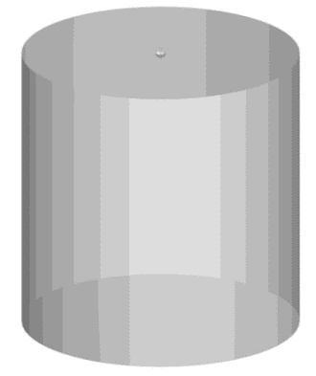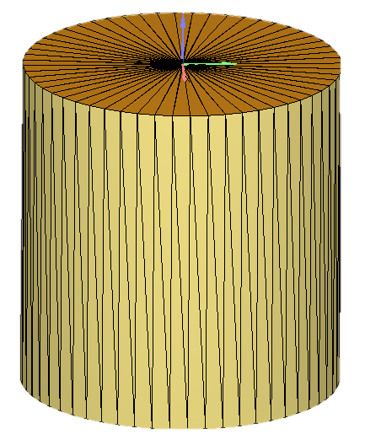
(a) NF19SK 3D model (b) triangulated model
FIGURE 2. Yanmar NF19SK engine 3D model dan triangulated model (Hafiz et al. 2018)

TABLE 2. Engine specification (Rey 2014; Hafiz et al. 2018)
Specification
Engine model | Yanmar NF19SK
Engine type | Compression ignition
Bore x stroke | 110 mm x 106 mm
Engine speed | 600 RPM
Intake valve close (IVC) | 179 ᵒCA BTDC
Exhaust valve open (EVO) | 179 ᵒCA ATDC
Compression ratio | 10
Intake pressure | 0.114 MPa
Injection pressure | 8 MPa
Nozzle diameter | 0.8 mm
Injection timing | 3 ᵒCA BTDC
Injection duration | 5 ᵒCA
Intake temperature | 380 K
Noble gas | Air, Argon, krypton, xenon

The combustion model used in this study is SAGE detailed chemistry solver, which works to accelerate the simulation. The turbulence model used in this simulation is Reynolds-averaged Navier-Stokes (RANS) because of its small memory spaces, which shortened the operating time The Navier-stokes equation can solve all the models and equations based on PISO solver. Models of base grid with size of 0.003 m, 0.004 m, 0.005 m and 0.006 m tested. Results found that the most suitable grid size for this study is 0.005 m with the lowest percentage error of 9.89%, compared to the experiment conducted by (Rey 2014). Numerical studies by Hafiz 2018, and Shahsavan 2020 support the results of this study (Hafiz et al. 2018; Shahsavan et al. 2020).

RESULTS AND DISCUSSION

Figure 4 shows the compression of noble gases-oxygen and air, in the absence of hydrogen. The result shows that the compression of argon produced the highest pressure followed by krypton, xenon and air. It indicates that when the molecular weight of the gas decrease, the compression pressure increases. Even though nitrogen has a lower molecular weight than argon, krypton and xenon, its low specific heat ratio results in extremely low compression pressure.

FIGURE 4. Compression pressure of noble gases atmosphere at ambient intake temperature

Figure 5 shows the in-cylinder pressure and temperature of hydrogen combustion in noble gases-oxygen and air atmosphere at the intake temperature of 380 K. When the hydrogen fuel is injected, the pressure rises exclusively in the argon-oxygen atmosphere, indicating that the ignition of hydrogen occurs only in the argon-oxygen atmosphere with a maximum pressure of 4.69 MPa. The ignition timing of hydrogen is found to be at 1.98 ᵒCA BTDC, with a very short delay of 0.004 ms. Hence argon is suggested as the stable working gas for hydrogen combustion in low compression ratio engine (Taib, 2021).

Injection timing
(3°CA BTDC)
FIGURE 5. Compression pressure of noble gases atmosphere at intake temperature of 380 K

The in-cylinder temperature of hydrogen combustion in krypton-oxygen and air shows a decreasing trend before the piston reaches the TDC position. The temperature distribution in the krypton-oxygen atmosphere is narrower compared to the xenon-oxygen atmosphere. The fundamental explanation was due to the lower specific heat capacity of noble gases compared to the lighter ones. However, in the study presented, the ignition is supplied from the ignition sources, which initiates and enhances the combustion (Shahsavan 2017).

 | 3 ᵒCA BTDC | 2 ᵒCA BTDC | TDC | 2 ᵒCA ATDC
Argon |  |  |  | 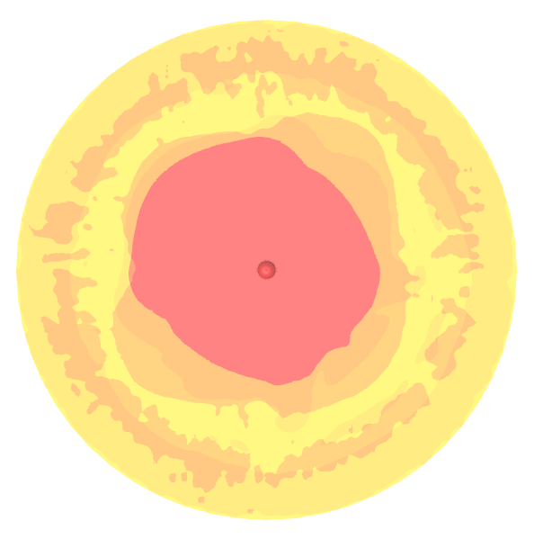 | 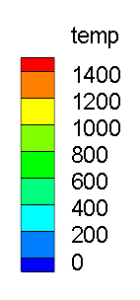  (K)
Krypton |  |  |  | 
Xenon |  |  |  | 
Nitrogen |  |  |  | 
FIGURE 6. Flame temperature distribution of hydrogen combustion in noble gases atmosphere

CONCLUSION

The study found that the noble gases atmosphere reduces the hydrogen ignition stability when operated at low intake temperature and low compression ratio. High molecular weight of xenon and krypton shows that the compression of these gases results in higher compression temperature and pressure. However, further suitable setup is needed to identify the stable ignition. The study proves that argon-oxygen atmosphere is the most promising working gas for hydrogen combustion in compression ignition engines, compared to krypton and xenon-oxygen atmosphere. Future studies should study the engine operation with a high compression ratio and a suitable hydrogen injection parameter for the noble gas atmosphere to improve engine thermal efficiency.

ACKNOWLEDGEMENT

The authors would like to thank Universiti Kebangsaan Malaysia for supporting this research with grant GUP-2018-099 and Ministry of Education Malaysia for supporting this research with grant FRGS/1/2017/TK07/UKM/02/1.

REFERENCES

Cengel, Yunus A. 2007. Thermodynamics An Engineering Approach. Mc-Graw Hill publisher.

Dibble, Robert Woodrow, Miguel Sierra Aznar, Timothy Burke Sennott, and Jyh-Yuan Chen. 2017. Recirculating Noble Gas Internal Combustion Power Cycle. US 2017/0211515 A1, issued 2017.

Hafiz, Nik Muhammad, Mansor, Mohd Radzi Abu, and Wan Mohd Faizal, Wan Mahmood. 2018. “Simulation of the Combustion Process for a CI Hydrogen Engine in an Argon-Oxygen Atmosphere.” International Journal of Hydrogen Energy 43 (24): 11286–97. https://doi.org/10.1016/j.ijhydene.2018.05.022.

Hafiz, Nik Muhammad, Mansor, Mohd Radzi Abu, Wan Mohd Faizal, Wan Mahmood, and Masahiro Shioji. 2016. “Simulation of the Effect of Initial Temperature and Fuel Injection Pressure on Hydrogen Combustion Characteristics in Argon-Oxygen Compression Ignition Engine.” SAE Technical Papers 2016-Octob: 1–8. https://doi.org/10.4271/2016-01-2227.

Hafiz, Nik Muhammad, Mansor, Mohd Radzi Abu, Wan Mohd Faizal, Wan Mahmood, Fadzli Ibrahim, Shahrir Abdullah, and Kamaruzzaman Sopian. 2016. “Numerical Study of Hydrogen Fuel Combustion in Compression Ignition Engine under Argon-Oxygen Atmosphere.” Jurnal Teknologi 78 (6–10)

Kadir, Murat, Yesilyurt Zeki, and Yilbasi Mustafa. 2020. The Performance , Emissions , and Combustion Characteristics of an Unmodified Diesel Engine Running on the Ternary Blends of Pentanol / Safflower Oil Biodiesel / Diesel Fuel. Journal of Thermal Analysis and Calorimetry. Springer International Publishing. https://doi.org/10.1007/s10973-020-09376-6.

Morovatiyan, Mohammadrasool, Martia Shahsavan, and John Hunter Mack. 2019. “Numerical Study on Direct Injection of Hydrogen-Methane Blends into a Constant Volume Combustion Chamber.” In 11th U.S. National Combustion Meeting, 1–11. Pasadena, California. https://doi.org/10.31224/osf.io/ebvah.

Rayleigh, Lord. 1997. “The Noble Gases: Helium, Neon, Argon, Krypton, Xenon and Radon.” In Chemistry of the Elements, edited by N.N. Greenwood, 888–904. https://doi.org/10.1016/b978-0-7506-3365-9.50024-9.

Rey, Sopheak. 2014. “Study on the SI-CI Combustion and the Spontaneous Ignition of Hydrogen Jets Using a Rapid Compression Expansion Machine.” Kyoto University.

Shahsavan, Martia, Mohammadrasool Morovatiyan, Mammadbaghir Baghirzade, and J. Hunter Mack. 2020. “Implementing Natural Gas in a Compression Ignition Cycle Using Noble Gas Addition.” In ASME 2019 Internal Combustion Engine Division Fall Technical Conference, ICEF 2019, 1–9. Chicago, USA: American Society of Mechanical Engineers (ASME). https://doi.org/10.1115/ICEF2019-7159.

Taib, Norhidayah Mat, Mansor, Mohd Radzi Abu, and Wan Mohd Faizal Wan Mahmood. 2021. “Combustion Characteristics of Hydrogen in a Noble Gas Compression Ignition Engine.” Energy Reports 7 (May): 200–218. https://doi.org/10.1016/j.egyr.2021.07.13

