The Title Should be in Sentence Case and Centered Across the Page (It should be typed in 14-point Times New Roman)

Marlia Mohd Hanafiah ^{a,b}, Siti Norliyana Harun^{a*} , & Noorashikin Md Noorª

ªCentre for Tropical Climate Change System, The University of Malaysia, Bangi, Selangor, Malaysia
^{b}Department of Earth Science and Environment, Faculty of Science and Technology, The University of Malaysia, Bangi, Selangor, Malaysia
*Corresponding author: sitinorliyana@ukm.edu.my

ABSTRACT

Place your abstract in this section. It should be formatted with single spacing and typed in Times New Roman, font size 10. Ideally, the abstract should be between 200 and 250 words. It should be clear and descriptive, providing concise information on the problem addressed. This should be followed by a brief description of the methodology and a summary of the results. Conclude the abstract with a comment on the significance of the results or a brief conclusion. No table, figure, citation, or reference shall be included in the abstract. The manuscript must be saved in Microsoft Word format (.docx/.doc).

Keywords: Maximum of 5 keywords separated by semi-colon (;)

1. KEY REQUIREMENTS

This document outlines the guidelines for preparing and submitting manuscripts. Please use this template for preparing your manuscript. The following lists the essential requirements for an article to be published in JCCaSS:

- the page size should be A4;
- pages should contain page numbers;
- all articles must contain an abstract;
- in the Microsoft Word (.docx/.doc).
- The manuscript's similarity index should be below 15%.

  - Layout of the title page

The title should be in sentence case, centered across the page, and typed in 14-point Times New Roman. The title should be followed by a list of all authors’ names and their affiliations. Author names should be typed in Times New Roman, font size 9. The authors’ affiliations follow the author list. If there is more than one address then a superscripted number should come at the start of each address; each author should also have a superscripted number or numbers following their name to indicate which address, or addresses, are the appropriate ones for them. Type an asterisk (*) right after the name of the corresponding author.

2. FORMATTING THE TEXT

The text of your article should start on the same page as the abstract. Any Acknowledgments should be placed immediately after the last numbered section of the paper, and any appendices after the Acknowledgments section.
The text of your paper should be formatted as follows:
- 11-point Times or Times New Roman.
- The text should be set to single line spacing.
- Paragraphs should be justified.
- The first paragraph after a section or subsection heading should not be indented; subsequent paragraphs should be indented by 5 mm.

  - Sections, subsections and subsubsections
The use of sections to divide the text of the paper is optional and left as a decision for the author. Where the author wishes to divide the paper into sections the formatting shown in Table 1 should be used.

Table 1. Formatting sections, subsections, and subsubsections.
 | Font | Spacing
Section | 11-point Times bold | 1 line space before a section  No additional space after a section heading
Subsection | 11-point Times Italic | 1 line space before a subsection  No space after a subsubsection heading
Subsubsection | 11-point Times Italic | Subsubsections should end with a full stop (period) and run into the text of the paragraph

Sections should be numbered with a dot following the number and then separated by a single space:
- sections should be numbered 1., 2., 3., etc
- subsections should be numbered 2.1, 2.2, 2.3, etc
- subsubsections should be numbered 2.3.1, 2.3.2, etc
3. FIGURES AND TABLES

Figures and tables should be numbered serially and positioned (centred on the width of the page) close to where they are mentioned in the text, not grouped together at the end. Captions should be placed at the bottom of the figure and top of the table, with font size 10-point and should have a full stop (period) at the end.

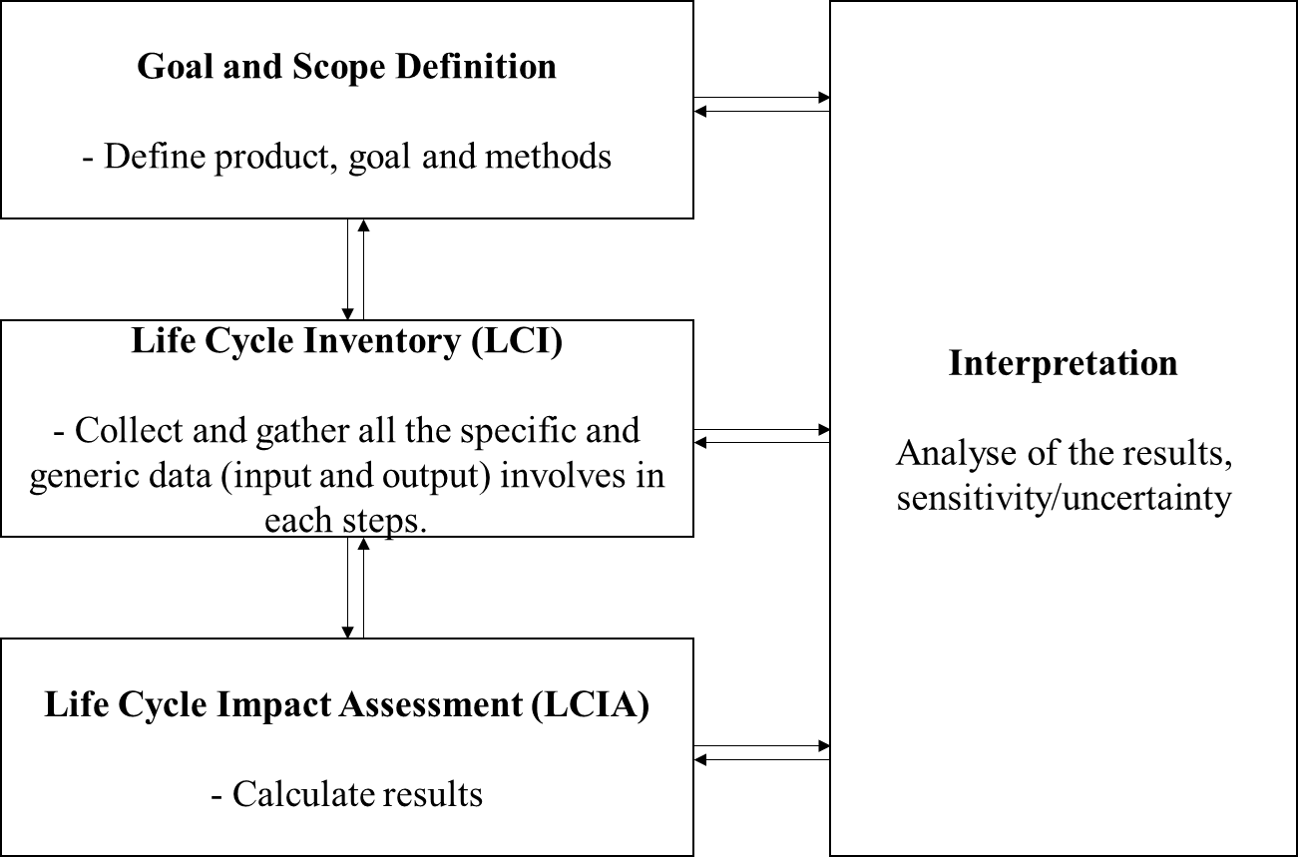
Figure 1. Caption with font size 10-point and should have a full stop (period) at the end.

3.1 Colour figures
There are no restrictions on the use of colour in the online version of your article. However, you should bear in mind that any print version of your article is likely to be in black and white which may make coloured lines difficult to distinguish.

4. SUPPLEMENTARY DATA

We are happy for authors to submit supplementary data attachments to enhance the online versions of published articles. Supplementary data enhancements typically consist of video clips, animations or supplementary data such as data files, tables of extra information or extra figures.

5. REFERENCES

Online references will be linked to their original source or to the article within a secondary service such as INSPEC or ChemPort wherever possible. To facilitate this linking extra care should be taken when preparing reference lists.

A complete reference should provide enough information to locate the article concerned in print or electronic form. If you are unsure of a particular journal’s abbreviated title it is best to leave the title in full. The terms loc. cit. and ibid. should not be used. The reference list should be in 9-point font size.

5.1 References to printed journal articles
References to printed journal articles should typically contain:
- the authors, in the form: family name (only the first letter capitalized) followed by initials with no periods after the initials;
- the year of publication;
- the article title (optional) in lowercase letters, except for an initial capital;
- the journal title (italic and abbreviated). Parts denoted by letters should be inserted after
- the journal in Roman type;
- the volume number in bold type;
- the article number or the page numbers.

5.2 A typical (alphabetical order) reference list
References
Note that APA style is used for references. All publications cited in the text should be included in the reference list. Reference should be listed in alphabetical order. A list of references should be provided under the section of references. List of references should have minimum 15 references, which should have recent five years published references. More than 2/3 of references should cite from journals, books not proceedings and internet. All journal names, publisher name need to write in full without abbreviation. Such as J. Mech. Eng. should be writing as Journal of Mechanical Engineering.
Examples of references:

Harun, S. N., Hanafiah, M. M., & Noor, N. M. (2022). Rice straw utilisation for bioenergy production: A brief overview. Energies, 15(15), 5542.
Noor, N. M., & Abdul Maulud, K. N. (2022). Coastal vulnerability: a brief review on integrated assessment in Southeast Asia. Journal of Marine Science and Engineering, 10(5), 595.

Acknowledgments
Authors wishing to acknowledge assistance or encouragement from colleagues, special work by technical staff or financial support from organizations should do so in an unnumbered Acknowledgments section immediately following the last numbered section of the paper

