Guidelines for Extended Abstract Preparation

Author Oneª, Author Two^{a*}, and Author Three^{b}

ª Department of XXXXXX, University of XXXXX, Selangor, Malaysia
^{b} Department of XXXXXX, University of XXXXXX, Johor, Malaysia

*Corrensponding Author e-mail: xxxx@xxxx.xxx.xx

Keywords: material; process; output (up to six keywords)

Extended Abstract

This article serves as the template for all extended abstracts (three pages only) submitted to the 7th Powder Metallurgy & Advanced Processes and Systems in Manufacturing Symposium (PM7 & APSIM2023). All extended abstracts will be reviewed. Please use this template when preparing the extended abstract. This will ensure a uniform format in the publication.

The extended abstract should be written in UK English and is to be prepared in MS Word. The extended abstract should include: Title, information of Author(s) and Affiliation(s), e-mail address of the Corresponding Author, Abstract itself and Keywords. Besides, the use of Equations, Tables, Figures, Acknowledgements, and References are also encouraged. Throughout the extended abstract, use Times New Roman font with single spacing between lines. The recommended font size is 14 pts for the title and 11 pts elsewhere. The main text should be justified on both sides. The use of footnotes is discouraged. Please note that the length of the extended abtstract should not exceed three (3) A4 pages.

Other specific guidelines for each section are given below.
- Title – Please provide a descriptive title of the paper. The title should be concise and not span more than 2 lines. Use Times New Roman with a font size of 14 pts and in bold.

- Authors and Affiliations – Include the first name, middle initial and surnames of all the authors. The name of the registered/presenting author should be underlined. The affiliations of all the authors should be included. The e-mail address of the corresponding author (*) should be shown.

- Abstract – Use Times New Roman with a font size of 11 pts. The main text should be justified on both sides.

- Keywords – Provide up to 6 keywords, separated by semi-colons.

- Equations – The equations should be indented with the numbers displayed on the right side in parenthesis.
(1)
- Tables – Number of tables consecutively in accordance with their appearance in the text. Please use Arabic numerals and supply a heading. Tables and their caption should be centered on the page. Place footnotes to the table below the table body and indicate them with superscript lowercase letters. Be sparing in the use of the tables and ensure that the data presented in the table do not duplicate results described elsewhere in the article.

Table 1: Important Dates for POCER 2022
Date | Activity
1 March 2023 | Abstract Submission
1 June 2023 | Acceptance Notification
1 July 2023 | Extended Abstract Submission
10-13 September 2023 | PM7 & APSIM 2023

- Figures – The figures should be numbered and captioned (use “Figure 1” in text). It is recommended that the figures be produced in colour/gray-scale and has at least 300 dpi. As a guideline, the extended abstract should not contain more than 3 figures.
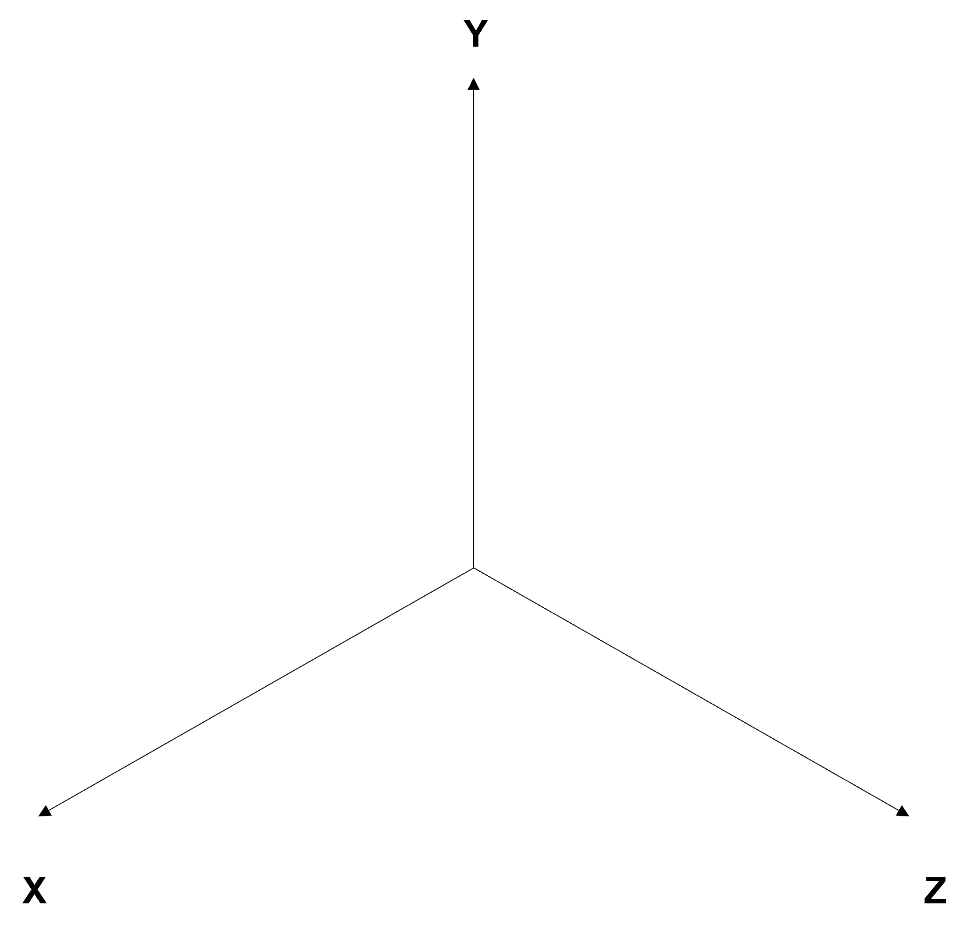
Figure 1: The Drawing

- Nomenclature, symbols and abbreviation – Only wide used accepted symbols and forms of abbreviations should be used, but always give full expression followed by the abbreviation the first time it appears in the text. Abbreviations and symbols used in the tables and figures should be explained in the legend. The used of symbols in the text should be avoided as much as possible as they disrupt the flow of the sentences as well as the appearance of the typeset page. In no case should a combination of symbols and words be used.

- Acknowledgements – Any acknowledgements can be included at the end of the main body of the extended abstract but before the references.

- Citations and References – All publications cited in the text should be included in the reference list. Reference should be listed in alphabetical order according to UKM styles format. Example of references appear in the text.

Acknowledgements
The authors thank the Ministry of Science, Technology and Innovation for the Science Fund project of XXXXX.

References
Zeng C, Liu L, Hu Y, Bian W, Leng J, Liu Y. A viscoelastic constitutive model for shape memory polymer composites: Micromechanical modeling, numerical implementation and application in 4D printing. Mechanics of Materials 2022;169. https://doi.org/10.1016/j.mechmat.2022.104301.
Lim BH, Majlan EH, Daud WRW, Rosli MI, Husaini T. Numerical analysis of modified parallel flow field designs for fuel cells. Int J Hydrogen Energy 2017;42:9210–8. https://doi.org/10.1016/j.ijhydene.2016.03.189.
Wang J, Jin X. Comparison of Recent Fiber Orientation Models in Autodesk Moldflow Insight Simulations with Measured Fiber Orientation Data. Proceedings of the Polymer Processing Society 26th Annual Meeting 2010.
Davim JP, editor. Nontraditional Machining Processes. London: Springer London; 2013. https://doi.org/10.1007/978-1-4471-5179-1.

