Template for Extended Abstracts

First Author*¹, Second Author2, Third Author1
¹Solar Energy Research Institute (SERI), Universiti Kebangsaan Malaysia, 43600 Bangi, Selangor, Malaysia
²Faculty Engineering and Built Environment, Universiti Kebangsaan Malaysia, 43600 Bangi, Selangor, Malaysia
*Corresponding Author Email: colloquiumseri@gmail.com.

ABSTRACT

This document presents the instructions for the preparation of extended abstract to be included in the proceedings of the 4th Colloquium SERI 2016. All abstracts should be written in English [1]. In order to achieve graphical consistency, the extended abstract should be preferably written using Microsoft Word. It should start with the paper’s title, authors, affiliation, corresponding e-mail, abstract and keywords.

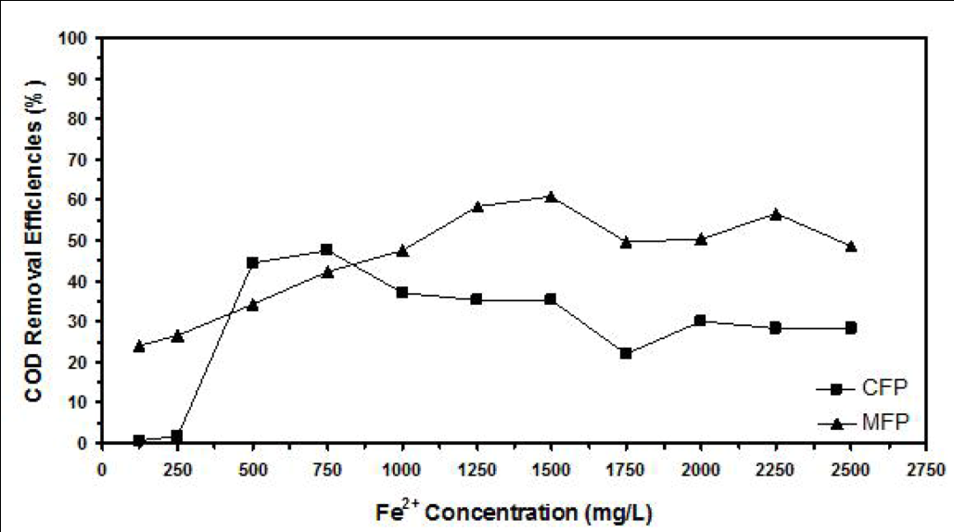

Fig. 1 Example graph for the extended abstract

The one-page extended abstract should be written in MS Word format in single-spaced in 12 point Times New Roman. The margin is 1” for top, bottom, left and right. Do not indent the text paragraphs. Please, briefly explain the aim and scope of your study, your materials and methods, and the main conclusions of the study. Max 1 figures/photographs can be placed in the abstract [2]. Authors are requested to submit Abstracts (max 1 pages in the length) in electronic form (MS-Word) via email to colloquiumseri@gmail.com. Please strictly follows the template. The incorrect formats may result in your abstract being returned to you by e-mail.

Keywords: up to 5 words arranged in alphabetical order

References
[1] J. van der Geer, J.A.J. Hanraads, R.A. Lupton, J. Sci. Commun. 163 (2010) 51–59.
[2] W. Strunk Jr., The Elements of Style, fourth ed., Longman, New York, 2000.
[3] G.R. Mettam, L.B. Adams, in: B.S. Jones, R.Z. Smith (Eds.), Introduction to the Electronic Age, E-Publishing Inc., New York, 2009, pp. 281–304.

