Track 4: ACROSS DISCIPLINES (TOPIC EXPLORATION)

ARE ALL SPORTSMEN DESCRIBED IN THE SAME WAY?

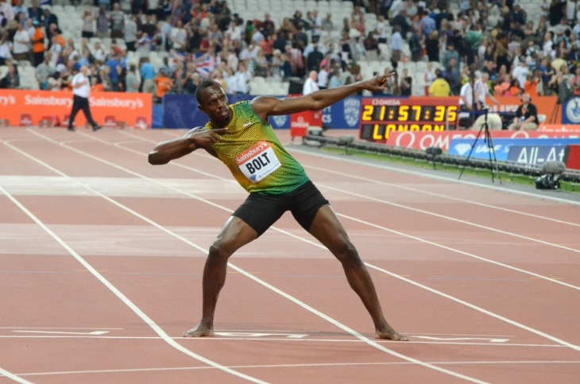 | 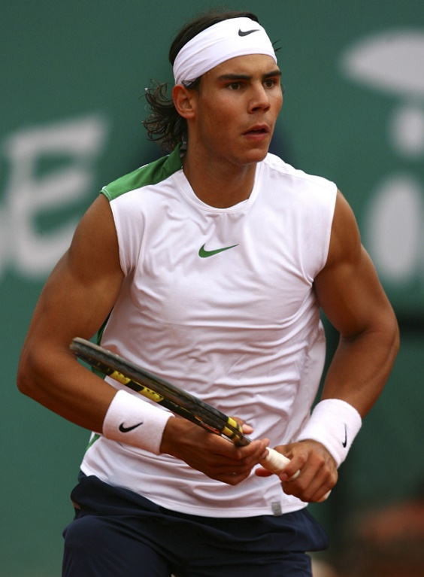
Instructions

- Get yourself into groups of three or four.
- Look at the pictures carefully.
- Identify the sportsmen and the sports they are in.
- Read the short excerpts that follow.
- In turn, share with your friends the sport and your knowledge of the sportsmen.
- How would you describe these sportsmen?
- What are the qualities associated with them?
- Keep these qualities in mind as we go through the lesson.
USAIN BOLT
24th July 2015 – Usain returned to racing with a win in the Sainsbury’s Anniversary Games 100m recording 9.87 secs in wet and cold conditions to win his heat and then exactly the same time to win the final one hour later.
“Bolt is back,” was the message from the stadium announcer after the men’s 100m at the IAAF Diamond League meeting in London on Friday evening. Usain St. Leo Bolt, born 21 August 1986), is a Jamaican sprinter. Widely regarded as the fastest person ever, he is the first man to hold both the 100 metres and 200 metres world records. Along with his teammates, he also set the world record in the 4x100 metres relay. He is the reigning Olympic champion in these three events, the first man to win six Olympic gold medals in sprinting, and an eight-time World champion. He was the first to achieve a "double double" by winning 100 m and 200 m titles at consecutive Olympics (2008 and 2012), and topped this through the first "double triple" (including 4×100 m relays).
Bolt's achievements in sprinting have earned him the media nickname "Lightning Bolt" and awards including the IAAF World Athlete of the Year, Track and Field Athlete of the Year, and Lureus World Sportsman of the Year (three times). He is the highest paid athlete ever in track and field. He has been called the world's most marketable athlete. By winning three gold medals at the 2013 World Championships, Bolt became one of the most successful athletes in the 30-year history of the athletics world championships.

RAFAEL NADAL
Rafael "Rafa" Nadal Parera is a Spanish professional tennis player currently ranked world No. 10. He is widely regarded as the greatest clay court player in history and has been titled "The King of Clay" His evolution into an all-court threat has established him as one of the greatest players in tennis history, with some considering Nadal to be the greatest player of all time.
Nadal has won 14 Grand Slam single titles, the 2008 Olympic gold medal in singles, a record 27 titles ATP World Tour Masters 1000 and 15 ATP World Tour 500 tournaments. He was also a member of the winning Spain Davis Cup team in 2004, 2008, 2009, and 2011. In 2010, he became the seventh player in history and youngest of four in the Open Era to achieve the Career Grand Slam. He is the second male player, after Andre Agassi, to complete the singles Career Golden Slam. In 2011, Nadal was named the Laureus World Sportsman of the Year.
Nadal and Mats Wilander are the only two male players in history who have won at least two Grand Slam titles on three different surfaces—hard court, grass, and clay. By winning the 2014 French Open, Nadal became the only male player to win a single Grand Slam tournament nine times and the first to win at least one Grand Slam tournament for ten years.

